CHAPTER-9
STRATEGIES FOR ENHANCEMENT IN FOOD PRODUCTION

CRITICAL AND CREATIVE THINKING BASED QUESTIONS

1. Vegetative propagation of Fragaria sp. is traditionally carried out using stolons. This system of propagation, in addition to being slow, can spread plant diseases, particularly serious being viral. In vitro culture and the establishment of micropropagation protocols are important tools for solving these problems. In recent years, considerable effort has been made to develop in vitro propagation of the commercial strawberry in order to produce virus-free plants of high quality. These previous results can serve as the basis for developing in vitro-based propagation technologies in the less studied species Fragaria chiloensis.
- Name one traditional method of vegetative propagation. (L1)
- What are the disadvantages of propagation of a plant through stolons?(L2)
- Suggest one method of fast propagation of plants in vitro. (L3)
- Which part of the plant used as explant by the scientists for in vitro propagation?(L4)
- Describe the procedure that scientists followed to recover the healthy parts from a diseased or virus infected plants. (L5)
- Why only certain plant tissues can be used for in vitro culture of plants?(L6)

2. Plant breeding is the purposeful manipulation of plant species in order to create desired genotypes and phenotypes for specific purposes. This manipulation involves either controlled pollination, genetic engineering, or both, followed by artificial selection of progeny. Plant breeding often, but not always, leads to plant domestication. Plant breeding has been practiced for thousands of years, since near the beginning of human civilization. It is now practiced worldwide by government institutions and commercial enterprises. International development agencies believe that breeding new crops is important for ensuring food security and developing practices through the development of crops suitable for their environment. Classical plant breeding uses deliberate interbreeding (crossing) of closely or distantly related individuals to produce new crop varieties or lines with desirable properties. Plants are crossbreed to introduce traits/genes from one variety or line into a new genetic background. For example, a mildew-resistant pea may be crossed with a high-yielding but susceptible pea, the goal of the cross being to introduce mildew resistance without losing the high-yield characteristics. Progeny from the cross would then be crossed with the high-yielding parent to ensure that the progeny were most like the high-yielding parent, (backcrossing). The progeny from that cross would then be tested for yield and mildew resistance and high-yielding resistant plants would be further developed. Plants may also be crossed with themselves to produce inbreed varieties for breeding.
- What are the main aims of plant breeding? L1
- What do you mean by inbreeding? L2
- How is it useful in plant breeding? L3
- How inbreeding is different from cross breeding? L4
- How classical plant breeding is different from modern plant breeding? L5
- How new characters are introduced in modern plant breeding? Suggest in two. L6

3. Animals and livestock contribute 40 percent of the global value of agricultural output and contribute to the livelihoods and food security of almost a billion people worldwide. Advances in animal breeding, genetics, and genomics are facilitating a more efficient industry. For example, the number of cattle has decreased over the past decade, yet the total production of beef and milk has increased. This was largely possible because genetic advancements led better animal feed efficiency, which is critical to improving livestock production and lowering costs for producers.
- Is agriculture include only crop production and management? Justify your answer. L1
- What do you call the breeding and raising livestock? L2
- The number of cattle has decreased over the past decade, yet the total production of beef and milk has increased. How it becomes possible? L3
- You are planning to set up a Dairy Farm. Describe the various aspects you would consider before you start the venture. L4
- Explain the term genetic mother and surrogate mother with reference to animal breeding technique? L5
- How can we improve the success rate of ovulation and fertilisation in animal husbandry programmes? L6

4. The Green Revolution refers to a set of research and development of technology transfer initiatives occurring between the 1930s and the late 1960s that increased agricultural production worldwide, particularly in the developing world, beginning most markedly in the late 1960s. The initiatives resulted in the adoption of new technologies, including: ...new, high-yielding varieties (HYVs) of cereals, especially dwarf wheats and rices, in association with chemical fertilizers and agro-chemicals, and with controlled water-supply (usually involving irrigation) and new methods of cultivation, including mechanization. All of these together were seen as a 'package of practices' to supersede 'traditional' technology and to be adopted as a whole. The initiatives, led by Norman Borlaug, the "Father of the Green Revolution," who received the Nobel Peace Prize in 1970, credited with saving over a billion people from starvation, involved the development of high-yielding varieties of cereal grains, expansion of irrigation infrastructure, modernization of management techniques, distribution of hybridized seeds, synthetic fertilizers, and pesticides to farmers.
- Do you suggest any two ways to increase agriculture production responsible for the success of green revolution? L 1
- Why Norman Borlaug known as the "Father of the Green Revolution? L 2
- How can crop varieties be made disease resistant to overcome food crisis in India? Explain. L 3
- Name one disease resistant variety in India - L 4
  - Wheat to leaf and strips rust
  - Brassica to white rust.
- Is the use of chemical fertilizers and agro-chemicals to increase production justified? Explain. L5
- Is use of agrochemicals should be followed by controlled water-supply? What would be the long term consequences of when a farmer use excess of water to irrigate his crop fields? L 6

5. Study the flow chart showing steps of plant breeding and answer the questions-
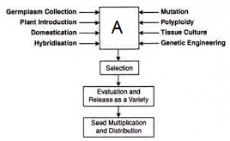
- Identify the step A.
- How mutation helps in the completion of step A?
- Describe the procedure that plant breeders follow for selection of the parents.

6. Study the flow chart showing steps of plant breeding and answer the questions-
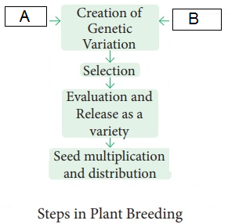
a. how genetic variations are created in plant breeding? Suggest any two methods.
b. evaluation of progeny is done before release of new variety?
c. write one drawback of this traditional hybridisation technique.

8. Observe the diagram carefully and answer the following-
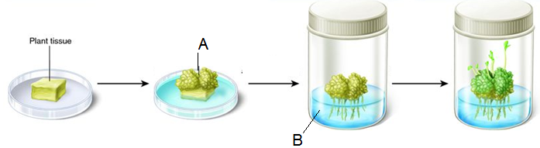
a. Identify A and B in figure.
b. Explain the significance of this technique.
c. Give the correct term for the plant tissue or part used to start the process. Which kind of plant tissues are preferred for this?
d. what do the ‘B’ contain to produce the somaclones?
e. why do the term somaclones is used for the progeny developed by this technique?

9. Observe the diagram given below and write appropriate caption for the technique and complete the missing steps 1, 2, 3 and 4.
Mention the property of plant cells that has helped them to grow into a new plant in vitro condition.
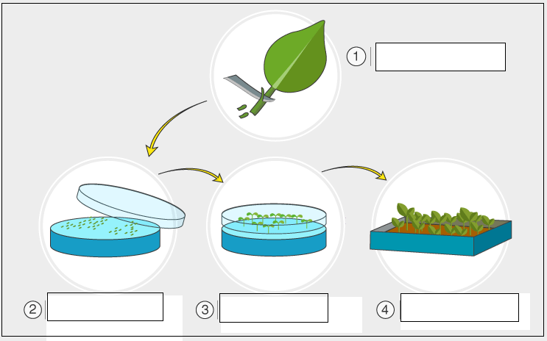

20. Fill in the blanks-
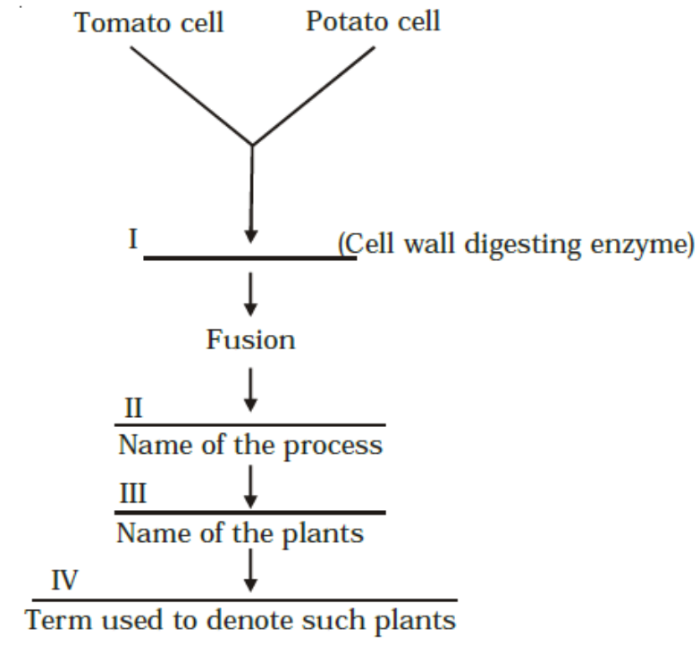

(HOTS- BASED QUESTIONS FOR 2 MARKS)
- Why is bagging of the emasculated flowers essential during hybridization experiments?
- Mention the strategy used to increase homozygosity in cattle for desired traits.
- How can pollen grains of wheat and rice which tend to lose viability within 30 minutes of their release be made available months later for breeding programmes?
- Why is the South Indian Sugarcane preferred by agriculture?
- How can haploid plants plants be raised in the laboratory?
- Mention the property that enables the explants to regenerate into a new plant.
- A banana herb is virus infected. Describe the method that will help in obtaining healthy banana plant from this diseased plant.
- Why should a bisexual flower be emasculated and bagged prior to artificial pollination?
- Describe the technology that has successfully increased the herd size of catte in a short-time to meet the increasing demands of growing human population.
- How does culturing Spirulina solve the food problems of the growing human population?
- How are biofortified Maize and Wheat considered nutritionally improved?
- The term ‘desirable trait’ can mean different things for different plants. Justify the statement with suitable examples.
- A farmer was facing the problem of low yield from his farm. He was advised to keep a beehive in the vicinity. Why? How would the beehive help in enhancing yield?

