Case Study based Questions
Chapter: Neural Control and Co-ordination
- Observe the diagram given below and give answer--

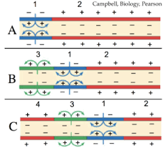
- What does the image depict?
- Why the charge across the membrane changed in picture A to B?
- Expain depolarization and repolarisation progression shown in picture B.
- Observe the diagram given below and give answer--

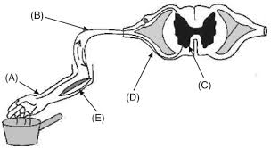
- Why reflex action is only controlled by spinal cord and not by brain?
- A, B,D and E indicate to what?
- Define reflex arc.
- Observe the diagram carefully and answer the following questions-
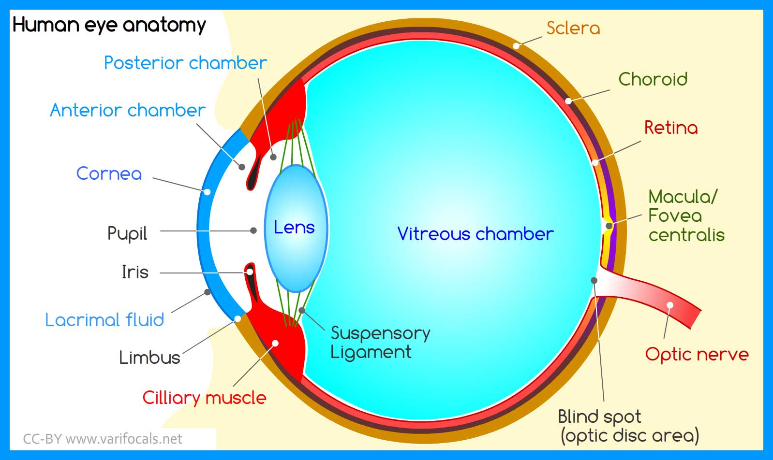

- Identify the area of most clear image formation.
- Which different kinds of cells are present in retina layer?
- Infection of which part of eye is called conjunctivitis?
- Study the diagram carefully and answer the given questions-
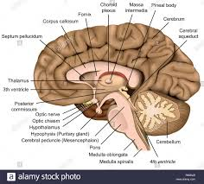
- Identify the part of brain where respiratory centre located.
- Locate the neuroendocrine part in the figure.
- Why neurons are adjusted as sulci and gyri as shown in figure?
- In a gymnastic championship a gymnast rated 100% score while rated behind—
- Which part of brain do you find more developed in player who scored maximum?
- Name the different parts/lobes of part responsible for scored maximum.
- Compare the reflex action and walking.

