KENDRIYA VIDYALAYA SANGATHAN
PRE – BOARD EXAMINATION TERM - 1 2021-2022
SUBJECT BIOLOGY (044)

Class XII Maximum Marks: 35
Time: 90 Minutes

General Instructions:
1. The Question Paper contains three sections.
2. Section A has 24 questions. Attempt any 20 questions.
3. Section B has 24 questions. Attempt any 20 questions.
4. Section C has 12 questions. Attempt any 10 questions.
5. All questions carry equal marks.
6. There is no negative marking.
Q No. | SECTION - A  Section – A consists of 24 questions. Attempt any 20 questions from this section. The first attempted 20 questions would be evaluated.
1 | From the statements given below choose the option that is/are true for a typical female  gametophyte of a flowering plant:  i. It is 8-nucleated and 7-celled at maturity.  ii. It is free-nuclear during development.  iii. It is situated inside the integument but outside the nucellus.  iv. It has an egg apparatus situated at the chalazal end.  a) i and ii  b) ii and iii  c) ii and iv  d) i and iv
2 | The figure shown is a portion of TS of angiosperm anther. Label the parts A to E.  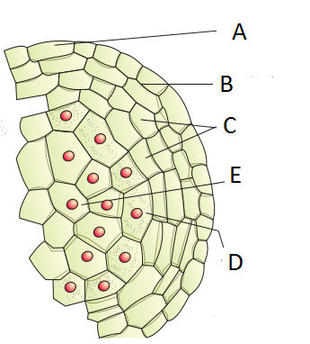  a) A.Epidermis B.Middle layers C.Endothecium D.Tapetum E.Microspore mother cell  b) A.Epidermis B.Endothecium C.Middle layers D.Tapetum E.Microspore mother cell  c)A.Epidermis B.Middle layers C.Endothecium D.Microspore mother cell E.tapetum  d)A.Epidermis B.Endothecium C.tapetum D.Microspore mother cell E.Middle layers.
3 | Which of the following is incorrect about the male reproductive structures in Angiosperms?  i)The microsporangia develop and become pollen sacs  ii) A typical angiosperm anther is bilobed  iii) Each lobe of the anther has one theca  iv) Each anther consists of two microsporangia  - i),ii)  - ii) iii)  - iii) iv)  D.i) iii)
4 | The coconut water from tender coconut is  A. cellular endosperm.  B. free nuclear endosperm.  C. both cellular and nuclear endosperm.  D. free nuclear embryo
5 | Observe the diagram A and B and choose the correct statement  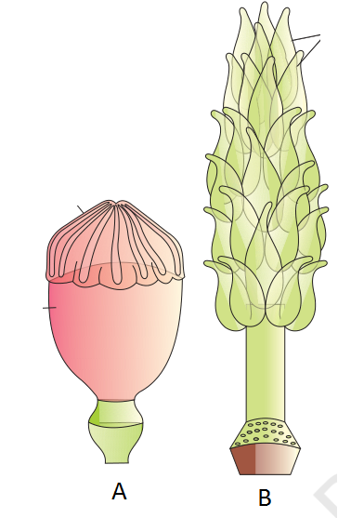  a)Multicarpellary syncarpous ovary and Multicarpellary apocarpous ovary  b) Monocarpellary syncarpous ovary and Monocarpellary apocarpous ovary  c) Bicarpellary Syncarpous ovary and multicarpellary apocarpous ovary  d) Multicarpellary apocarpous ovary and multicarpellary syncarpous ovary
6 | Which of the following statements are correct with respect to hormones secreted by  placenta?  (i)Placenta secretes relaxin during later stage of pregnancy.  (ii) Placenta secretes high amount of FSH during pregnancy.  (iii) Placenta secretes relaxin during initial stage of pregnancy.  (iv) Placenta secretes hCG and hPL during pregnancy.  A. (i) and (iv)  B. (i), (ii) and (iv)  C. (iii) and (iv)  D. (ii), (iii) and (iv)
7 | Write the number of chromosomes in the following cells shown in the figure:  1.Sertoli cell 2.Primary spermatocyte 3.Spermatid 4.Spermatogonium  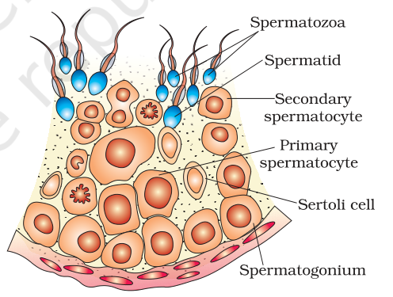  - 1)3n 2)2n 3)n 4)n  - b)1)2n 2)n 3)3n 4)n  - c)1)2n 2)2n 3)n 4)2n  - d)1)2n 2)2n 3)3n 4)2n
8 | The edges of the infundibulum of the oviduct possess finger-like projections called fimbriae-------  - which help in collection of the ovum after ovulation  - which help in driving the sperm towards the egg  - which helps in the implantation of the blastocyst  - which guides the zygote during embryogenesis
9 | Certain cells of the inner cell mass of a human embryo have the potency to give rise to all the tissues and organs. They are------------  A. Ectoderm cells  B. Mesoderm cells  C. Trophoblast  D. Stem cells
10 | In the dioecious aquatic plant shown, identify the characteristics of the male flowers  that reach the female flowers for pollination:  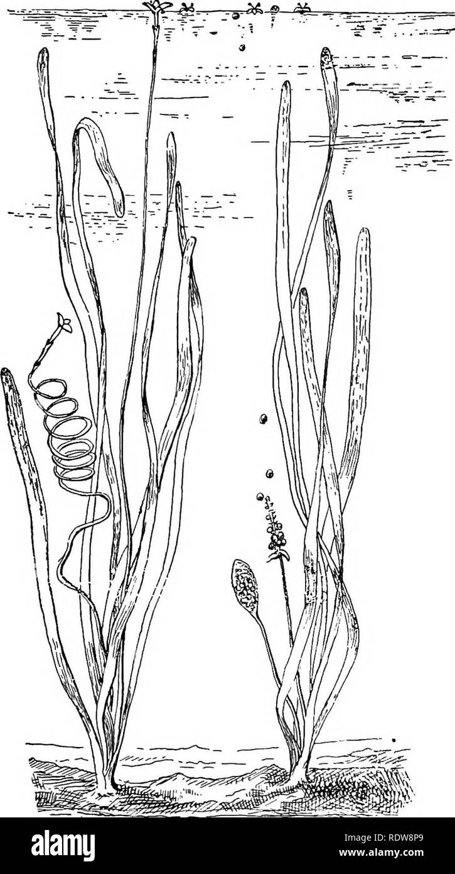
   | Size of the flower | Characteristic feature of pollen grain
  A | small | Light weight and non-sticky
  B | large | large and sticky
  C | small | small, covered with mucilage
  D | large | non sticky
11 | The entomophilous flower is pollinated by ________.  a) Birds  b) Wind  c) Bats  d) Insects
12 | What types of gametes are produced in a plant with genotype TtRr?  a) Tt and Rr b) TR, Tr, tR and tr c) Tr, rr,TR and tr d) tR, tr, tT, and TR
13 | A man with blood group A marries a woman with blood group B. What are all the possible blood groups of their offsprings?  a) A,B only  b) O only  c) B only  d) A,B,AB,O
14 | The reason why haemophilia is more commonly observed in human males than in females is due to  (a) the disease is due to Y-linked recessive mutation  (b) the disease is due to X-linked recessive mutation  (c) as a huge population of girls die in infancy  (d) the disease is due to X-linked dominant mutation
15 | In human beings, where genotype AABBCC represents dark skin colour, aabbcc  represents light skin colour and AaBbCc represents intermediate skin colour; the  pattern of genetic inheritance can be termed as:  A. Pleiotropy and codominance  B. Pleiotropy and incomplete dominance  C. Polygenic and qualitative inheritance  D. Polygenic and quantitative inheritance
16 | In XO type of sex determination,  a)females produce two different types of gametes  b)males produce two different types of gametes  c)females produce gametes with Y chromosomes  d)males produce single type of gametes.
17 | Match the Syndrome and Chromosomal abnormalities given in column I and II respectively  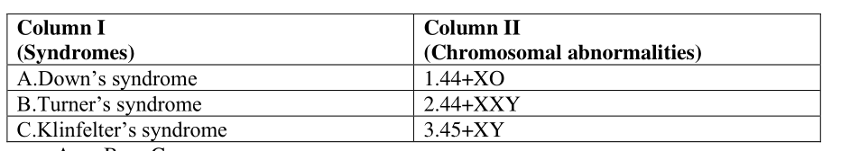  A B C  a) 1 2 3  b) 3 2 1  c) 2 1 3  d) 3 1 2
18 | Chemically, RNA is ___(i)_______reactive and ____(ii)_______stable as compared to DNA  (a)(i) equally, (ii) equally  (b)(i) less, (ii) more  (c)(i) more, (ii) less  (d)(i) more, (ii) equally
19 | In transcription in eukaryotes, heterogenous nuclear RNA (hnRNA) is transcribed by  a)RNA polymerase I  b)RNA polymerase II  c)RNA polymerase III  d)RNA polymerase I and II
20 | During transcription, if the nucleotide sequence of the DNA strand that is being transcribed is ATACG then the nucleotide sequence in the mRNA would be  (a)TATGC (b)TCTGG (c)UAUGC (d)UATGC
21 | Identify A to C in the correct sequence  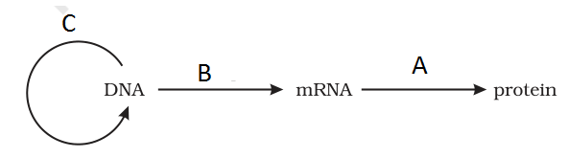  a)A.Replication B.Transcription C.Translation  b)A.Transcription B.Translation C.Replication  c)A.Translation B.Replication C.Transcription  d)A.Translation B.Transcription C.Replication
22 | In the female and male fowls given  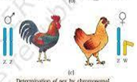  - Males show heterogamety  - Females show heterogamety  - Females show homogamety  - Both females and Males show homogamety
23 | The main reason for the presence of both a leading and a lagging strand during DNA replication is,  A. DNA polymerase can read only in the direction of 3' to 5'  B. DNA polymerase can only synthesize one strand at a time  C. Only one strand is available to be read at any given time  D. There are not enough RNA primers to have both strands be synthesized simultaneously
24 | In Hershey Chase experiment Protein tagging was done by-  a)Radioactive Phosphorus P37  b)Radioactive sulphur S 34  c)Radioactive sulphur S 35  d)Radioactive Phosphorus P32
SECTION - B
Section - B consists of 24 questions (Sl. No.25 to 48). Attempt any 20 questions from this section. The first attempted 20 questions would be evaluated.
Question No. 25 to 28 consist of two statements – Assertion (A) and Reason (R). Answer these questions selecting the appropriate option given below:
A. Both A and R are true and R is the correct explanation of A
B. Both A and R are true and R is not the correct explanation of A
C. A is true but R is false
D. A is False but R is true
25 | Assertion: There is statutory ban on Amniocentesis in India  Reason: In Amniocentesis Amniotic fluid is taken to analyse some foetal cells.
26 | Assertion: During the middle of a menstrual cycle, graafian follicle rupture and release the ovum  Reason: Both LH and FSH attain a peak level in the middle of the menstrual cycle.
27 | Assertion: The sperms produce energy that facilitate sperm motility essential for fertilisation  Reason: The middle piece of a spermatozoa possesses numerous mitochondria
28 | Assertion: It is not possible for human parents heterozygous for skin colour to have children darker or lighter than themselves.  Reason: Human skin colour is controlled by many genes.
29 | The figure shows a section of human ovary. Select the option which gives the correct identification of either A or B with function/ characteristic.  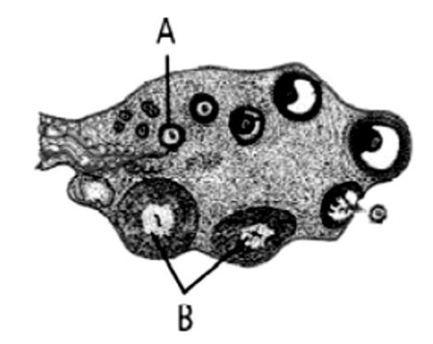  (a) B- Corpus luteum Secretes progesterone  (b) A - Tertiary follicle Forms Graafian follicle  (c) B - Corpus luteum Secretes estrogen  (d) A - Primary oocyte prophase I of the meiotic division
30 | Which of the following is incorrect with regard to pollen grain  A.Pollen grain exine has prominent apertures called germ pores  B. exine is made up of sporopollenin  C. Exine cannot withstand high temperatures  D. Intine is made up of cellulose and pectin
31 | Self-incompatibility is a mechanism that prevents self-fertilization in many flowering plant species. Identify another mechanism that prevents self-fertilization.  A Bisexual flowers  B Both anther & stigma mature at the same time in the flower  C Anther and stigma are placed at different positions in the flower  D Monoecious plants
32 | Which of the following is considered as a terminal method of contraception?  - IUDs  - Tubectomy  - Oral pills  - Implants
33 | Which of the following is incorrect with regard to STIs?  A. STIs are not only transmitted sexually but also through blood transfusions  B. STIs like genital herpes & HIV are curable if detected in the early stages.  C. Women with STIs could have complications such as Abortions, Ectopic pregnancies etc.  D.The incidences of STIs are more in the age group of 15-24 yrs, as reported .
34 | An embryo formed in-vitro is transferred with sixteen blastomeres into the female body . This method of ART is known as  - ZIFT  - GIFT  - IUT  - ICSI
35 | How many meiotic divisions would be required for a plant that undergoes monosporic development to give rise to 100 functional eggs?  A.25  B.100  C.400  D.200
36 | A haemophilic man marries a normal homozygous woman. What is the probability that their daughter will be haemophilic?  A. . 25%  - 0%  C . 50%  D..75%
37 | The F1 offspring of Mendel's classic pea cross always looked like one of the two parental varieties because  - one allele was completely dominant over the other.  - each allele affected phenotypic expression.  - the traits blended together during fertilization.  - no genes interacted to produce the parental phenotype
38 | The genotype of a plant showing the dominant phenotype can be determined by  (a) Criss cross  (b) dihybrid cross  (c) pedigree analysis  (d) test cross.
39 | Given below is a pedigree chart showing the inheritance of a certain trait in humans.  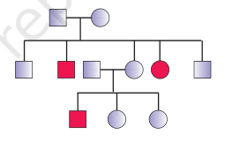  The trait traced in the above pedigree chart is  - sex-linked recessive  - sex-linked dominant  - Autosomal recessive  - Autosomal dominant
40 | Genes with multiple phenotypic effects are known as  (a) hydrostatic genes (b) duplicate genes  (c) pleiotropic genes (d) complimentary genes
41 | In Antirrhinum, RR is phenotypically red flowers, rr is white and Rr is pink. Select the correct phenotypic ratio in F1 generation when a cross is performed between RR X Rr:  - 1 red: 2 Pink: 1 white B. 2 Pink: 1 white C. 2 Red: 2 Pink D. All Pink
42 | Removal of RNA polymerase III from the nucleus of a cell will affect the synthesis of  (A) t RNA (B) hn RNA (C) m RNA (D) r RNA
43 | Which of the following is not an application of DNA fingerprinting?  A. Paternity testing  B. In forensic science  C. Treatment of genetic disease.  D. Determining population and genetic diversities.
44 | A certain DNA sample is found to have a makeup consisting of 28% thymine. Use Chargaff’s rules to fill in the percentages for the other three nitrogenous bases.  - 28%, 22%, 22%  - 22%,28%,28%  - 28%,22%,28%  - 22%,22%,28%
  Adenine | Guanine | Thymine | Cytosine
   |  | 28%
45 | Oswald Avery, Colin MacLeod and Maclyn McCarty used enzymes to purify biochemicals such as proteins, DNA and RNA from the heat-killed S cells to see which ones could transform live R cells into S cells in Griffith's experiment. They observed that  A. Proteases and RNases affected transformation.  B. DNase inhibited transformation.  C. Proteases and Lipases affected transformation.  D. RNases inhibited transformation.
46 | In RNA, every nucleotide residue has an additional _____ group present at _____ position of ribose,  - PO₄³⁻ at 3’  - OH – at 3’  - OH – , at 2’  - PO₄³⁻ at 2’
47 | Lactose operon produces enzymes  (a) βgalactosidase, permease and glycogen synthetase.  (b) βgalactosidase, permease and transacetylase.  (c)Permease, glycogen synthetase and transacetylase.  (d) βgalactosidase, permease and phosphoglucose isomerase.
48 | Okazaki fragments are joined by enzyme  a. DNA helix b. DNA ligase c. DNA polymerase II d. RNA polymerase II
CASE | SECTION - C  Section-C consists of one case followed by 6 questions linked to this case (Q.No.49 to 54). Besides this, 6 more questions are given. Attempt any 10 questions in this section.  The first attempted 10 questions would be evaluated.
49 | 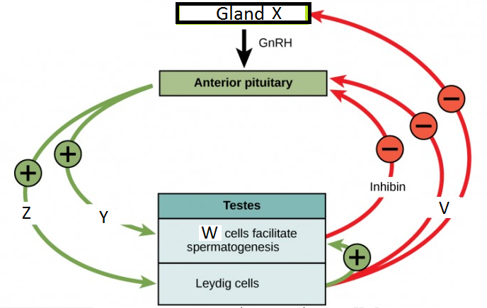  The gland marked X is  A Hypophysis  B Hypothalamus  C Pituitary gland  D Pineal gland
50 | Y & Z stands for hormones  A. FSH & LH  B. LH & FSH  C. GH & LTH  D. GH & Testosterone
51 | The ‘w’ cells are  A Interstitial cells  B Spermatogonia  C Sertoli cells  D Spermatids
52 | Identify the incorrect statement with regard to ‘V’  A. V is secreted by Interstitial cells of Leydig  B. It has a stimulatory effect on spermatogenesis  C. it inhibits secretion from pituitary gland  D. It causes lysis of Spermatozoa
53 | Identify the Correct statement based on the flow chart.  A. Release of Pituitary hormones will cause spermatogenesis to slow down.  B. Release of Y & Z will have opposite effects on the testes.  C. The increased secretion from Leydig cells will decrease GnRH.  D. Hormone V is oestrogen
54 | Role of Leydig cell is  A. synthesis of testosterone  B. nourishment of sperms  C. maturation of sperms  D. provide motility to sperms
55 | The gene that controls the ABO blood group system in human beings has three  alleles IA IB i. Match the following genotypes and the respective blood groups?  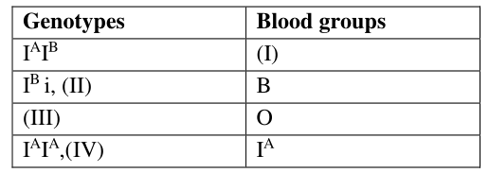  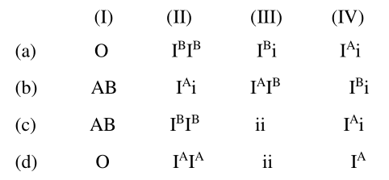
56 | A pea plant parent having violet flower colour with unknown genotype was crossed with a plant having white flower colours, in the progeny 50% flowers were violet and 50% were white. The genotypic constitution of the parent having violet colour flower was  - Homozygous  - Heterozygous  - Merozygous  - hemizygous
57 | A transcription unit in DNA is given below. Identify the labelled parts in correct sequence?  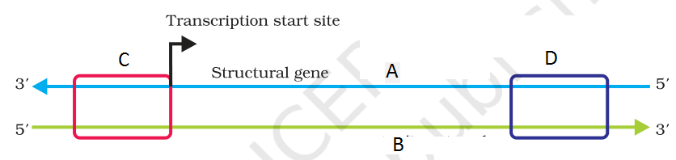  a)A.Promoter B.Template strand C.Terminator D.coding strand  b)A.Template strand B.Coding strand C.Terminator D.Promoter  c)A.Template strand B.Terminator C.Promoter D.Coding strand  d)A.Template strand B.Coding strand C.Promoter D.Terminator
58 | Match the names of scientists shown in column I with their contribution shown in column II, choose the answer which gives the correct combination of alphabets.  a. A=p B=s;C=r, D=q  b. A=s;B=p;C=q, D=r  c. A=r;B=s;C=q, D=p  d. A=s;B=r;C=p, D=q
   | column I |  | column II
  A | Avery, MacLeod and McCarty | p | Semiconservative DNA replication
  B | Chargaff | q | Demonstrated the double helical model of DNA
  C | Meselson | r | Base equivalence rule
  D | Watson and Francis Crick | s | Biochemical characterisation of transforming principle
59 | Which of the following combination is a correct observation for the transformation experiment performed by Griffith?  - S strain (living) + mouse = dead  - S strain (heat killed) + mouse = dead  - R strain (living) + mouse = dead  D. S strain (heat killed) + R strain (living) + mouse = living
60 | The diagram shows a typical nucleosome , identify the A, B and C in the given diagram.  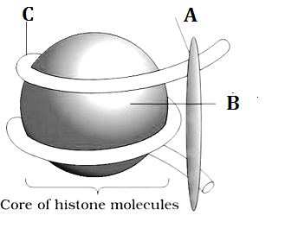  - H1 histone, DNA,Histone octamer  - DNA,H1 histone, Histone octamer  - DNA, H1 histone, Histone octamer  - H1 histone, Histone octamer, DNA

