SAMPLE QUESTION PAPER
(TERM I) 2021-22
CLASS XI BIOLOGY
TIME: 90 min M.M: 35
General instructions:
- The question paper contains three sections.
- Section A has 24 questions. Attempt any 20 questions.
- Section B has 24 questions . Attempt any 20 questions.
- Section C has 12 questions. Attempt any 10 questions.
- All questions carry equal marking.
- There is no negative marking.

SECTION – A

Section A consists of 24 questions. Attempt any 20 questions from the section. The first attempted 20 questions will be evaluated.

1. | Difference between virus and viroid is:  - Absence of protein coat in viroid but present in virus  - Presence of low molecular weight RNA in virus but absent in viroid  - Both a and b  - None of the above
2. | Match the following and choose the correct combination from the options given:  Column –I (Group) Column-II (Example)  - Eubacteria 1. Trichoderma  - Dinoflagellates 2. Albugo  - Phycomycetes 3. Gonyaulax  - Deuteromycetes 4. Anabena  (a)A-1,B-2, C-3, D-4 (b) A-2,B-3, C-4,D-1  (c)A-4,B-3,C-2,D-1 (d)A-3,B-4,C-1,D-2
3. | National Botanical Research Institute is located in  (a) Shimla  (b) Dehradun  (c) Howrah  (d) Lucknow
4. | Systema naturae was written by-  - Darwin  - Aristotle  - Linnaeus  - None of the above
5. | Identify A,B shown in the diagram and match with its function:  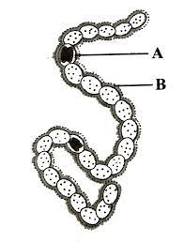  - A-Heterotrophic bacteria, B-chlorophyll- Photosynthesis  - A-Rhizobium, B- capsule – Nitrogen fixation  - A- Heterocyst , B- Mucilagenous sheath- Nitrogen fixation  - A- Mycorrhiza ,B- Fungi- water absorption
6. | Protonema is –  - Haploid and is found in mosses  - Diploid and is found in liverworts  - Diploid and found in pteridophytes  - Haploid and is found in pteridophytes
7. | Examine the figure given below and select the right option giving all the four parts a, b,c,d-  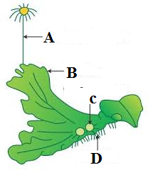  A B C D  - Seta Sporophyte Protonema Rhizoids  - Atheridiophore Male thallus Globule Roots  - Archegoniophore Female thallus Gemma cup Rhizoids  - Archigoniophore Female thallus Bud Foot
8. | Match the column A and column B and choose the correct option:  - A-ii B-iii C-v D-iv E- i  - A-ii B-v C-iii D-iv E-i  - A-i B-iii C-v D-iv E-ii  - A-i B-v C-iii D-iv E-ii
  Column A | Column B
  - Porifera  - Aschelminthes  - Annelida  - Arthropoda  - Echinodermata | - Canal system  - Water vascular system  - Muscular pharynx  - Jointed appendages  - Metameres  - Comb plates
9. | A group of students found a fish on the sea beach and carried to their teacher. The teacher told them that it is a bony fish not a cartilage fish. Identify the characters of bony fish:  - Mouth is located ventrally, gills are separate without operculum, placoid scales  - Mouth is located terminally, Gill are covered by an operculum, ctenoid scales  - Sucking and circular mouth without jaws  - All of the above
10. | Read the following statements and select the incorrect option :  - Circulatory system in arthropods is of closed type.  - Parapodia in annelids help in swimming.  - Phylum mollusca is second largest phylum of animalia.  - Aschelminthes are dioecious.  - A and C are wrong  - A alone is wrong  - C alone is wrong  - C and D are wrong
11. | When the margins of sepals or petals overlap one another without any particular direction  The condition is termed as:  - Vexillary  - Imbricate  - Twisted  - Valvate
12. | In the figure given below , identify flower based on the position of calyx , corolla and androecium in respect of the ovary on thalamus.    - Hypogynous, Superior  - Perigynous, half inferior  - Epigynous, inferior  - Gamosepalous
13. | Epipetalous is condition of  (a) Aestivation of petal  (b) Placentation  (c) Stamens  (d) Position of ovary
14. | This A₃₊₃ combination is present in family-  - Liliaceae  - Solanaceae  - Both a and b  - None of the above
15. | Given below is the diagrammatic sketch of a certain type of connective tissue. Identify the parts labelled A,B,C and D –  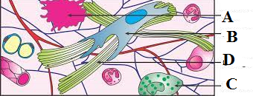  A B C D  - Mast cell Macrophage Fibroblast Collagen fiber  - Mast cell Collagen fiber Fibroblast Macrophage  - Macrophage Fibroblast Mast cell collagen fiber  - Macrophage Mast cell Collagen fiber Fibroblast
16. | Most of cartilages in vertebrate embryo are replaced in adult by-  - Blood  - Muscles  - Bones  - Tendons
17. | The epithelial tissue present in the inner surface of bronchioles and fallopian tubes is:  - Cuboidal  - Glandular  - Squamous  - Ciliated
18. | Match the columns and identify the correct option:  Column I Column II  - Thylakoids i. Disc- shaped sacs  - Cristae ii. Condensed structure of DNA  - Cisternae iii. Flat membranous sac in stroma  - Chromatin iv. Infoldings in mitochondria  - A-iii, B-i, C-iv, D-ii  - A-iii, B-iv, C-ii, D-i  - A-iv ,B-iii, C-i ,D-ii  - A-iii, B-iv, C-i, D-ii
19. | The chromosomes in which centromere is situated close to one end are:  - Telocentric  - Sub- metacentric  - Acrocentric  - Metacentric
20. | Chlorophyll in chloroplast is located in  - Grana  - pyrenoids  - Stroma  - Both grana and stroma
21. | The cytoplasmic connections from cell to cell are known as  (a) middle lamella  (b) plasmodesmata  (c) cell membrane system  (d) endoplasmic reticulum
22. | Exoskeletons of arthropods have this complex polysaccharide-  - Glycogen  - Chitin  - Cellulose  - Starch
23. | Which of the following biomolecules does have a phosphodiester bond?  - Amino acids in a polypeptide  - Fatty acids in a diglyceride  - Nucleic acids in a nucleotide  - Monosasaccharides in a polysaccharide
24. | The figure given below shows the conversion of a substrate into product by an enzyme. In which one of the four options (A-D) the components of reaction labelled as A,B,C and are identified correctly?  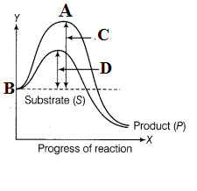  A B C D  - Potential energy Transition state activation energy Activation energy  With enzyme without enzyme  - Transition state Potential energy Activation energy Activation energy  without enzyme With enzyme  - Potential energy Transition state Activation energy Activation energy  With enzyme without enzyme  - Activation energy Transition state Activation energy Potential energy  Without enzyme
SECTION- B
Section- B consist of 24 questions ( Sl.no. 25 to 28) . Attempt any 20 questions from this section . The first attempted 20 questions would be evaluated.

Question no. 25 to 28 consist of two statements – Assertion (A) and reason( R) .answer these questions selecting the appropriate option given below.
- Both A and R are true and R is the correct explanation of A.
- Both A and R are true and R is not the correct explanation of A.
- A is true but R is false.
- A is false but R is true.
25. | Assertion: Symbiosis is furnished by mycorrhiza.  Reason: In mycorrhiza, symbiosis is established between fungus and alga.
26. | Assertion: In liverworts, both male and female sex organs may be present on same thalli or different thalli.  Reason: A sporophyte is formed from the zygote which is differentiated into foot ,seta and capsule.
27. | Assertion: Peripheral proteins are totally or partially buried in the membrane.  Reason: Integral proteins lie on the surface of membrane
28. | Assertion: Each enzyme has a substrate binding site in its molecule which forms highly reactive enzyme substrate complex.  Reason: The enzyme- substrate complex is long lived and dissociates into its product and unchanged enzyme.
29. | Systematics aims at  (a) Identification and arrangement of organisms on the basis of cytological characteristics  (b) The classification of organisms based on broad morphological characters  (c) Delimiting various taxa of organism and establishing their relationships  (d) The classification of organisms based on their evolutionary history and establishing their phylogeny on the totality of various parameters from all fields of studies
30. | Cell wall is absent in  - Mycoplasma  - Nostoc  - Aspergillus  - Funaria
31. | Organisms which obtain energy by the oxidation of reduced inorganic compounds are called  - Photoautotrophs  - Chemoautotrophs  - Saprozoic  - None of the above
32. | Which one of the following is a living fossil?  - Pinus  - Cycas  - Moss  - Spirogyra
33. | In case of Poriferans, the spongocoel is lined with flagellated cells called-  - Ostia  - Chitin  - Choanocytes  - Osteocoel
34. | Pneumatic bones are found in-  - Shark  - Rana  - Pigeon  - Whale
35. | Coelom is found between-  - Body wall and ectoderm  - Ectoderm and endoderm  - Mesoderm and Mesoderm  - Mesoderm and ectoderm
36. | In which of the following division gametophyte is dominant-  - Bryophyte  - Gymnosperm  - Both a and b  - None of the above
37. | Identify A,B,C, and D in the given diagram-  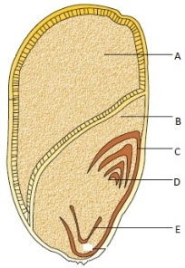  - A- Coleoptile, B- Endosperm, C-Aleurone layer, D-Radicle  - A – Endosperm, B-Scutellum, C-Coleoptile , D- Plumule  - A- Coleoptile, B- Aleurone layer, C- Radicle, D-Endosperm  - A- Coleoptile, B- Aleurone layer, C- Endosperm, D-Radicle
38. | Which one of these refers as outer wall of fruit-  - Mesocarp  - Pericarp  - Endocarp  - Parthenocarpic
39. | The supportive skeletal structures in the human external ears and in the nose tip are examples of-  - Ligament  - Areolar tissue  - Bone  - Cartilage
40. | Osteoblasts are found in  (a) blood  (b) muscle  (c) bone  (d) catrilage
41. | Which of the following types of plastids does not contain stored food material?  - Chromoplast  - Elaioplasts  - Aleuroplast  - Amyloplast
42. | Polyribosomes are aggregates of-  - Ribosomes and rRNA  - Only r RNA  - Proteins  - Several ribosomes held together by string of mRNA
43. | A major site for synthesis of lipids is-  - Symplast  - Nucleoplasm  - RER  - SER
44. | Which is the most abundant protein in animal world?  - Lectin  - Haemoglobin  - Collagen  - Insulin
45. | Identify the basic amino acid from the following?  - Lysine  - Glutamic acid  - Valine  - All of the above
46. | A student put few drops of Iodine in a test tube containing potato and another containing crushed plant pulp. The colour change was observed only in the Test tube contain Potato. The reason is-  - Plant material contains chlorophyll and potato contains protein.  - Potato contains starch and plant contains cellulose.  - Starch ( helical secondary structure) can hold Iodine molecules where as cellulose cannot.  - Both b and c
47. | The excretory structures of flat worms are-  - Flame cells  - Protonephredia  - Malpighian tubules  - Green glands
48. | Ribbon shaped chloroplasts occur in  (a) Ulothrix  (b) Spirogyra  (c) Chlamydomonas  (d) Riccia
Case | SECTION- C  Section C consist of one case followed by 6 questions linked to this case (Q 49 to 54). Attempt any 10 questions in this section.  Study the following picture and answer the following questions  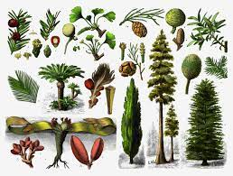
49. | The fungal association found in the roots of Pinus is-  - Parthenocarpy  - Symbiosis  - Mycorrhiza  - Heterospory
50. | Which of the following statement is correct?  - Ovules are not enclosed by ovary wall in gymnosperm.  - Stems are usually unbranched in cycas.  - Gymnosperms are homosporous.  - Pollen tubes are not formed towards archegonia.
51. | Small specialized roots containing cyanobacteria is–  - Mycorrhiza  - Microsporophyll  - Coralloid  - Rhizoid
52. | Needle like leaves in gymnosperms helps to withstand extreme temperatures as-  - It has large surface area.  - It reduces surface area and has sunken stomata.  - It reduces Photosynthesis.  - It has tap roots.
53. | Gymnosperm are called naked seed plant because these lack-  - Cotyledon  - Endosperm  - Ovary wall  - Pericarp
54. | Conifers can tolerate extreme environments because of  - Presence of vessels  - Thick cuticle  - Superficial stomata  - Broad hardy leaves
55. | Choose the correctly matched pair-  - Tendon- specialized connective tissue  - Adipose tissue –Dense connective tissue  - Areolar tissue- loose connective tissue  - Cartilage – Loose connective tissue
56. | Identify the given tissue shown in the diagram along with label A-  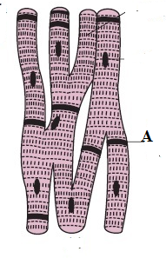  - Smooth muscle fiber, A- Nucleus  - Skeletal muscle fiber, A – collagen fiber  - Cardiac muscle fiber,A- Intercalated disc  - None of the above
57. | The character of resistance to antibiotics in bacteria is due to-  - RNA  - Ribosome  - DNA  - Plasmid DNA
58. | With the increase in substrate concentration ,the reaction reaches V_{max} which is not exceeded further by any rise of concentration . Why?  Study the graph given below and choose the correct option:  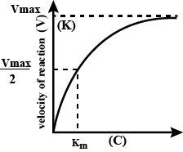  - Enzyme molecules are more than the substrate molecule.  - Due to competitive inhibition.  - Enzyme molecules are less than the substrate molecule.  - Both a and b
59. | The linkage formed between two carbon atoms of two adjacent monsaccharides is-  - Peptide bond  - Glycosidic bond  - Phosphodiester bond  - None of the above
60. | Label the given diagram A,B,C-  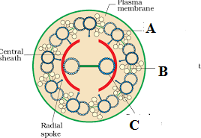  - A –Peripheral microtubules, B- Interdoublet bridge, C- central microtubule  - A-Interdoublet bridge, B-Peripheral microtubules, C- Central microtubule  - A-Central microtubule, B- peripheral Microtubules ,C-Interdoubletbridge  - A-Peripheral microtubules, B- Central microtubule, C- Interdoublet bridge

