Chapter 2
Sexual Reproduction in Flowering Plants

Solutions

SECTION - A

School/Board Exam. Type Questions

Very Short Answer Type Questions :
- Name the fertile whorls of a flower.

Sol. Androecium and gynoecium
- Define tetrasporangiate condition in an anther.

Sol. Tetrasporangiate means presence of four microsporangia in an anther.
- Name the wall layers of anther.

Sol. Epidermis, endothecium, middle layers and tapetum.
- What is the ploidy level of cells in a microspore tetrad?

Sol. Haploid
- What is the function of germ pore?

Sol. To help in the exit of pollen tube.
- What is the function of pollen banks?

Sol. Pollen bank helps in cryopreservation of pollen in liquid nitrogen (–196°C) which is further used in crop breeding programmes.
- What is the ploidy level of the cells in a female gametophyte?

Sol. Haploid
- In which type of plants both autogamy and geitonogamy are prevented?

Sol. Dioecious plants like papaya.
- Which type of plants are emasculated in artificial hybridisation experiments?

Sol. Female parents which have bisexual flowers.
- What type of endosperm is represented by coconut water?

Sol. Free nuclear endosperm

18 Sexual Reproduction in Flowering Plants Solutions of Assignment (Set-1)

Short Answer Type Questions :
- What are perispermic seeds? Give examples.
Sol. Seeds with remnants of nucellus which perform nutritive function.
Examples - Black pepper and beet
- Which two properties of seeds are crucial for storage?
Sol. Dehydration and dormancy
- List two features of pollen grains of flowers of maize plant.
Sol. Pollen grains are :
  - Light and non-sticky.
  - Produced in large number.
- Mention the name of outer pollen wall. What is its chemical composition?
Sol. Exine. It is made of sporopollenin.
- What is inbreeding depression?
Sol. Inbreeding depression means decrease in vigour of plants due to continuous self-pollination.
- What is seed dormancy? What conditions are required for seed germination?
Sol. Failure of the seed to germinate due to metabolic inactivity of embryo is called as seed dormancy.
Conditions for seed germination :
  - Adequate moisture
  - Oxygen
  - Suitable temperature
- Mention the name of layer of anther wall having high DNA content. What is the ploidy level of innermost wall of anther?
Sol. The innermost wall layer is tapetum. The cells of this layer are polyploid.
- Define ovule. Which part of ovule has abundant reserve food?
Sol. Ovule is integumented megasporangium. Nucellus has abundant food reserves.
- Differentiate between xenogamy and autogamy.
Sol.
1.
Transfer of pollen grains from one Transfer of pollen from anther to
flower to stigma of another flower of stigma of the same flower. different plants.
It results in genetic variation.
2.
It results in inbreeding depression.
Autogamy
Xenogamy
S.No.

- Write a short note on pollen reward.
Sol. Pollen rewards are provided to pollinating agents by the plants to sustain their visits.
It includes :
  - Nectar
  - Pollen grains
  - Safe place to lay eggs, for example, Amorphophallus.

Solutions of Assignment (Set-1) Sexual Reproduction in Flowering Plants 19

- List any three devices in plants to discourage self-pollination and to encourage cross-pollination. Explain the importance of each.
Sol. Three outbreeding devices in plants :
  - Difference in maturation time of pollen and stigma or pollen release and stigma receptivity are not synchronised.
  - Anther and stigma are placed at different position so that the pollen cannot come in contact with the stigma of the same flower.
  - Self-incompatibility : It is a genetic mechanism that prevents self-pollen from fertilising the ovules by inhibiting pollen germination or pollen tube growth in the pistil.
- Why is apple referred as false fruits? How are they different from parthenocarpic fruits?
Sol. Apple is referred as false fruit because thalamus take part in fruit formation in addition to the ovary.
Parthenocarpic fruits are formed without fertilisation. Hence, they are seedless.
- How apomixis is differ from polyembryony?
Sol. Apomixis : It is a type of asexual reproduction that mimics sexual reproduction. It takes places without fusion of gametes.
Polyembryony : Occurrence of more than one embryo in a seed.
- Draw a vertical section of seed of onion and label the different parts.
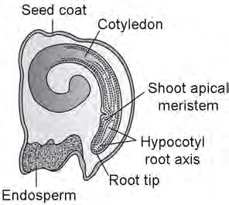Sol.

Onion seed
- Why is bagging of emasculated flowers essential during hybridisation experiments?
Sol. Covering of flowers on female parent with a polythene bag is called bagging. It prevents contamination of stigma with foreign pollen grains.
- Name the cell from which endosperm of coconut develops. Give the characteristic features of endosperm of coconut.
Sol. PEC (primary endosperm cell) forms the endosperm.
Coconut has two types of endosperm :
  - Free nuclear : Liquid endosperm
  - Cellular endosperm : White solid endosperm
- What are the main differences between microsporogenesis and megasporogenesis?
Sol.
1.

2.
3.
Formation of a haploid microspores Formation of a haploid megaspores
from microspore mother cell. from megaspore mother cell.
Takes place in microsporangium. Takes place inside megasporangium.
Forms four microspores. Forms four megaspores, out of which
generally one remains functional.
Megasporogenesis
Microsporogenesis
S.No.

20 Sexual Reproduction in Flowering Plants Solutions of Assignment (Set-1)

- Discuss the distribution of cells within a mature embryo sac.

Sol. A typical mature embryo sac is 7-celled and 8-nucleate. The 8-nuclei have characteristic 3 + 2 + 3 arrangement.

  - Egg apparatus consisting of two synergid cells and an egg cell at micropylar end.

  - Two polar nuclei within large central cell.

  - Three antipodal cells at chalazal end.

- What are the advantages of fertilised ovule to angiosperms?

Sol. Advantages of seed to angiosperms :

  - Seed often better adaptive strategies for dispersal to new habitat and help the species to colonise the other areas.
  - They have sufficient food reserves young seedlings are nourished until they are capable of photosynthesis on their own.
  - The hard seed coat provides protection to young embryo.

  - They generate new genetic combinations leading to variations.

- Explain what is double fertilisation. In which category of plants does it occur?

Sol. Double fertilisation involves two types of fusions in embryo sac.

  - Syngamy : Fusion of one male gamete with egg cell to form a zygote.

  - Triple fusion : Fusion of a male gamete with secondary nucleus to form primary endosperm nucleus (PEN) which form future endosperm. It serves as a nutritive tissue for developing embryo.
Long Answer Type Questions :

- (a) Draw a well-labelled diagram representing L.S. of monocot embryo.

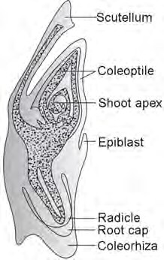(b) Endosperm development precedes embryo development. Explain.

Sol. (a)

(b) Endosperm development starts before embryo development to provide assured nutrition to the developing embryo.

Solutions of Assignment (Set-1) Sexual Reproduction in Flowering Plants 21

- Illustrate the stages with labelled diagram for pollen developing into a mature pollen grain.

Sol.

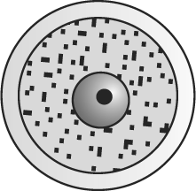Exine Intine Microspore

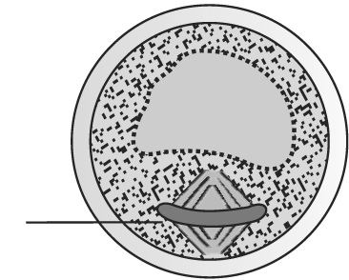
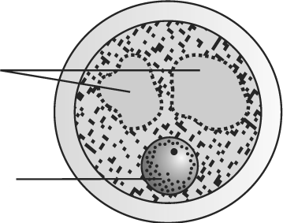
Vacuoles Nucleus

Asymmetric spindle

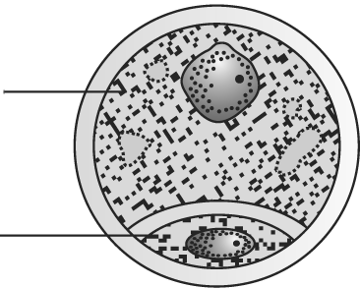
Vegetative cell

Generative cell

- (a) Name the type of flowers which may cause inbreeding depression.
- List the abiotic agents required for cross pollination.
- State three differences between flowers pollinated by these abiotic agents and flowers pollinated by biotic agents.
Sol. (a) Cleistogamous flowers, bisexual flowers with homogamous condition.
(b) Wind, water (c)
1.
2.
Flowers inconspicuous.
No smell and nectar.
3.
Pollen grains light and non-sticky.
Flowers large and showy.
Flowers are variously smelled and produce nectar.
Pollen sticky.
Flowers pollinated by biotic agents
Flowers pollinated by abiotic agents
S.No.

- (a) If the leaf cell of an angiospermic plant contain 18 chromosomes, what would be the chromosome number and ploidy level of (i) Megaspore mother cell (MMC) and (ii) Endosperm cell.
- Name the cell that develops into embryo sac.
- What is the role of synergids in embryo sac?
Sol. (a) Leaf cells are diploid, so 2n = 18.

 | Ploidy level | Chromosome number
MMC | 2n | 18
Endosperm | 3n | 27
- Functional megaspore
- Synergids have special cellular thickenings at micropylar tip called filiform apparatus which play an important role in guiding the pollen tube into the synergid. Synergid is the site for pollen tube discharge.

22 Sexual Reproduction in Flowering Plants Solutions of Assignment (Set-1)

- 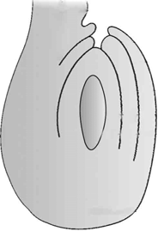

- Which type of ovule is shown in the figure? Give one reason.
- What is the function of funicle?
- What are the protective layers of this structure?
- Where is the megaspore mother cell (MMC) seen in this structure? How many MMC differentiate?
Sol. (a) Anatropous ovule. The funiculus lie close to micropyle. It is inverted ovule.
- It serves a stalk of ovule which attaches it to the placenta.
- Two protective layers called as integuments.
- Ovules generally differentiates a single megaspore mother cell in the micropylar region of the nucellus.
- State whether the following statements are true or false. Correct each false statement to make it true.
- Apomixis mimics sexual reproduction because there is syngamy.
- Development of fruits without fertilisation is called parthenogenesis.
- The function of tapetum is to help in the dehiscence of anther.
- The pollen viability in members of Solanaceae family is 30 minutes.
- Coleoptile is a sheath enclosing shoot tip.
Sol. (a) False (No syngamy).
- False (Parthenocarpy).
- False (Nutritive).
- False (Few months).
- True.
- Briefly describe the following :
- Polyembryony
- Triple fusion
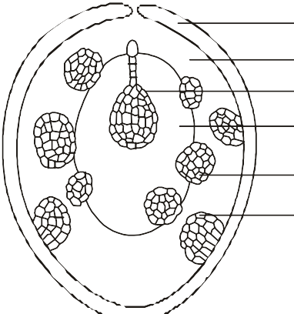
Sol. (a) Polyembryony : Occurrence of more than one embryo in a seed is referred as polyembryony.

Integument Nucellus Zygotic embryo
Endosperm

Nucellar embryo Integumentary embryo

Fig. : Polyembryony in Citrus

Solutions of Assignment (Set-1) Sexual Reproduction in Flowering Plants 23

The diagram above shows several embryo formation in Citrus. The embryos shown are
  - Zygotic
  - Nucellar
  - Integumentary
The nucellar and integumentary embryos are apomictic. The genetic nature of these embryo is diploid (2n) and they would be genetically identical to each other and can be called as a clone.
(b) Triple fusion :

Male gamete (n)
+ Two fused polar nuclei
(2n)
PEN
Primary endosperm nucleus

One of the male gametes moves towards the two polar nuclei located in the central cell and fuses with them to produce a triploid primary endosperm nucleus (PEN).
- 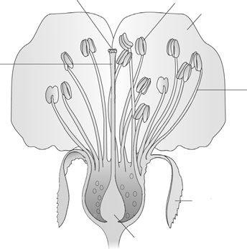F E
D

G

C

B

A
With respect to the above diagram answer the following questions :
- Label A to G.
- Name the non-essential whorls of the flower.
- Which structure forms the pollen grains?
- Inside which structure are integumented megasporangia present?
- State the function of non-essential whorls.
Sol. (a) A - Ovary
B - Sepal
C - Filament D - Petal
E - Anther F - Stigma G - Style
- Calyx and corolla
- Androecium
- Ovary
- Calyx and corolla are non-essential whorls which help in the protection of flower during bud stage and attracting insects for pollination respectively.

24 Sexual Reproduction in Flowering Plants Solutions of Assignment (Set-1)

- 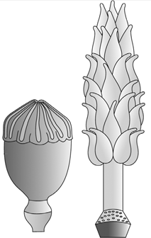

- (B)
- What type of conditions with reference to gynoecium are shown in the diagrams given below?
- Differentiate between condition (A) and (B) and state one example of each.
- Give examples of plants where single ovule is present in ovary.
Sol. (a) (A) Syncarpous pistil
- Multicarpellary apocarpous gynoecium

(b)
Syncarpous pistil | Apocarpous pistil
Consists of many carpels which are fused with each other.  Example - Papaver | Consists of many carpels which are free from each other.  Example - Michelia

(c) Wheat, paddy, mango.
- 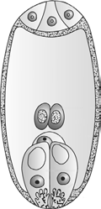

With reference to the above figure answer the following questions :
- Which cells make up the egg apparatus?
- What is the function of filiform apparatus?
- Which is the largest cell? Mention the type of fusion which takes in this cell.
- How many mitotic generations are required to obtain the condition as seen in the above diagram?
Sol. (a) Two synergids + one egg cell
- To facilitate the entry of pollen tube
- Central cell, triple fusion and syngamy
- Three

Solutions of Assignment (Set-1) Sexual Reproduction in Flowering Plants 25

- 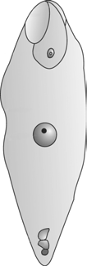A

B

C

With reference to the above figure answer the following :
- Label A, B, C.
- Which cell forms the future nutritive tissue. Define the process by which it is formed.
- What is formed by structure labelled B?
Sol. (a) A - Degenerating synergids B - Zygote
C - Degenerating antipodal cells
- Primary endosperm cell. Triple fusion is fusion of one male gamete with secondary nucleus leading to the formation of PEN.
- Embryo is formed.
- Differentiate between :
- Albuminous and exalbuminous seed
- Radicle and plumule
- Coleoptile and coleorhiza
- Pericarp and seed coat
Sol. (a)
Albuminous seed | Exalbuminous seed
Seeds where endosperm is present at maturity.  Example - Castor, barley, wheat, sunflower | Seeds where endosperm is consumed at maturity.  Example - Pea, groundnut

(b)
Radicle | Plumule
The portion of embryonal axis below the level of cotyledons is hypocotyl | The portion of embryonal axis above the level of cotyledons is the
that terminates at its lower end in the radicle. | epicotyl, which terminates with the plumule.

(c)
Coleoptile | Coleorhiza
In a monocot embryo, the shoot apex and few leaf primordia are enclosed in a hollow foliar structure | In a monocot embryo, the radicle and root cap are enclosed in an undifferentiated sheath called
called coleoptile. | coleorhiza.

26 Sexual Reproduction in Flowering Plants Solutions of Assignment (Set-1)

(d)
Pericarp | Seed coat
The wall of the fruit is called pericarp. It formed by the wall of the ovary. | The wall of the seed is called seed c oat. I t i s f or med by t he integument(s) of ovule.

- Fill in the blanks :
- Coconut water is made up of thousands of .
- Black pepper and beet have seeds.
- Seedless banana is an example of fruit.
- Pollen pistil interaction is a process involving pollen recognition followed by promotion or inhibition of the pollen.
- Outbreeding device in castor plant prevents but not .
Sol. (a) Nuclei
- Perispermic
- Parthenocarpic
- Dynamic
- Autogamy, geitonogamy
- Find out the wrongly matched pairs and correct each wrong pair to make it correct.

(a) | Egg apparatus | – Micropylar end
(b) | Polyembryony | – Citrus
(c) | Tapetal cell | – Low DNA content
(d) | Scutellum | – Single cotyledon
(e) | PEN | – Triple fusion
(f) | Mango | – Anemophily
(g) | Zostera | – Water-pollinated
(h) | Hydrilla | – Cleistogamy
(i) | Triploid nutritive tissue | – Perisperm
(j) | Epiblast | – Triploid structure
Sol. c, f, h, i, j
(c) High DNA content
(f) Entomophily
- Chasmogamy
- Endosperm
- Diploid structure
- (a) Which type of pollination is less common in hydrophytes?
- What adaptation is seen in pollen grains of hydrophilous species?
- What is self-incompatibility?
- What is epiblast?
- What does mean by hilum in ovule?
Sol. (a) Hydrophily
- Pollen grains are protected by from wetting by a mucilaginous covering.
- A genetic mechanism which prevents self-pollen from the same flower or other flowers of the same plant from fertilising the ovules by inhibiting pollen germination or pollen tube growth in the pistil.
- Epiblast is the remain of second cotyledon in monocots.
- It represents the junction between ovule and funicle.

Solutions of Assignment (Set-1) Sexual Reproduction in Flowering Plants 27

SECTION - B

Model Test Paper

Very Short Answer Type Questions :
- In the following figure of fruit, identify the part which is developed from ovary wall and that which is responsible for producing new plants.
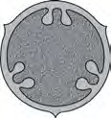A

B C
Sol. A - Pericarp; B - Seed (produce new plant)
- Name the plant in which each fruit contain thousands of tiny seeds.
Sol. Orchids
- Which of the following plant showns insect pollination?
  - Vallisneria (b) Water hyacinth
(c) Zostera (d) Maize
Sol. Water hyacinth
- Why is strawberry called as false fruit?
Sol. Strawberry is a false fruit because the thalamus takes part in fruit formation along with ovary.
- The pollen grains can be well-preserved as fossils. Mention the characteristic of pollen grain that makes it happen.
Sol. The outer layer of pollen wall is made of sporopollenin which is one of the most resistant organic material known.
Hence, pollen grains are preserved as fossils.
- What is the number of chromosomes in secondary nucleus if leaf cell of angiospermic plant contain 12 chromosomes?
Sol. Seconday nucleus (diploid) = 12.

Short Answer Type Questions :
- Explain how geitonogamy is functionally similar to cross-pollination and genetically similar to autogamy.
Sol. Geitonogamy involves transfer of pollen grains from anther to stigma of another flower on the same plant. It needs a pollinating agent for this transfer hence is functionally similar to cross-pollination. As the transfer takes place between genetically similar flowers, it is genetically autogamous.
- Mention the reasons for difference in ploidy of zygote and primary endosperm nucleus in an angiosperm.
Sol. Zygote is a product of syngamy which involves fusion of one male gamete (n) and the egg (n). Hence, the product (zygote) is diploid.
Primary endosperm nucleus is a product of triple fusion which involves fusion of three haploid nuclei i.e. one male gamete and two haploid polar nuclei. Hence, it is triploid.
- Name the haploid cells present at chalazal site of mature female gametophyle of a flowering plant. How many haploid nuclei are present in a mature embryo sac?
Sol. The haploid cells present at chalazal end in a mature female gametophyte of a flowering plant are antipodal cells.
There are eight nuclei present in a mature embryo sac.

28 Sexual Reproduction in Flowering Plants Solutions of Assignment (Set-1)

- If you squeeze a seed of orange you might observe many embryos of different sizes. How is it possible? Explain.
Sol. Orange show polyembryony. The various types of embryo seen inside the orange seeds are :
- Single zygote embryo formed as a result of sexual reproduction.
- Nucellar embryos formed as a result of proliferation of cells of nucellus.
- In Viola, assured seed set is there. Give reasons.
Sol. Because it possesses cleistogamous flowers. In such flowers, anthers and stigma lie close to each other. When anthers dehisce in the flower buds, pollen grains come in contact with the stigma to effect pollination.
Short Answer Type Questions :
- How do flowers reward their insect pollinators. Explain.
Sol. Flowers reward their insect pollinators by providing them with
  - Nectar
  - Pollen
  - Safe place to lay eggs, for example, Amorphophallus.
- Describe in brief the different wall layers of anther with the help of well-labelled diagram.
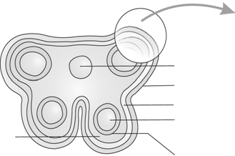
Sol.

Middle layers
Connective Epidermis
Endothecium Sporogenous tissue
Tapetum

The different wall layers are as follows :
- Epidermis : Protective in function.
- Endothecium : Has fibrous thickening and help in dehiscence of anther.
- Middle layers : Usually undergo degeneration and nourish sporogenous tissue.
- Tapetum : Nutritive in function. Also responsible for production of enzymes, sporopollenin and compatibility proteins.
- Draw a well-labelled diagram of an anatropous ovule.
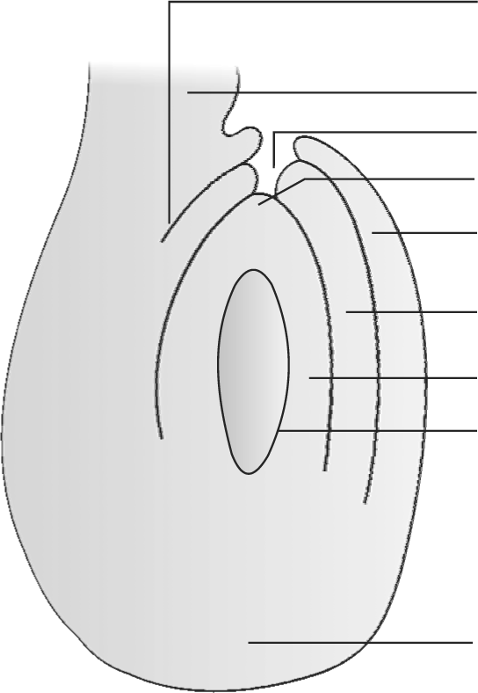Sol. Hilum

Funicle Micropyle
Micropylar pole Outer integument

Inner integument

Nucellus Embryo sac

Chalazal pole

Solutions of Assignment (Set-1) Sexual Reproduction in Flowering Plants 29

- Differentiate between vegetative cells and generative cell of pollen.
Sol.
1.
2.
It is large sized.
It forms pollen tube.
It is small sized.
It forms male gametes.
Generative cell
Vegetative cell
S.No.

- Mention any four strategies adopted by flowering plants to promote self-pollination.
Sol. Four strategies adopted by flowering plants to promote self-pollination are :
- Same maturation time of anther and stigma. Hence, pollen release and stigma receptivity are synchronised.
- Cleistogamy
- Production of bisexual flowers.
- (i) Even though each pollen grain has two male gametes why are at least ten pollen grains and not five pollen grains are required to fertilise ten eggs present in a particular carpel.
(ii) What is seed dormancy?
Sol. (i) Because in each pollen only one of the male gametes contributes to zygote formation (syngamy). The other is involved in triple fusion.
(ii) The inability of the seed to germinate even in the presence of favourable condition is called seed dormancy.
- Make the labelled diagram of castor seed.
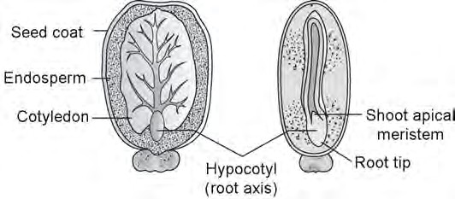Sol.

Castor seed
- Explain the following terms :
- Parthenocarpic fruits
- Apomixis
- Exalbuminous seeds
Sol. (i) Parthenocarpic fruits are seedless fruits produced without fertilisation.
- Apomixis is production of seeds without fertilisation.
- Seed in which the endosperm is consumed and is not a part of mature seed.
Long Answer Type Questions :
- Explain the process of artificial hybridisation to get improved crop variety in
- Plants bearing bisexual flowers.
- Female parent producing unisexual flowers.
Sol. (i) In plants, bearing bisexual flowers removal of anthers from the flower bud before anther dehisces is necessary. This step is called as emasculation. Emasculated flowers have to be covered with a bag to prevent contamination of the stigma with unwanted pollen. This process is called bagging. When the stigma of bagged flowers attains receptivity, mature pollen grains collected from anthers of the male parent are dusted on the stigma and the flowers are rebagged.
(ii) If the female parent produces unisexual flowers, there is no need of emasculation. The female flowers buds are bagged before the flowers open when the stigma becomes receptive, pollination is carried out using the desired pollen and the flower is rebagged.

30 Sexual Reproduction in Flowering Plants Solutions of Assignment (Set-1)

- Draw labelled diagrams for :
  - Angiospermic dicot embryo
  - Longitudinal section of a flower showing growth of pollen tube
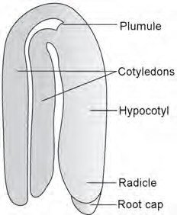Sol. (a)

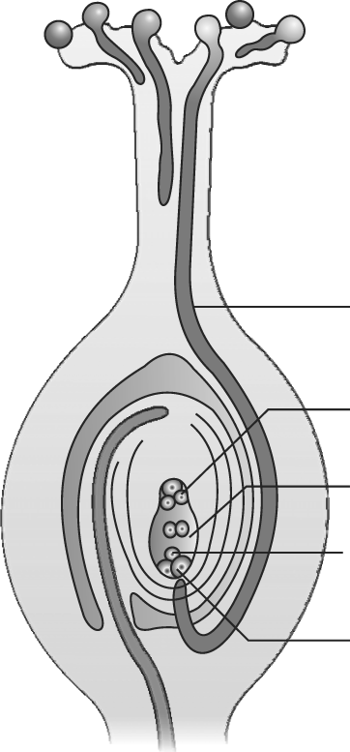(b)

Pollen tube

Antipodal

Polar nuclei Egg cell
Synergid

❑ ❑ ❑

