Chapter 4
Molecular Basis of Inheritance

Solutions

SECTION - A

School/Board Exam. Type Questions
Very Short Answer Type Questions :
- What is the number of N-glycosidic linkages in φ × 174 bacteriophage?
Sol. φ × 174 bacteriophage – 5386 nucleotides, therefore 5386 N-glycosidic linkages.
- Write down the components of cytidine and uridine.
Sol. Cytidine → Cytosine + Sugar (ribose) Uridine → Uracil + Sugar
- Two nucleotide molecules are linked by which bond?
Sol. Phosphodiester bond
- Which biomolecule acts as messenger, structural as well as adapter?
Sol. RNA
- Calculate the length of DNA in human diploid cell.
Sol. 6.6 × 109 bp × 0.34 × 10–9 m/bp = 2.2 meter
- Which structure can be observed as “beads-on-string” when chromatin is viewed under electron microscope?
Sol. Nucleosome
- What determines the order and sequence of amino acids in proteins?
Sol. Sequences of bases in mRNA
- Who gave experimental proof of semiconservative mode of DNA replication in prokaryotes?
Sol. Meselson and Stahl (1958)
- Write down the sequence in mRNA if the sequence of nucleotides in DNA is : 3′-ATGCATTGCCAT-5′
Sol. 5′-UACGUAACGGUA-3′
- What is coded by i-gene and y-gene of lac operon?
Sol. i-gene → Repressor protein y-gene → Permease

48 Molecular Basis of Inheritance Solutions of Assignment (Set-1)

Short Answer Type Questions :
- Explain degeneracy of codons. Give the examples of non-degenerate codons.
Sol. Some amino acids are coded by more than one codon, hence the code is degenerate.
Non-degenerate codons are AUG and UGG.
- Write down the name of any three non-human model organisms, genome of which have been sequenced.
Sol. (Any three)
  - Bacteria
  - Yeast
  - Caenorhabditis elegans
  - Drosophila
  - Rice
  - Arabidopsis
- How many nucleosomes do you imagine are present in a mammalian cell?
Sol. One nucleosome has about 200 bp.

6.6 × 10⁹ ₇

200
= 3.3 × 10
nucleosomes / 33 × 106 nucleosomes

- Which features of DNA confer the stability of the helical structure?
Sol. (i) The plane of one base pair stacks over the other base pair.
(ii) H-bonds in base pairs of two strands.
- Identify the following components (a to c) in the given diagram.


(b)
3′ 5′

U C A
A G U
(a)
(c)

Sol. (a) Anticodon
- Serine (Ser)
- Codon
5′ 3′

- Mention the chemical differences between DNA and RNA. (Any three)

Sol.
S. No. | DNA | RNA
i. | Deoxyribose sugar | Ribose sugar
ii. | Absence of 2′OH in sugar | 2′OH present
iii. | Thymine is present | Uracil is present

Solutions of Assignment (Set-1) Molecular Basis of Inheritance 49

- Write down the evidences that justify the statement “RNA was the first genetic material”.

Sol. Essential life processes, such as metabolism translation, splicing etc., evolved around RNA. It used to act as genetic material as well as catalyst. There are some important biochemical reactions in living systems that are catalysed by RNA catalysts (ribozyme) and not by protein enzymes. But, RNA being a catalyst was reactive and hence unstable. Therefore, DNA has evolved from RNA with chemical modifications that make it more stable.
- What is the significance of release factors in the process of translation?

Sol. At the end of translation, a release factor binds to the stop codon, terminating translation and releasing the complete polypeptide from the ribosome.
- How many types of DNA polymerase are found in bacteria? Mention the rate of polymerisation and direction of exonuclease activity of main polymerising enzyme.
Sol. Three types of DNA polymerase in bacteria are :

DNA polymerase I - Exonuclease activity in 5′ → 3′ and 3′ → 5′ direction. DNA polymerase II - Exonuclease activity in 3′ → 5′ direction.
DNA polymerase III–Rate of polymerisation is 2000 bp per second and exonuclease activity in 3′ → 5′ direction.
- In which respect polynucleotide phosphorylase is different from RNA polymerase?

Sol. Polynucleotide phosphorylase (Severo Ochoa enzyme) polymerises RNA with defined sequences in a template independent manner.
- (a) What do you mean by tailing of RNA?

(b) Where does it occur in cell?

Sol. (a) During this process, adenylate residues (200–300) are added at 3’-end of RNA in a template-independent manner.
(b) It occurs in the nucleus.

- (a) Define chromatin.

(b) Write the composition of its repeating unit.

Sol. (a) Nucleosomes constitute the repeating unit of a structure in nucleus called chromatin. In nucleus, it is visible in the form of thread-like stained bodies.
(b) Nucleosome consists of histone octamer around which negatively charged DNA is wrapped which contain 200 bp.
- Consider the given strand of DNA duplex. 3′-TACCATTGAGACCGACTC-5′
- Draw the complementary DNA polynucleotide chain.

- Write down the mRNA sequence transcribed by it.

Sol. (a) 5′-ATGGTAACTCTGGCTGAG-3′
(b) 5′-AUGGUAACUGUGGCUGAG-3′

50 Molecular Basis of Inheritance Solutions of Assignment (Set-1)

- Frame shift mutations form the genetic basis of proof that codon is a triplet and it is read in a contiguous manner. Explain it.
Sol. Insertion or deletion of three or its multiple bases insert or delete one or multiple codon hence one or multiple amino acids and reading frame remains unaltered from that point onwards.
- Given below sequence represent steps involved in eukaryotic transcription. Fill up the blanks A, B and C shown in the sequence.

Enzyme (A) Splicing
DNA B
mRNA
7-mG
C
5′ 3′

Sol. A - RNA polymerase-III B - hnRNA
C - Poly A-tail

- Write down the significance of operator in operon.

Sol. The accessibility of promoter regions of prokaryotic DNA is regulated by the interaction of proteins with operators.
- Expand VNTR, SSR, SNPs, RFLP.

Sol. VNTRs – Variable Number of Tandem Repeats SSRs – Single Sequence Repeats
SNPs – Single Nucleotide Polymorphism

RFLP – Restriction Fragment Length Polymorphism

- (a) What is contribution of Friedrich Meischer in molecular biology?

(b) Which experimental material was used by Griffith for finding transforming principle?

Sol. (a) DNA as an acidic substance present in nucleus was first identified by Meischer in 1869 and he named it as ‘Nuclein’.
(b) Streptococcus pneumoniae

- Differentiate between codon and anticodon.
S. No. | Codon | Anticodon
i. | It is a sequence of three successive nitrogenous bases which specifies an amino acid. | Sequence of three nitrogenous bases which is complementary to a codon.
ii. | Present on mRNA. | Present on tRNA.

Sol.

Solutions of Assignment (Set-1) Molecular Basis of Inheritance 51

- (a) Draw a clover-leaf secondary structure of tRNA.

(b) How does charging of tRNA take place?

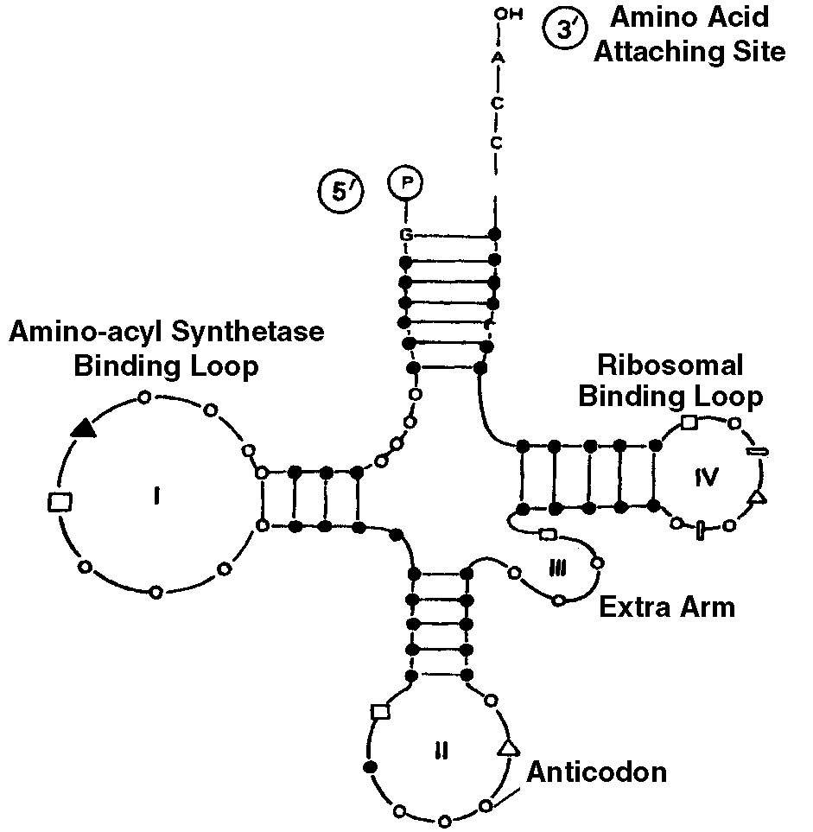Sol. (a)
A.

(b) Attachment of activated amino acids with specific tRNA. Thus, amino acid is transferred to tRNA. Enzyme and AMP are released. It is also called as aminoacylation of tRNA.
AA1 - AMP - E1complex + tRNA1 → AA1 - tRNA1 + AMP + E1
Long Answer Type Questions :

- (i) Which feature in DNA generates approximately uniform distance between the two strands?

(ii) Explain Chargaff’s rule.

Sol. (i) Adenine forms hydrogen bonds with thymine from opposite strand and vice versa. Similarly, guanine is bonded with cytosine. It means, always a purine comes opposite to a pyrimidine or vice versa. This generates approximately uniform distance between the two strands of the helix.
- Chargaff’s rule explains that :

  - Purine and pyrimidines occur in equal amounts, i.e., purine adenine is equimolar with pyrimidine thymine, purine guanine is equimolar with pyrimidine cytosine.

  - A + G = T + C or
A + G T + C

= 1 in all species.

  - Base ratio
A + T C + G

is specific for a species.

  - Sugar deoxyribose and phosphate residues occurs in equal number.

52 Molecular Basis of Inheritance Solutions of Assignment (Set-1)

- How did Hershey and Chase prove that DNA is the genetic material?

Sol. Hershey and Chase performed experiment in three steps:

- Infection

- Blending

- Centrifugation
Hershey and Chase raised T2 bacteriophage over two different bacterial colonies. One having radioactive phosphorus 32P and the other having radioactive sulphur 35S. Radioactive sulphur got incorporated in the capsid proteins of bacteriophage. Radioactive phosphorus 32P became component of DNA of bacteriophage. The two types of bacteriophages were introduced to infect different bacterial colonies of E. coli. The two cultures were taken out and independently agitated on a blender. The empty phage capsid got separated from the bacterial
cells. The virus particles were separated from the bacteria by spinning them in a centrifuge.

Bacteria which was infected with viruses that had radioactive DNA were radioactive, indicating the DNA was the material that passed from virus to the bacteria. Bacteria that were infected with viruses that had radioactive proteins were not radioactive. This indicates that protein did not enter the bacteria from the viruses. DNA is therefore the genetic material.
- Mention the salient features of DNA.

Sol. The salient features of DNA are as follows:

  - It is made of two polynucleotide chains, where the backbone is constituted by sugar-phosphate, and the bases project inside.
  - The two chains have anti-parallel polarity i.e., one chain has the polarity 5′ → 3′ and the other has 3′ → 5′.
  - The bases in two strands are paired through hydrogen bonds i.e., A = T(by two H-bonds) and G ≡ C (by three H-bonds)
  - The two chains are coiled in a right-handed fashion. The pitch of the helix is 3.4 nm and there are roughly 10 bp in each turn. The distance between a bp in a helix is approximately equal to 0.34 nm.
  - The plane of one base pair stacks over the other in double helix. This, in addition to H-bonds, confers stability to the helical structure.
- (a) What do you mean by reverse central dogma?

(b) What is nu-body? What will be the length of DNA of a nucleosome?

Sol. (i) Reverse central dogma is the flow of information in reverse direction i.e., from RNA to DNA in some viruses
e.g., retrovirus.

Transcription
DNA
Reverse
transcription

RNA Translation

Protein

(ii) nu-body is the central octamer histone protein (two copies of each– H2A, H2B, H3 and H4) of nucleosome.
DNA coils around the histone octamer has 200 bp. The distance between one bp is approximately
0.34 nm. Thus, length of DNA with 200 bp = 200 × 0.34 = 68 nm.

Solutions of Assignment (Set-1) Molecular Basis of Inheritance 53

- Discuss the role of NHC proteins. Differentiate between euchromatin and heterochromatin.

Sol. The packaging of chromatin at higher level requires additional set of proteins that collectively are referred to as NHC (Non-histone chromosomal) proteins.

S. No. | Euchromatin | Heterochromatin
i. | Genetically active region. | Inactive.
ii. | Chromatin is loosely packed. | Densely packed.
iii. | Lightly stained region. | Darkly stained region.

- Transforming principle was biochemically characterised by Avery et. al. Explain their work.

Sol. Avery, MacLeod and McCarty worked to determine the biochemical nature of “transforming principle” in Griffith’s experiment.
They purified biochemicals (proteins, DNA, RNA etc.) from the heat killed S-cells to see which ones could transform live R-cells into S-cells. They discovered that DNA alone from S-bacteria caused R-bacteria to become transformed.
They also discovered that protein-digesting enzymes i.e., proteases and RNA digesting enzymes i.e., RNases did not affect transformation, so the transforming substance was not a protein or RNA. Digestion with DNase did inhibit transformation, suggesting that the DNA caused the transformation. Thus, they concluded that DNA is the hereditary material.
- (a) Regulation of gene expression considering polypeptide formation in eukaryotes could be exerted at how many levels? Write down these levels.
- Which is the main level of DNA regulation in bacteria?
Sol. (a) Regulation of gene expression refers to a very broad term that may occur at various levels. Considering that gene expression results in the formation of a polypeptide, it can be regulated at several levels. In eukaryotes, the regulation could be exerted at:
  - Transcriptional level i.e., formation of primary transcript.
  - Processing level i.e., regulation of splicing.
  - Transport of mRNA from nucleus to the cytoplasm.
  - Translational level.
(b) In bacteria, the main level of DNA regulation occurs at transcription level.
- Explain semiconservative mode of replication. How was it experimentally proved and by whom?
Sol. In semiconservative mode of DNA replication, the two strands separate and act as template for the synthesis of new complementary strands. After the completion of replication, each DNA molecule would have one parental and one newly synthesised strand.
It was experimentally proved by Meselson and Stahl in E. coli. by cesium chloride density gradient centrifugation technique.
They grew E. coli in a medium containing 15NH4Cl (15N is the heavy isotope of nitrogen) as the only nitrogen source for many generations. The result was that 15N was incorporated into newly synthesised DNA (as well as other nitrogen-containing compounds). This heavy DNA molecule could be distinguished from the normal
DNA by centrifugation in a cesium chloride (CsCl) density gradient. Then they transferred the cells into a medium with normal 14NH4Cl and took samples at various definite time intervals as the cells multiplied, and extracted the DNA that remained as double-stranded helices. The various samples were separated independently on CsCl gradients to measure the densities of DNA.

54 Molecular Basis of Inheritance Solutions of Assignment (Set-1)

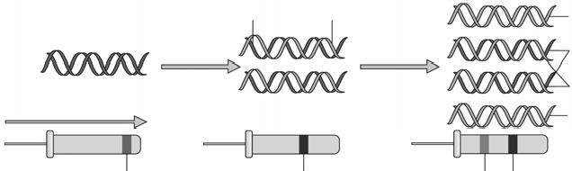
Generation I
Generation II
15
N-DNA
14
N-DNA
15
14
N-DNA
N-DNA
15
N-DNA
20 min
40 min
14
N-DNA
Gravitational Force
14
N-DNA
15 15
N N
14 15
N N
Hybrid
(Separation of DNA by centrifugation)
14 14
N N
14 15
N N
Heavy
Light Hybrid

Messelson and Stahl’s Experiment
Thus, the DNA that was extracted from the culture one generation after the transfer from 15N to 14N medium [that is after 20 minutes; E.coli divides in 20 minutes] had a hybrid or intermediate density. DNA extracted from the culture after another generation [that is after 40 minutes, II generation] was composed of equal amounts of this hybrid DNA and of light DNA.
- Label a, b and c and identify the figure. Write the name of main enzyme of this process.
5′ 3′

(a)
(b)

5′
3′

(c)

3′ 5′
5′ 3′
Sol. (a) Continuous DNA synthesis

- Template DNA (parental strands)

- Discontinuous DNA synthesis

It is figure of replicating fork. Main enzyme of this process is DNA-dependent DNA polymerase.

- (a) How many types of RNA polymerases are found in eukaryotes? Mention their functions also.

(b) Name the specific amino acids coded by GAG, UUC, AUG and UGG.

Sol. Three types of RNA polymerase in eukaryotes are :

- RNA polymerase I – 5.8S, 18S, 28S rRNA synthesis RNA polymerase II – HnRNA, mRNA
RNA polymerase III – tRNA, ScRNA, 5S rRNA, SnRNA

- GAG – Glutamic acid UUC – Phenylalanine AUG – Methionine UGG – Tryptophan

Solutions of Assignment (Set-1) Molecular Basis of Inheritance 55

- Explain the transcription unit and its components with the help of diagram.

Sol. The segment of the DNA which takes part in transcription is called transcription unit. It has a promoter region in the beginning, a terminator region in the end and a structural gene in between promoter and terminator region.

Transcription start site

Promoter
3′

5′

Structural gene
Terminator Template strand
5′

Coding strand 3′

Schematic structure of a transcription unit

- Write the salient features of genetic code.

Sol. Salient features of genetic code:
  - Triplet nature
  - Non-overlapping nature
  - Non-ambiguous nature
  - Genetic code is commaless
  - Initiation codons : They function as start signals for the synthesis of polypeptides e.g., AUG
  - Termination codon : They are stop signals which cause termination of polypeptide synthesis, e.g., UAA, UAG, UGA
  - Degeneracy of codons : More than one codon specify one amino acid.

- Study the schematic representation of the genes involved in the lac operon given below and answer the following questions.

p | i | p | o | z | y | a

  - Identity and name the regulatory gene in this operon. Explain its role in “switching off” the operon.

  - Identity and name the structural genes in this operon and trace the events that lead to the transcription of these structural genes.
  - Why the regulation of lac operon by repressor is referred to as negative control?

  - Name the inducer molecule and the product of ‘y’ gene. Write the function of this gene product.

Sol. (i) Regulator gene is i-gene, it codes for repressor protein. Repressor protein covers the operator gene (O) so that RNA polymerase is unable to pass over and reach the structural genes for transcription.
- z, y and a are structural genes. Presence of lactose or galactoside activates the operon. It binds to repressor and removes it from operator gene. RNA polymerase is now able to reach over the structural genes and transcribe them. Thus, switching on the operon.
- Negative regulation is the one in which presence of a substrate or a factor inhibits a process. Here, presence of the product of regulatory gene acts as a repressor of lac operon.
- Lactose or allolactose is the inducer of lac operon. Gene y codes for galactoside permease which permits entry of lactose into the cell.

56 Molecular Basis of Inheritance Solutions of Assignment (Set-1)

- (a) Give an outline of the steps involved in technique that was initially developed by Alec Jeffreys.

- Mention the causes of DNA polymorphism.

Sol. (a) Steps involved in DNA fingerprinting are :

  - Extraction of DNA from source i.e., WBCs, semen, saliva, vaginal swabs, skin cells etc.

  - DNA amplification by PCR

  - Fragmentation of DNA by restriction enzymes

  - Separation of VNTRs, by gel electrophoresis

  - Denaturation of VNTRs by alkali or high temperature treatment.

  - Southern blotting : Transfer of DNA from gel to synthetic membrane, i.e., nitrocellulose or nylon.

  - DNA probes synthesis

  - Hybridisation between VNTR and DNA probe

  - Exposure to X-ray film to recognise hybridised DNA segments.

- The cause of DNA polymorphism is

  - Allelic polymorphism i.e., occurrence of multiple alleles of a gene.

  - Single nucleotide polymorphism : Over 1.4 million single base difference occurs in DNA.

  - RFLP (Restriction Fragment Length Polymorphism) : Differences appear in the restriction maps of individuals.
- Briefly describe the following :

  - Template strand

  - VNTR

  - RFLP

  - Exons

  - ESTs

Sol. (i) Template strand : It is a strand of DNA which takes part in transcription. It shows 3′ → 5′ polarity. Its nucleotide sequence is complementary to one present in mRNA.
- VNTR (Variable Number Tandem Repeats) : It is the part of satellite DNA or it is minisatellite sequence. The numbers of repeat show very high degree of polymorphism. As a result the size of VNTR varies in size from 0.1 to 20 Kb. It is the basis of DNA fingerprinting.
- RFLP (Restriction Fragment Length Polymorphism) : The length of minisatellites and position of restriction sites is different for each person. Therefore, when the genomes of two people are cut using the same restriction enzyme, the length and number of fragments obtained are different for both. This is called RFLP.
- Exons : Coding sequences of DNA that specify functional polypeptides.

- ESTs : Expressed sequence tags. Identity all the genes that are expressed as RNAs and sequence the same.

Solutions of Assignment (Set-1) Molecular Basis of Inheritance 57

SECTION - B

Model Test Paper

Very Short Answer Type Questions :
- Mention the number of base pairs, N-glycosidic bonds and phosphate radicles in lambda bacteriophage.
Sol. In λ-bacteriophage, No. of bp → 48502
No. of N-glycosidic bonds → 48502 × 2 = 97004 No. of phosphate radicles → 97004
- Name the protein required in packaging of chromatin at higher level.
Sol. Set of acidic proteins or non-histone chromosomal proteins (NHCs)
- Which nucleic acid is better for the transmission of genetic information?
Sol. RNA
- What is the average rate of polymerisation of DNA polymerase III?
Sol. 2000 base pairs per second
- Mention the transcribed products of RNA polymerase I.
Sol. RNA polymerase I – 5.8S, 28S, 18S rRNA
- How many codons specify valine and serine?
Sol. Valine – 4 codons; Serine – 6 codons
- Discuss the significance of heavy isotopes of nitrogen in Meselson and Stahl’s experiment.
Sol. The heavy DNA molecule with incorporated 15N could be distinguished from the normal DNA by centrifugation in CsCl density gradient.
- Consider the DNA strand given below and write down the codons sequence of codons in mRNA strand. Template strand 3′ - A TG CATGCATTTC TCTCC - 5′
Coding strand 5′ - T AC GTACGTAAAGAGAGG - 3′
Sol. Codon sequence on mRNA is given below: 5′-UACGUACGUAAAGAGAGG-3′
Short Answer Type Questions :

- P y
O
x
A

  - Identify the above given molecule.
  - What type of linkage are represented by ‘x’ and ‘y’?
Sol. (i) AMP (Adenosine monophosphate)
(ii) x - N-glycosidic bond y - Phosphoester bond

58 Molecular Basis of Inheritance Solutions of Assignment (Set-1)

- “A low level of expression of lac operon occurs all the time.” Explain the logic behind this phenomenon.

Sol. The lactose is transported into the cells through the action of permease which is the product of y-gene. So, low level of expression of lac operon is always present otherwise lactose cannot enter the cell.
- Why capping and tailing is required for hnRNA?

Sol. Capping or addition of 7mG (methylated gnanosine) is required for binding of smaller subunit of ribosome (40 S) and formation of mRNA-ribosome complex. Tailing for efficient-translation mechanism.
- What is the cause of discontinuous synthesis of DNA on one of the parental strands? What happens to these short stretches of synthesised DNA?
Sol. Both strands are antiparallel and DNA polymerase activity occurs only in 5′ → 3′ direction for new chain elongation. Replication is discontinuous over the strand template with 5′ → 3′ polarity over which only small stretches of DNA are open due to opposite running of template strand. These short stretches of synthesised DNA are Okazaki fragments that are joined by DNA ligase.
- Define various methods used in sequencing the human genome.

Sol. Various methods used in sequencing the human genome are:
  - Expressed Sequence Tags (ESTs) : It is a method to identify all the genes that are expressed as RNAs and sequence the same.
  - Sequence Annotation : The whole genome, including both coding and non-coding regions, is first sequenced. Later, functions are assigned to different regions.

Replication
transcription
DNA mRNA

translation
protein

What is represented in the above diagram? How it is different in some viruses?
Sol. It is central dogma which states that the genetic information flows from DNA → RNA → Protein. The flow of information is in reverse direction, that is from RNA to DNA in some viruses (e.g., HIV)
- How deoxyribonucleoside triphosphates serve dual purposes in replication?

Sol. In addition to acting as substrates, they provide energy for polymerisation reaction.

The two terminal phosphates in a deoxyribonucleoside triphosphates are high energy phosphates same as in case of ATP.
- Mention the types of structural genes with examples.
Sol. The structural gene in a transcriptional unit could be monocistronic (mostly in eukaryotes) or polycistronic (mostly in bacteria).
- What is a major difference between RNA polymerase and DNA polymerase?

Sol. The DNA polymerases on their own cannot initiate the process of replication while RNA polymerase can initiate the process of transcription.
- Why both the strands of DNA are not copied during transcription? Give one reason.

Sol. If both strands act as a template, they would code for RNA molecule with different sequences, and in turn, if they code for proteins, the sequence of amino acids in the proteins would be different. Hence, one segment of the DNA would be coding for two different proteins, and this would complicate the genetic information transfer machinery.

Solutions of Assignment (Set-1) Molecular Basis of Inheritance 59

- Transcription and translation can be coupled in bacteria. Explain it.
Sol. (i) There is no separation of cytosol and nucleus in bacteria, therefore transcription and translation take place in the same compartment.
(ii) mRNA does not require any processing to become active.

Long Answer Type Questions :

- Discuss the process of translation in detail.

Sol. Translation

It is the mechanism by which the triplet base sequences of mRNA molecules are converted into a specific sequence of amino acids in a polypeptide chain. It occurs on ribosomes. The major steps are :
- Activation of amino acids. In the presence of enzyme aminoacyl - tRNA synthetase (E), specific amino acids (AA) bind with ATP.

AA1

+ ATP

2
⎯⎯^{E}1, ⎯^{Mg}⎯→ AA
+
1
- AMP - E1
complex + PPi

- Charging of tRNA. The AA1-AMP-E1 complex formed in first step reacts with a specific tRNA. Thus, amino acid is transferred to tRNA. As a result, the enzyme and AMP are liberated.

AA1-AMP-E1 complex + tRNA1 →
AA1-tRNA1 + AMP + E1
(Charged tRNA)

- Formation of polypeptide chain. It is completed in three steps.

  - Chain Initiation. It requires three initiation factors in prokaryotes.

Nine intiation factors are required in eukaryotes. The cellular factory responsible for synthesising proteins is the ribosome. The ribosome consists of structural RNA and about 80 different proteins. In its inactive state, it exists as two subunits, a large subunit and a small subunit.
    - Binding of mRNA with smaller subunit of ribosomes (30S/40S).

    - Binding of 30S/40S-mRNA complex with tRNA. Non-formylated methionine is attached with tRNA in eukaryotes and formylated methionine in prokaryotes.
40S/30S-mRNA complex + tRNAmet ⎯⎯GTP⎯→ 40S/30S-mRNA-tRNAmet complex.
    - Attachment of larger subunit of ribosomes.
  - Chain elongation. Ribosomes have two sites for binding amino acyl tRNA (i) Amino acyl or A site (acceptor site) (ii) Peptidyl site or P site (donor site). A second charged tRNA molecule along with its appropriate amino acid approaches the ribosome at A site close to the P site. Its anticodon binds to complementary codon of mRNA chain. A peptide bond is formed between COOH group of first amino acid
(methionine) and NH2 group of second amino acid. The formation of peptide bond requires energy and is catalysed by enzyme peptidyl transferase (23S rRNA in bacteria and 28S rRNA in eukaryotes). The
initiating formyl methionine or methionine tRNA can bind only with P site. All other newly coming aminoacyl tRNA bind to A site.Translocation is movement of ribosome on mRNA.
  - Chain termination. The termination of polypeptide is signalled by one of the three terminal codons in the mRNA. The three terminal codons are UAG, UAA and UGA. A GTP-dependent factor known as release factor is associated with termination codon. It is eRF1 in eukaryotes and RF1 and RF2 in prokaryotes.

At the time of termination, the terminal codon immediately follows the last amino acid codon. After this the polypeptide chain, tRNA, mRNA are released and the subunits of ribosomes get dissociated.

60 Molecular Basis of Inheritance Solutions of Assignment (Set-1)

mRNA
5′
xxx yyy

zzz
3′
mRNA 5′
xxx yyy

zzz
3′

Initiating amino acid
1

P
Site

A
Site
1

P
Site
2

A
Site

- Binding of first charged tRNA at P site (B) Binding of next charged tRNA at A site

mRNA
xxx yyy zzz
5′ 3′

mRNA

xxx yyy zzz

5′ 3′

2

P A
Site Site 1

2
P
Site 1

A
Site

  - Peptide bond formation by peptidyl transferase
  - Translocation movement of ribosome on mRNA, so peptidyl tRNA is at P site.
A site is open for the next charged tRNA

- Give the correct word or phenomenon in column B for statements mentioned in column A.

Column A Column B

- Highly condensed non-transcribing part of chromosome

- Small RNA fragments help in DNA replication initiation

- Subunit of chromatin

- Enzyme required to release of DNA supercoils or tensions

- Coding sequence of eukaryotic chromosome

- Experimental organism of transformation

Sol. a - Heterochromatin b - Primer
c - Nucleosome

d - Topoisomerase e - Exons
f - Streptococcus pneumoniae (Pneumococcus)

❑ ❑ ❑

