Chapter 2
Human Reproduction

Solutions

SECTION - A
School/Board Exam. Type Questions Very Short Answer Type Questions :
- When do the egg cells of a human female begin meiosis? Are any oogonia added after birth?
Sol. In human female oogenesis is initiated during embryonic development; no more oogonia are added after birth.
- State whether the following statements are True or False. Correct each false statement to make it true.
  - Fertilisation takes place in uterus.
  - Corpus luteum develops from the ruptured follicle after ovulation.
Sol. (a) False.
True statement is fertilisation takes place in the fallopian tubes.
(b) True.
- What might happen if more than one egg were released from ovaries prior to fertilisation?
Sol. If more than one egg is released from the ovaries prior to fertilisation and both are fertilised, twins born would be fraternal.
- How long is the period of gestation in humans?
Sol. Gestation period in human beings is 9 months.
- Sequence the path that mature sperm take from the testes to the outside of the body.
Sol. Path of mature sperm
Epididymis → Vas deferens → Ejaculatory duct → Urethra.
- What do you think the doctors inject to induce delivery?
Sol. If the labor pains are less, the doctors along with the drip inject oxytocin/pitocin hormone.
- Why scientifically it is correct to say that sex of baby is determined by the father and not by the mother?
Sol. The chromosome pattern in human female is XX and that in male is XY. All the haploid gametes produced by female have the sex chromosome X, whereas in male gamete the sex chromosome could be either X or Y. After fusion of male and female gametes, the zygote would carry either XX or XY chromosomes, depending upon type of sperm fertilising the ovum.

10 Human Reproduction Solutions of Assignment (Set-1)

- What is menarche?
Sol. The first menstruation begins at puberty and is called menarche.
- What is hymen?
Sol. The opening of vagina is often covered partially by a membrane hymen.
- What is lactiferous duct?
Sol. Lactiferous duct is a duct in mammary glands through which milk is sucked out.
Short Answer Type Questions :
- What do you think the mitochondria do in a sperm cell?
Sol. Numerous mitochondria present in the middle piece, produce energy for the movement of tail that facilitate sperm motility essential for fertilisation.
- What is the function of vas deferens?
Sol. Vas deferens is one of the accessory ducts of male for the transport of sperms towards the urethra.
- Which structures in a male produce fluids that mix with sperm to form semen?
Sol. Male accessory glands include paired seminal vesicles, a prostate and paired bulbourethral glands. Secretions of these glands constitute seminal plasma. Seminal plasma along with sperms form semen.
- What role does luteinising hormone (LH) play in the ovarian cycle?
Sol. LH (luteinising hormone), also called as ovulation hormone. LH surge in the mid of menstrual cycle of 28 days induces the rupture of Graafian follicle and thereby the release of ovum. It also helps in the formation and maintenance of corpus luteum, if fertilisation does not occur.
- What is corpus luteum?
Sol. After ovulation, the remaining parts of the Graafian follicle transform as the corpus luteum. Corpus luteum is yellowish mass like structure and secretes large amount of progesterone which is essential for maintenance of endometrium. It also secretes estrogen and relaxin hormone.
- How do high levels of estrogen and progesterone during the follicular phase and luteal phase respectively of the ovarian cycle affect the uterus?
Sol. High levels of estrogen during the follicular phase, helps the endometrium of the uterus to regenerate through proliferation. During the luteal phase, the corpus luteum secretes large amounts of progesterone which is essential for maintenance of the endometrium.
- What is menstruation?
Sol. In the absence of fertilisation, the corpus luteum degenerates. This causes disintegration of the endometrium leading to menstruation, this is due to deficiency of progesterone hormone. Menstruation lasts for 3–5 days. The menstrual flow results due to breakdown of endometrial lining of uterus and the blood vessels which forms liquid that comes out through the vagina.
- What is blastocyst?
Sol. Blastocyst is a hollow ball of cells, and its central cavity is called as blastocoel. The blastomeres in the blastocyst are arranged into an outer layer called trophoblast and an inner group of cells attached to trophoblast called inner cell mass. Implantation occurs in blastocyst stage.
- Where does the zygote begin to undergo cleavage?
Sol. The zygote begins to undergo cleavage in the oviduct/fallopian tubes. It divides to form 2, 4, 8, 16 daughter cells called blastomeres.
- What is the process of implantation?
Sol. Approximately one week after fertilisation, the blastocyst embeds itself in the thickened wall of the uterus, a process called as implantation, and pregnancy is established. In this process, the trophoblast layer of blastocyst gets attached to the endometrium. After attachment, the uterine cells divide and rapidly covers the blastocyst. As a result, the blastocyst becomes embedded in the endometrium of uterus. This is implantation.

Solutions of Assignment (Set-1) Human Reproduction 11

- What changes occur in the foetus during fifth month of pregnancy?
Sol. The first movement of the foetus and the appearance of hair on the head are usually observed during the fifth month.
- What is ovulation? When does it occur? Which meiotic division is completed prior to ovulation?
Sol. Ovulation is the release of ovum into the abdominal cavity due to rupture of Graafian follicle. It occurs on the 14th day of 28th days menstrual cycle due to LH surge. 1st meiotic division is completed prior to ovulation, and the ovum is released from the ovary in secondary oocyte stage.
- Why certain environmental factors, such as stress, a poor diet, and prolonged strenuous exercise can affect menstrual cycle?
Sol. Certain environmental factors such as stress, a poor diet and prolonged strenuous exercise can lead to lack of menstruation. These factors also affect the secretion of gonadotropins.
- What is menopause?
Sol. In human beings, the menstrual cycle ceases around 50 years of age; that is termed as menopause. It is due to senile change in ovaries. Gonadotropins are being produced but the ovaries are not responding to these hormones, because all the ovarian follicles are degenerated.
- Describe the process of cleavage upto the formation of blastocyst.
Sol. Cleavage is a phase in embryogenesis, in which the single-celled zygote is converted into a multicellular structure morula then blastocyst. The cleavage divisions which are mitotic division start, when the zygote is still in fallopian tubes. The first cleavage division leads to the formation of 2-celled stage. 2, 4, 8, 16 daughter cells are formed called as blastomeres. During cleavage, zona pellucida is intact, so there is no growth of blastomeres. The solid embryo with 8 to 16 blastomeres is called as a morula. The morula is converted into blastocyst as it moves towards the uterus. Blastocyst is hollow ball of cells with outer trophoblast layer and inner cell mass. The central cavity is blastocoel.

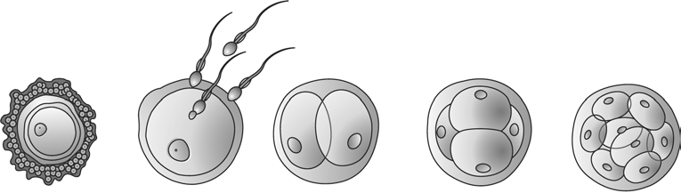
2-celled
stage
4-celled
stage
8-celled
stage

A B C

16-celled stage
D (Morula)
E

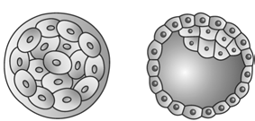

Morula F
(Blastocyst) G

- Mention the function of vagina.
Sol. Cervical canal along with vagina are called birth canal. During copulation, the semen is released by the penis into the vagina.
- Mention the function of pituitary gonadotropins in males.
Sol. In males, LH acts at the Leydig cells and stimulates synthesis and secretion of androgens. Androgens, in turn stimulate the process of spermatogenesis. FSH acts on the Sertoli cells and stimulates secretion of some factors which help in the process of spermiogenesis.

12 Human Reproduction Solutions of Assignment (Set-1)

- What is foetal ejection reflex?
Sol. The signals for parturition originate from fully developed fetus and the placenta which induce mild uterine contractions called foetal ejection reflex.
- Describe the effect of estrogen production on the secretion of LH in mid cycle.
Sol. In the mid cycle estrogen surge has a positive feedback effect on the anterior lobe of pituitary for the secretion of LH.
- What causes the lining of the uterus to thicken and then to be shed during menstrual cycle?
Sol. Estrogen hormone during the follicular phase causes the endometrium of the uterus to regenerate through proliferation. During luteal phase, the further thickening of endometrium is due to estrogen and progesterone. The corpus luteum secretes large amounts of progesterone which is essential for the maintenance of endometrium. In absence of fertilisation, the corpus luteum degenerates, progesterone level falls, endometrium is not maintained. This causes disintegration of endometrium leading to menstruation.
Long Answer Type Questions :
- Given below is the diagrammatic sectional view of female pelvis showing the reproductive system.

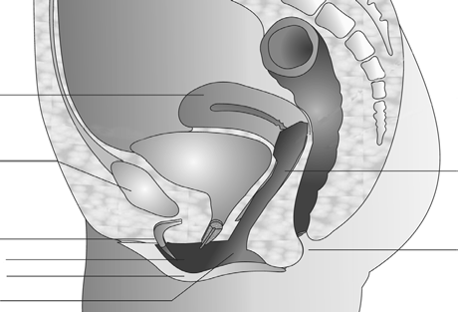A

Pubic symphysis B

C D E
Vaginal orifice
  - Identify the parts labelled as A, B, C, D and E.
  - Which of these labelled parts are included in external genitalia of female?
  - What is clitoris?
Sol. (a) A is Uterus
B is Vagina C is Clitoris
D is Labia minora

Anus

E is Labia majora
- The female external genitalia includes mons pubis, labia majora, labia minora, hymen and clitoris. So, the labelled parts included in the external genitalia of female are
C – Clitoris
D – Labia minora E – Labia majora
- Clitoris is a tiny finger like structure which lies at the upper junction of the two labia minora above the urethral opening.

Solutions of Assignment (Set-1) Human Reproduction 13

- Given below is a diagrammatic sketch of a portion of human male reproductive system.
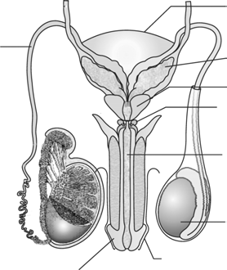
Urinary bladder

D

Glans penis
  - Identify the parts labelled as A, B, C and D.
A B
C

Urethra

Testis

Foreskin

  - Which of the labelled parts are male accessory glands?
  - What is seminal plasma?
Sol. (a) A is Seminal vesicle
B is Prostate gland
C is Bulbourethral gland D is Vas deferens
- The labelled parts which are included in male accessory glands are A – Seminal vesicle
B – Prostate gland
C – Bulbourethral gland
- The secretions of the accessory glands i.e. paired seminal vesicles, a prostate and paired bulbourethral glands is seminal plasma. It is rich in fructose, calcium and some enzymes.
- 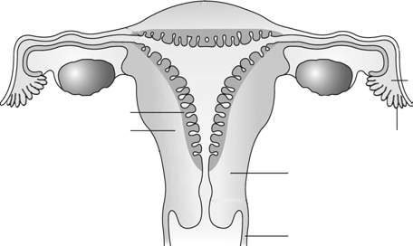Given below is diagrammatic sectional view of the female reproductive system.
C
B A
E
D
Ovary
Fimbriae
Cervix
Cervical canal

Vagina
  - Identify the parts labelled as A, B, C, D and E.
  - Mention the function of D and E.
  - What is womb?
Sol. (a) A is Infundibulum
B is Ampulla C is Isthmus
D is Myometrium E is Endometrium

14 Human Reproduction Solutions of Assignment (Set-1)

- Function of D
Myometrium exhibits strong contractions during delivery of baby as it is made up of a thick layer of smooth muscles.
Function of E
Endometrium is the inner glandular layer of uterus which lines the uterine cavity. Endometrium undergoes cyclical changes during menstrual cycle.
- In human beings, there is single uterus, also called as womb, where the development of embryo occurs.
- 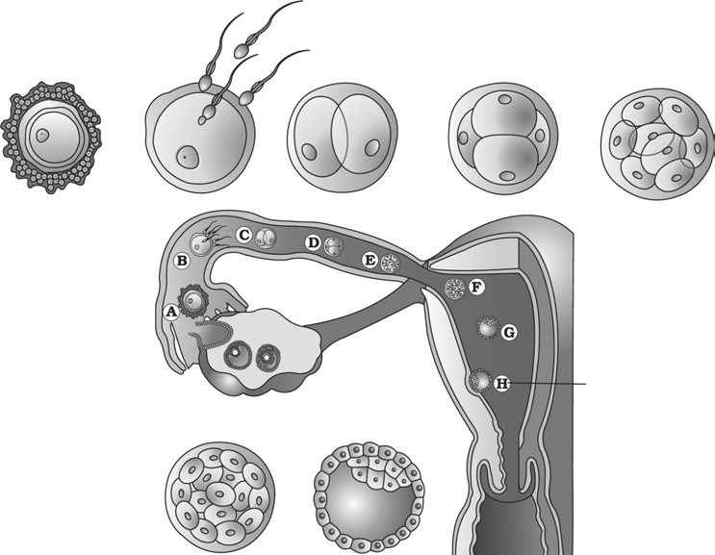Following is a diagrammatic representation of transport of ovum, fertilisation and the passage of growing embryo through the fallopian tube.
A
B
C
D
E
J
Blastocyst
Implantation
I
F G
  - In which part of the fallopian tube the stage B occurs?
  - Identify the stages F and G.
  - Identify the labelled parts I and J and mention their function.
Sol. (a) Stage B represents fertilisation. It occurs in the ampullary-isthmic junction.
- Stage F is morula and stage G is blastocyst.
- I is trophoblast. It is the outer layer of blastocyst and J is inner cell mass.
Function : The trophoblast layer does not take part in the formation of embryo proper, it forms the foetal portion of the placenta. The trophoblast gets attached to endometrium and inner cell mass gets differentiated as the embryo. After implantation, finger like projections appear on the trophoblast called chorionic villi which interdigitate with uterine tissue.
- 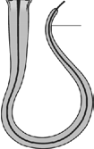
2

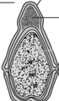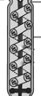1
3

(A) (B) (C)

Solutions of Assignment (Set-1) Human Reproduction 15

  - Write correct sequence of the diagrams A, B and C representing parts of the spermatozoan.
  - Label 1 in A and write down its function.
  - Label 2 in B and write down its function.
  - Label 3 in C in write down its function.
Sol. (a) The correct sequence of the parts is A, C and B.
- Labelled part 1 in A is Acrosome. Acrosome is filled with enzymes that help in fertilisation of the ovum.
- Labelled part 2 in B is Tail of spermatozoan. Tail facilitates sperm motility essential for fertilisation.
- Labelled part 3 in C is middle piece which contains numerous mitochondria, which provide energy for the movement of the tail.
- In the given diagrammatic section view of ovary identify

  - (i) Corpus luteum

    - Secondary oocyte

Blood C B
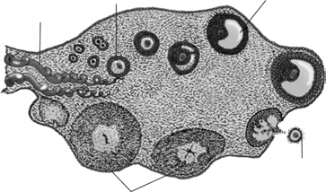vessels
A

    - Antrum

    - Primary follicle

    - Graafian follicle D
  - What are the parts of ovarian stroma? _{E}
Sol. In the given T.S. of human ovary, the labelled part
- (i) E is Corpus luteum
  - D is Secondary oocyte
  - B is Antrium
  - C is Primary follicle
  - A is Graafian follicle
- Stroma is divided into peripheral cortex and an inner medulla.
- 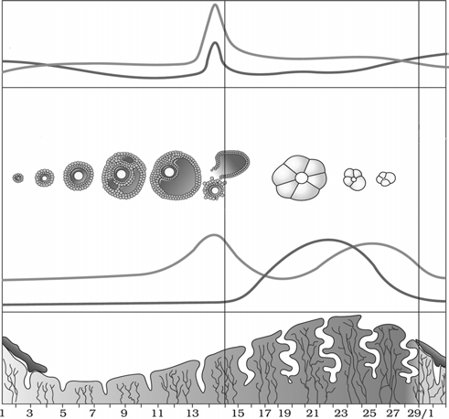The events of the menstrual cycle are represented below. Use the graph to answer the questions.
D
FSH
Developing follicle Mature follicle
E
Regressing
corpus luteum
Ovulation
A
C
B
Menses
Pituitary Hormone levels
Ovarian events

Days
Ovarian Hormone levels
Uterine events

Menstruation Follicular phase (Proliferative phase)

Luteal phase (Secretory phase)

Next cycle begins

16 Human Reproduction Solutions of Assignment (Set-1)

  - In which of the above mentioned phases does the egg travel into the fallopian tube?
  - The blood levels of which substance are described by curve A?
  - The source of the increase in concentration of hormone indicated at point B is
  - The source of increase in concentration at point C is
  - Identify the structure labelled as E. Also, mention the hormones secreted by it.
Sol. (a) Egg travels into the fallopian tubes during the luteal phase.
- The blood levels of progesterone hormone are described by the curve A.
- The source of increase in concentration of estrogen hormone at point B is Graafian follicle.
- The source of increase in concentration of estrogen at point C is corpus luteum.
- The structure labelled as E is corpus luteum. It secretes large amounts of progesterone hormone which is essential for maintenance of endometrium.
- Given below is the diagram of the human foetus within the uterus.

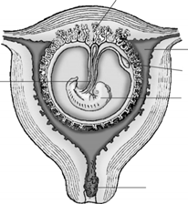B

Cavity of uterus Yolk sac
A
Embryo

Plug of mucus in cervix

  - Identify the structure labelled as A.
  - Mention the function of A.
  - Identify B and mention its function.
Sol. (a) The structure labelled as A is umbilical cord.
- The placenta is connected to the embryo through an umbilical cord which helps in the transport of substances to and from the embryo.
- The structure labelled as B is placental villi / chorionic villi.
Finger like projections appear on the trophoblast called as chorionic villi which are surrounded by the uterine tissue and maternal blood. Chorionic villi and uterine tissue become interdigitated with each other to form placenta.
- (a) Identify the ducts labelled as A, B, C and D in the diagram given below.
Urinary bladder

D

A
B C

Testicular lobules

Glans penis
Seminal vesicle Prostate
Bulbourethral gland
Urethra

Testis

Foreskin

Solutions of Assignment (Set-1) Human Reproduction 17

- Trace the correct path of movement of the sperms upto urethra in the ducts labelled as A, B, C and D of male reproductive system.
- What is ejaculatory duct?
Sol. (a) The labelled part
A is Epididymis
B is Vasa efferentia C is Rete testis
D is vas deferens
- Path of sperms upto urethra in the labelled ducts is
C
B
A
D
- The vas deferens receives a duct from the seminal vesicle and opens into the urethra through ejaculatory duct.
- Given below is the sectional view of male pelvis showing reproductive system.

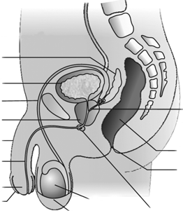B
Urinary bladder
C D
Penis Urethra
Glans penis Foreskin

Testis Scrotum

A

Rectum Anus

E

  - Identify the parts labelled as A, B, C, D and E.
  - Mention the function of the part labelled as E.
  - What is the function of urethra and penis?
Sol. (a) The labelled part
A is Ejaculatory duct B is Seminal vesicle C is Vas deferens
D is Prostate gland
E is Bulbourethral gland
- Function : The labelled part E is bulbourethral glands. The secretions of these gland take part in the formation of seminal plasma. The secretions also help in the lubrication of penis.
- The urethra originates from the urinary bladder and extends through the penis to its external opening called as urethral meatus. The ejaculatory duct also opens into urethra. So, the urethra in male can carry urine and sperms. Penis is the male external genitalia, made up of a special tissue that helps in its erection to facilitate insemination.

18 Human Reproduction Solutions of Assignment (Set-1)

- 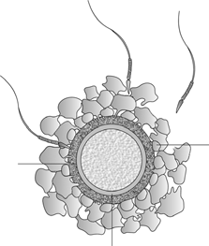Given below is the diagram of ovum surrounded by few sperms.
A
Ovum

B

C
  - Identify the parts labelled as A, B and C.
  - What is insemination?
  - Why not all copulations lead to fertilisation and pregnancy?
  - What induces the completion of meiotic division in secondary oocyte?
Sol. (a) The labelled part
A is Zona pellucida B is Corona radiata
C is Perivitelline space
- During copulation semen is released by the penis into the vagina of female called as insemination.
- Fertilisation can occur only if the ovum and sperms are transported simultaneously to the ampullary-isthmic junction.
- The entry of the sperm into the cytoplasm of the ovum induces the completion of the meiotic division of the secondary oocyte.
- Describe the function of placenta.
Sol. Placenta facilitate the supply of oxygen and nutrients to the embryo and also removal of carbon dioxide and excretory/waste materials produced by the embryo.
Placenta also acts as an endocrine tissue and produces several hormones like human chorionic gonadotropin (hCG), human placental lactogen (hPL), estrogen and progesterone.
- What are the major features of embryonic development at the following months of pregnancy?
  - After first month
  - By the end of second month
  - By the end of 12 weeks (first trimester)
  - During fifth month
  - By the end of 24 weeks (second trimester)
Sol. (a) In human beings after one month of pregnancy, the embryo’s heart is formed. The first sign of growing foetus may be noticed by listening to the heart sound carefully through stethoscope.
- By the end of second month of pregnancy, the foetus develops limbs and digits.
- By the end of 12 weeks (first trimester), most of the major organ systems are formed, the limbs and external genital organs are well-developed.
- The first movements of the foetus and the appearance of hair on the head are usually observed during fifth month.
- By the end of 24 weeks (second trimester), the body is covered with fine hair, eye-lids separate and eye-lashes are formed.

Solutions of Assignment (Set-1) Human Reproduction 19

- (a) Give a schematic representation of spermatogenesis in humans.
- At which stage of life does gametogenesis begin in human male and female respectively?
- Name the organs where gametogenesis gets completed in human male and female respectively.
Sol. (a)
Chromosomes number per cell
46

23

23
At puberty
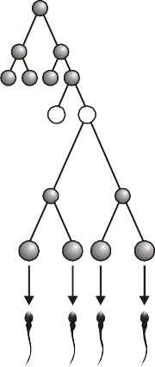
Spermatogonia
Mitosis differentiation

Primary spermatocytes
1st meiotic division

Secondary spermatocytes
2nd meiotic division

Spermatids
Differentiation

Spermatozoa

- In human female, oogenesis is initiated during embryonic development and no more oogonia are formed and added after birth. Whereas, spermatogenesis starts at the age of puberty due to significant increase in the secretion of GnRH.
- In human male, gametogenesis is completed in the testis. Whereas in human female, meiosis-II is completed after the entry of sperm into the cytoplasm of ovum.
- (a) Give a schematic representation of oogenesis in humans.
- Mention the number of chromosomes at each stage.
- Correlate the life phases of the individual with stages of the process.
Sol. (a)

Oogonia

Fetal life
Birth Childhood Puberty

Adult

First polar body

Mitosis differentiation

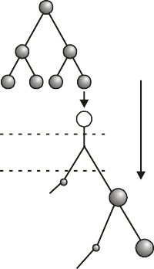Primary oocyte
st
1 meiotic
division (completed prior to ovulation)

Secondary oocyte

Ovum

reproductive
life Second polar body

- Number of chromosomes in oogonia 2n = 46 Number of chromosomes in primary oocyte 2n = 46
Number of chromosomes in secondary oocyte n = 23 Number of chromosomes in ovum n = 23
- (i) Fetal life : Oogenesis is initiated during the embryonic development when a couple of million gamete mother cells or oogonia are formed in fetal ovary. These cells start division and enter into prophase-I of the meiotic division and it temporarily gets arrested at that stage called primary oocytes.
  - At the time of puberty, the primary oocyte within the tertiary follicle completes its first meiotic division prior to ovulation. It is unequal resulting in the formation of a large haploid secondary oocyte and a tiny first polar body.
  - Secondary oocyte completes meiosis-II only after the entry of sperm into the cytoplasm of ovum.

20 Human Reproduction Solutions of Assignment (Set-1)

SECTION - B
Model Test Paper

Very Short Answer Type Questions :
- Mention the function of interstitial cells.
Sol. Interstitial cells are also called as Leydig cells. These cells synthesise and secrete group of testicular hormones called androgens. The main androgen is testosterone.
- Sequence the path the sperms follow in leaving the body.
Sol. Path of sperms :
Seminiferous tubules → Rete testis → Vasa efferentia → Epididymis → Vas deferens → Ejaculatory duct
→ Urethra
- State the function of infundibulum.
Sol. The infundibulum is a funnel-shaped structure closer to ovary. The edges of infundibulum possess finger-like projections called fimbriae, which helps in collection of the ovum after ovulation.
- What is birth canal?
Sol. Cervical canal along with vagina forms the birth canal.
- What is spermiogenesis and spermiation?
Sol. The spermatids are transformed into spermatozoa by the process called spermiogenesis. After spermiogenesis, sperm heads become embedded in the Sertoli cells, and finally released from the seminiferous tubules by the process spermiation.
- State the function of acrosome of sperm.
Sol. Acrosome is modified golgi apparatus, it is filled with enzymes that helps in the fertilisation of ovum.
Short Answer Type Questions :
- Draw a well-labelled diagram of structure of sperm.

Sol.

Head
Plasma membrane Acrosome
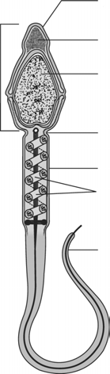
Nucleus containing chromosomal material

Neck

Middle piece Mitochondria
(energy source for swimming)

Tail

Solutions of Assignment (Set-1) Human Reproduction 21

- Why meiosis-I and meiosis-II show unequal division of cytoplasm in oogenesis?
Sol. In oogenesis, primary oocyte within the tertiary follicle grows in size and completes its first meiotic division. It is unequal division of cytoplasm resulting in the formation of a large haploid secondary oocyte and a tiny first polar body. Secondary oocyte retains the bulk of nutrient-rich cytoplasm of primary oocyte. Similarly, meiosis-II also involves unequal division of cytoplasm, so that all the nutrient-rich cytoplasm enter one large cell ovum, required for the development of early embryo. Polar bodies degenerate.
- Menstruation only occurs if the released ovum is not fertilised. Why?
Sol. If fertilisation takes place corpus luteum is retained in the ovary. It secretes large amounts of progesterone hormone which is essential for the maintenance of endometrium. In absence of fertilisation corpus luteum degenerates. This causes abrupt decline in progesterone hormone; causing disintegration of endometrium leading to menstruation.
- What induces the completion of meiotic division in secondary oocyte? Name the resultant cells formed.
Sol. The entry of sperm into the cytoplasm of ovum through zona pellucida and the plasma membrane induces the completion of meiotic division of secondary oocyte.
The second meiotic division is also unequal results in the formation of a second polar body and a haploid ovum.
- What is umbilical cord? Mention its function.
Sol. Umbilical cord connects the placenta to the embryo. It helps in transport of substances to and from the embryo.
Short Answer Type Questions :
- What are the major features of the embryonic development at various months of pregnancy?
  - After first month
  - By the end of 1st trimester
  - During 5th month
Sol. (a) In human beings, after one month of pregnancy, the embryo’s heart is formed. The first sign of growing foetus may be noticed by listening to the heart sound carefully through stethoscope.
- By the end of first trimester, most of the major organ systems are formed. For example, the limbs and external genitalia are well-developed.
- The first movements of the foetus and appearance of hair on the head are usually observed in the fifth month.
- Parturition is induced by a complex neuroendocrine mechanism. Explain.
Sol. Parturition is both under neural control and endocrine control. The signals for parturition originate from developed foetus and placenta which secrete C-RH (corticotropin-releasing hormone), this induces mild uterine contractions called as foetal ejection reflex. This triggers the release of oxytocin from maternal pituitary. Oxytocin acts on uterine muscles (myometrium) and causes stronger uterine contractions. This leads to the expulsion of baby out of uterus through birth canal called parturition.
- Draw a well-labelled diagram of female reproductive system.
Sol.
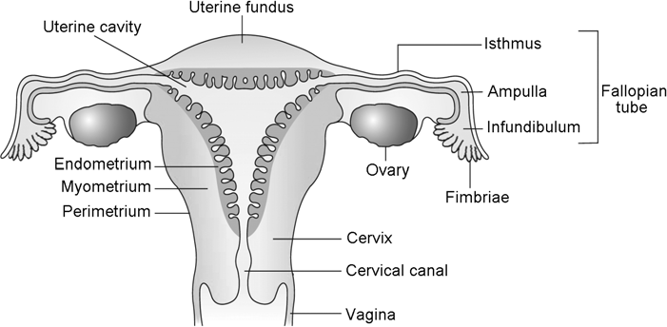

22 Human Reproduction Solutions of Assignment (Set-1)

- State the functions of FSH and LH hormones during menstrual cycle.
Sol. The secretion of gonadotropins (LH and FSH) increases gradually during the follicular phase, and stimulates follicular development as well as secretion of estrogens by the growing follicles. Both LH and FSH attain a peak level in the middle of the cycle (14th day). Rapid secretion of LH leading to its maximum level during the mid-cycle called LH surge induces rupture of Graafian follicle and release of ovum. LH hormone also stimulates the formation and maintenance of corpus luteum. It stimulates corpus luteum to produce progesterone and estrogen.
- Draw a well-labelled diagram of ovum showing (a) zona pellucida (b) corona radiata (c) perivitelline space.

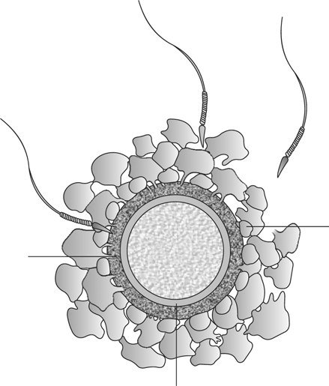Sol.

Sperm

Zone pellucida Ovum
Cells of the corona radiata

Perivitelline space

- State when spermatogenesis starts in human male. Explain the role of hypothalamic hormones and gonadotropin in regulation of spermatogenesis.
Sol. Spermatogenesis starts at the age of puberty due to significant increase in the secretion of gonadotropin- releasing hormone (Gn-RH). This is the hypothalamic hormone. The increased levels of Gn-RH then acts at the anterior pituitary gland and stimulates secretion of two gonadotropins – luteinising hormone (LH) and follicle- stimulating hormone (FSH). LH acts at the Leydig cells and stimulates synthesis and secretion of androgens. Androgens, in turn, stimulate the process of spermatogenesis. FSH acts on the Sertoli cells and stimulates secretion of some factors which help in the process of spermiogenesis.

Long Answer Type Questions :
- (a) Show diagrammatically stages of embryonic development from zygote to implantation in humans as the embryo moves through the fallopian tube.
- State where fertilisation takes place.
- Draw enlarged diagrams of morula and blastocyst and label them. State the function of cells of inner mass.

Solutions of Assignment (Set-1) Human Reproduction 23

Sol.

A B C D (Morula) E

Cells of inner mass
Blastocyst Implantation

F (Blastocyst) G

Trophoblast

- Zygote is B
Cleavage : C is 2-celled stage; D is 4-celled stage; E and F are morula with zona pellucida. Embryo with 8-16 blastomeres is called morula.
G is blastocyst with trophoblast and cells of inner mass. H is implantation of blastocyst.
- Fertilisation occurs in fallopian tubes in ampullary-isthmic junction.
- Cells of inner mass take part in the formation of embryo proper.
- (a) With the help of schematic labelled diagrams trace the development of mature spermatozoa and ovum in human beings.
(b) State the differences between meiosis-I and meiosis-II of spermatogenesis and oogenesis.

Sol. (a)

Spermatogonia
Mitosis differentiation

Primary spermatocytes
st
- meiotic
division

Secondary spermatocytes
nd
- meiotic
division

Spermatids

At puberty

Fetal life

Birth Childhood Puberty
Chromosomes number per cell
46

23

23

Adult

First polar body
Oogonia

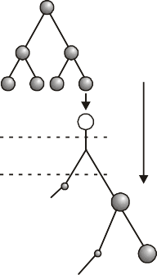Mitosis differentiation

Primary oocyte

st
1 meiotic
division (completed prior to ovulation)

Secondary oocyte

Ovum

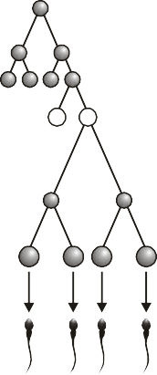
Differentiation

Spermatozoa
reproductive
life Second polar body

24 Human Reproduction Solutions of Assignment (Set-1)

(b) Differences between spermatogenesis and oogenesis

Meiosis-I
- Meiosis-I occurs in the primary Meiosis-I, occurs in primary oocyte spermatocyte leading to the formation of within the tertiary follicle. In this, the two equal, haploid cells called division of cytoplasm is unequal but secondary spermatocytes, which have nucleus is equal, leading to the 23 chromosomes each. formation of a large haploid secondary oocyte and a tiny 1st polar body. The
secondary oocyte retains bulk of nutrient-rich cytoplasm.
Meiosis-II
- Secondary spermatocytes undergo Meiosis-II is also unequal, leading to the meiosis-II to produce four equal, haploid formation of large ovum and 2nd polar spermatids. body.
Oogenesis
Spermatogenesis

❑ ❑ ❑

