PLANT KINGDOM
Whittaker classified the whole living organism into five kingdoms based on the complexity of cell structure
(Prokaryotic and Eukaryotic), complexity of body (unicellular and multicellular) and mode of nutrition
(autotrophs and heterotrophs).
Classification of plant kingdom:
All the classification system, starting from that of Aristotle to the 20th century, can be divided into three types-
Artificial, Natural and Phylogenetic.
• 1. Artificial system: Classification based on few morphological characters.
Theophrastus, Pliny and Linnaeus used artificial system of classification.
• 2. Natural system: Classification based on all the important related characters.
Both external and internal.
Bentham and hooker, Adanson, Candolle used natural system of classification.
• 3. Phylogenetic system: Classification based on evolutionary relationship of plants.
Eichler, Blessy, Whittaker, Engler and Prantl, Hutchinson used phylogeny.
Numerical taxonomy: Taxonomy based on statistical methods with equal importance using computer.
Cytotaxonomy: Taxonomy based on cytology or cell structure (chromosome number, shape, behaviouretc).
Chemotaxonomy: Taxonomy based on chemical constituents of plants (nature of protein, DNA sequence,taste, smell etc).
EICHLERS CLASSIFICATION: Classification of Plant kingdom based on flowering.
Divided into two-Cryptogamae (non flowering, seedless plants) and Phanerogamae (flowering, seed bearing plants).
Based on plant body Cryptogamae divided into Thallophyta, Bryophyta and Pteridophyta.
Thallophyta: Plant body is thallus like (undifferentiated plant body)
Bryophyta: plant body with root like structure, stem like structure, vascular tissues are absent).
Pteridophyta: Plant body is differentiated into true root, stem and leaves. Vascular tissues are present socalledvascular cryptogams.
Thallophytes again divided into
• 1. Algae (pigmented thallophytes)
• 2. Fungi (nonpigmentedthallophytes)
• 3. Lichens: Symbiotic association between algae and fungi.
Phanerogamae divided into two
• 1. Gymonosperma (naked seed plants) and
• 2. Angiosperma (covered seeded plants)
Angiosperms are again divided into two
• 1.Monocots (have single cotyledon, fibrous root system and parallel venation)
• 2. Dicots (have two cotyledons, tap root system and reticulate venation).
Pteridophytes, Gymnosperms and Angiosperms are called Tracheophytes due to the presence of vascular tissue.
Bryophyta, Pteridophyta, Gymnosperms and Angiosperms are called Embryophyta as they have embryo.

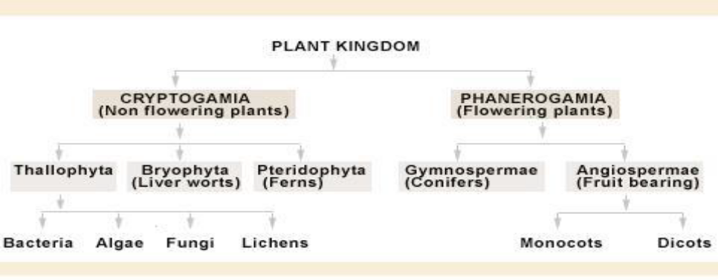

3.1 ALGAE:
Phycology: Branch of Biology which deals with the study of algae
Phycos=sea weed
Logos=study
Fritch –Father of phycology.
M.O.P.Iyengar is the father of Indian phycology.
Algal members are pigmented thallophytes.
Habitat:
Hydrophytes: Water is their habitat
Xerophytes: In desert habitat
Mesophytes- in medium habitat
Epiphytes-on plants
Lithophytes- on rocks
Halophytes- in salty areas.
In aquatic habitat-fresh water (Spirogyra) and marine (Sargassum).
Floating- Chlamydomonas, Spirogyra
Benthophytes - (attached to the bottom) –Chara(stone worts)
Epiphyte-growing on plant body (Cladophora)
Epizoic-growing on animal body (Trichophillus)
Moist soil-terrestrials (Fritschiella).
Plant body:
The vegetative plant body is a haploid gametophyte.
Unicellular, flagellated (Chlamydomonas) or non-flagellated (Chlorella)
Multicellular:
a) Coenobium-a colony with fixed number of cells and division of labour. Eg: Volvox
b) Aggregation-indefinite colony. Eg: Tetraspora
c) Filamentous-unbranched .Eg: Ulothrix
d) Filamentous branched. Eg: Cladophora
e) Siphonous- multinucleate. Eg: Vaucheria
f) Parenchymatous. Eg: Ulva
g) Branched like higher plants. Eg: Sargassum, Chara

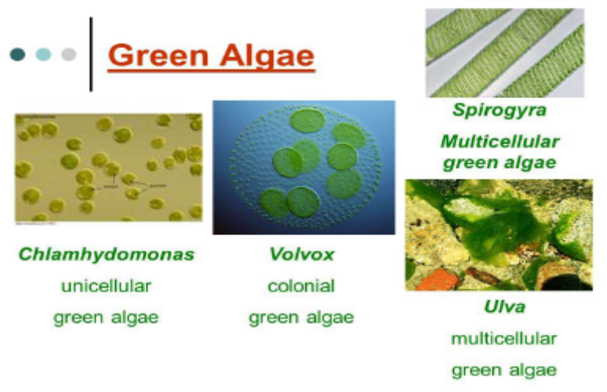
Nutrition:
Autotrophs - Photosynthetic (most of them)
Parasitic forms (rare). Eg: Cephaleuros.
Pigments:
• 1. Chlorophyll- a, b, c, d.
• 2. Carotenoids- carotene and xanthophyll-fucoxanthin (dominating pigment in brown algae).
• 3. Phycobillins- phycocyanin and phycoerythrin.
Reproduction:
Vegetative reproduction- Reproduction using the vegetative parts.
Different types are
• Fission
• Fragmentation
• Budding
• Tubers
• Gemmae.
Asexual reproduction-without the fusion of gametes.
Mainly by:
• Zoospores within sporangia
• Aplanospores
• Akinete
• Hypnospores
• Endospore
• Exospore
• Monospore
• Auxospore.
Palmella stage-spores become colonial and appear like the algae named Palmella.
Eg: Ulothrix, Chlamydomonas.
Sexual reproduction:
Homogametes-similar gametes
Heterogametes-dissimilar gametes
• Isogamy: fusion of morphologically and physiologically similar gametes.
Isogamy- flagellated (Chlamydomonas) and nonflagellated (Spirogyra).
• Anisogamy: fusion of morphologically or physiologically dissimilar gametes.
Morphologically dissimilar–eg: Chlamydomonas
Physiologically dissimilar –eg: Spirogyra.
• Oogamy- fusion of morphologically and physiologically dissimilar gametes.
Small motile male gamete + large nonmotile female gamete.
Eg: Fucus, Volvox.

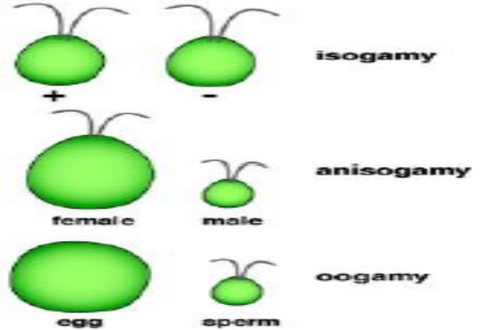

Exceptional cases:
Unicellular antheridium and oogonium .Eg: Oedogonium.
Special reproductive structures:
Conceptacles –Eg: Sargassum
Globule (antheridium) and nucule (oogonium) Eg: Chara
Spirogyra has a special type of sexual reproduction called conjugation.
The life cycle has two phases-haploid and diploid and some of them exhibit alternation of generation. The haploid phase alternates with the diploid phase.
Classification of algae:
They are classified into three-
• Chlorophyceae
• Phaeophyceae
• Rhodohyceae.
3.1.1 CHLOROPHYCEAE:
The plant body is unicellular as in Chlamydomonasor colonial as in Volvoxor filamentous as in Spirogyra.
Different shapes for the chloroplast-
• Ribbon shaped and spiral in Spirogyra
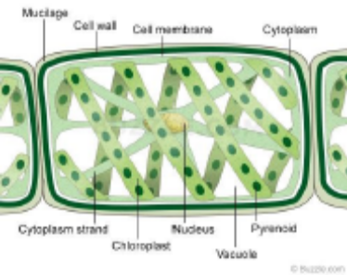

Girdle shaped in Ulothrix
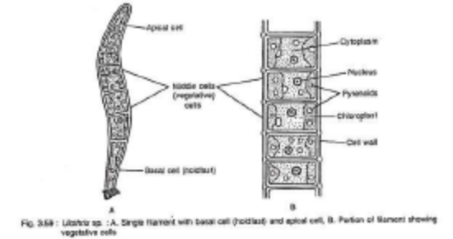

• Cup shaped chloroplast in Chlamydomonas

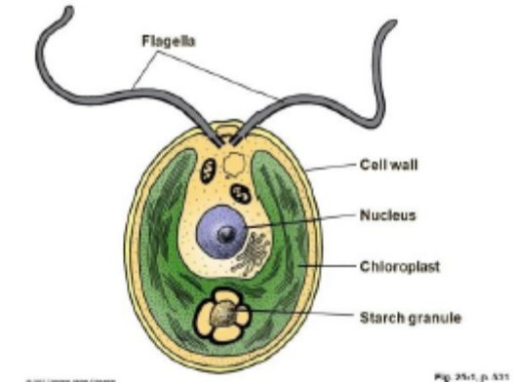

• Star shaped in Zygnema

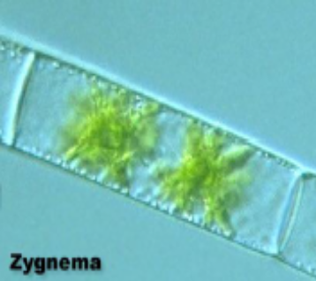

• Disc shaped in Caulerpa
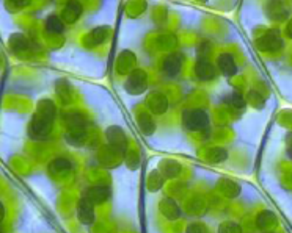
• Reticulate in Oedogonium.
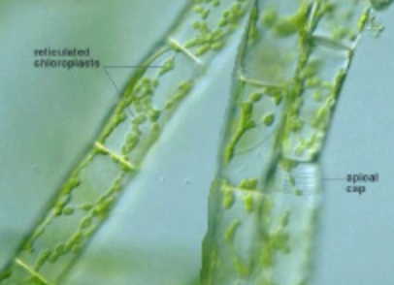

Photosynthetic pigments are chlorophyll a and b.
Store food in the form of starch and some store in the form of oil droplets.
Pyrenoids which are the storage bodies are present.
Cell wall is made up of an inner layer of cellulose and an outer layer of pectose.
The members reproduce
• Vegetatively by fragmentation
• Asexually by flagellated zoospores
• Sexually by isogamy, anisogamy and oogamy.
Common Chlorophycean members are
Chlamydomonas, Chlorella, Volvox, Ulothrix, Ulva, Caulrepa, Chara, Acetabulariaetc.

3.1.2 Brown algae or Phaeophyceae:

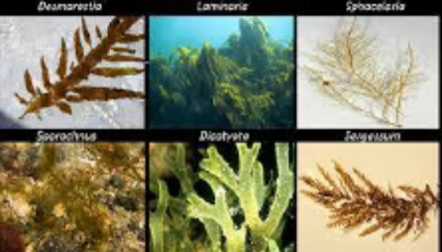
They are marine.Simple, branched and filamentous as in Ectocarpus, or flat ribbon shaped in Sargassum, Laminaria, Fucusetc.
Kelps which are the giant brown algae are the largest sea plants, some are free floating as in Sargassumand some are epiphytes on other plants like Ectocarpus.

Plant body has three parts-
• fixing structures called hold fast
• stalk like structure called stipe
• leaf like structure called frond.

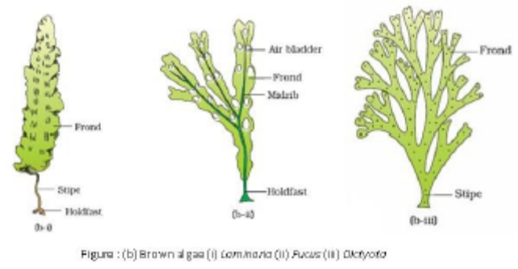

Pigments are chlorophyll a, c, carotenoids and xanthophylls.
Food is stored in the form of laminarin and mannitolwhich are complex carbohydrates.
Cell wall is made up of cellulose and is covered by a gelatinous coating called alginon the outer part which is a phycocolloid (hydrocolloid) and they prevents the thallus from drying in low tide.
Cell consists of cell organelles and centrally is the vacuole which helps the thallus to float.
Vegetative reproduction is by Fragmentation
Asexual by biflagellated zoospores which are pear shaped with two flagella attached laterally.
Sexual reproduction is by the fusion of gametes-
• Isogamy,
• Anisogamy
• Oogamy.
Gametes are pear shaped with 2 laterally attached flagella.
The common brown algae are Ectocarpus, Laminaria,Dictyota, Sargassumand Fucus.

3.1.3 RHODOPHYCEAEA (Red Algae): Commonly called as red algae.
They are mostly marine and rarely fresh water.
Eg: Betrachospermum.
They occur in well lighted region and also in depths of oceans.
The thallus is multicellular.
Pigments present are chlorophyll a, d and phycoerythrin.
Red colour is due to the presence of red pigment called r-phycoerythrin.
Food is stored in the form of floridean starch which is similar to amylopectin and glycogen in structure.
Vegetative reproduction by fragmentation
Asexual by nonmotile spores
Sexual by Oogamy and has complex post fertilization developments.
The common red algae are Polysiphonia, Porphyra, Gracilaria, Gelidium, Betrachospermumetc.

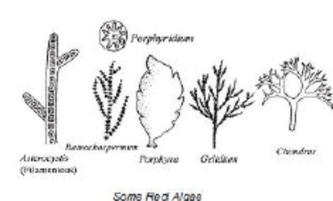

Economic Importance of algae:

• Algae are the primary producers in the food chain. They form the basis of the food cycles of all aquatic
animals.
• Half of the total carbon dioxide fixation on earth is carried out by algae by photosynthesis.
• Helps in purification of air and water.
• Some are edible. Eg- Chlorella, Spirulina, Laminaria, Porphyra, Sargassum, Ulva
• Some are used as fodder. Eg; Laminaria, Sargassum, Fucus.
• Food supplement for space travellers like Chlorella, Spirulina,
• Hydrocolloids or water holding substances like algin and carrageen are obtained from red algae.
• Agar is obtained by Gelidiumand Gracilaria. It is used to grow microorganisms.
• Used in the preparation of culture media in tissue culture experiments.
• Medicinal- Antibiotics. Eg: Chlorella, Polysiphonia.
• Source of minerals- Polysiphonia, Laminaria
• Biological research: Chlorella, Acetabularia.
Common names of algae:
• Water silk-Spirogyra
• Sea lettuce- Ulva
• Umbrella plant-Acetabularia( Largest unicellular algae)

3.2 Bryophytes:
Simplest non vascular land plants with undifferentiated plant body.
Bryology-Study of Bryophyta
Hedwig- Father of bryology
S.R.Kashyap-Father of Indian bryology
Bryophytes are known as the amphibians of the plant kingdom.
Bryophytes grows in dense patches on the moist shady places like walls, damp soil, tree trunks etc.
Features:
Habitat: Mainly terrestrial
Some are aquatic .E.g- Ricciafluitans
Epiphyllous –E.g: Radula
Plant body-Thallus like and Prostrate.
Eg: Riccia, Anthoceros, Marchantiaor
Erect. Eg- Moss.
Root like structures called rhizoids fix them to the soil.
Plant body is differentiated into stem like and leaf like structures.
Vascular tissues are absent.
Vegetative reproduction by fragmentation, budding, tubers etc.
Asexual by Gemmae- asexual buds in liver worts.
Sexual reproduction-The vegetative plant body is the gametophyte and all members are homosporous.

Multicellular sex organs present and are found in clusters.
Male reproductive organs is the club shaped antheridium and the female part is the flask shaped archegonium.
Anthredium produce biflagellatedantherozoids which are motile and archegonium produce the egg.
Antherozoid fuses with the egg to form the zygote.
The sporophyte is not free living and it derives nourishment from the photosynthetic gametophyte.
Haploid spores are formed in the sporophyte after meiosis and the spore germinates to form the gametophyte.
Alternation of generation present- haploid phase alters with the diploid phase.
Both phases are multicellular.
The dominant photosynthetic free living stage is gametophyte.
The sporophyte is short lived and depends on the gametophyte. Water is essential for fertilization.

Classification of Bryophytes:
3 classes
• 1.Hapticospida (liver worts)
• 2.Anthocerotopsida (Horn worts)
• 3.Bryopsida.(Moss)
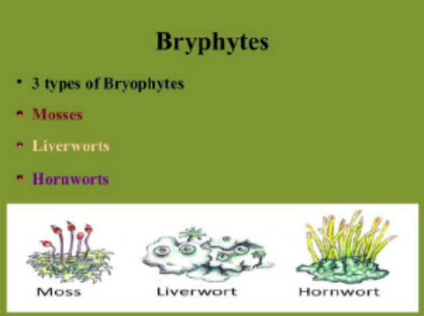

3.2.1 Hepaticopsida or Liver worts: Plant body is photosynthetic, flat, dorsiventralthallus .E.g.: Riccia, Marchantia
The rhizoids help the thallus to get attached to the soil.
Vegetative reproduction is by fragmentation. E.g.: Riccia, Marchantia
In some bryophytes, by the gemmae formation. E.g.: Marchantia
Gemmae are green multicellular, asexual buds which develop into small receptacles called gemma cups.
It gets detached from the parent body and germinate to form the new thallus.
Sexual reproduction: Sex organs are antheridia and archegonia. They are formed either on the same thalli or on different thalli.
Sporophyte is differentiated into three parts-foot, seta and capsule. Meiosis takes place in the capsule to form the haploid spores which germinate into free living thalloid gametophyte.

Antheropsida or Horn worts: E.g.: Anthoceros, Notothylas.

Anthoceros is commonly known as hornworts
They contain pyrenoids
Symbiotic nitrogen fixation is present.

3.2.2 Bryopsida (Moss):

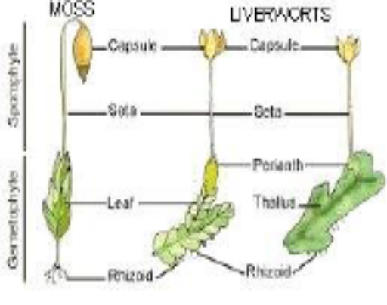

They are higher bryophytes
The gametophyte consist of two stages-protonema and leafy stage.
Protonema are green filamentous, branched, creeping structures directly developed from the spore on
germination and they bears branched rhizoids and lateral buds.
Leafy stage is developed from the secondary protonema as a lateral bud.
Plant body consist of root like, stem like and leaf like structures. Eg: Funaria.
Rhizoids are multicellular and branched. Leafy stages bears the sex organs.
Vegetative reproduction takes place by fragmentation and budding in the secondary protonema.
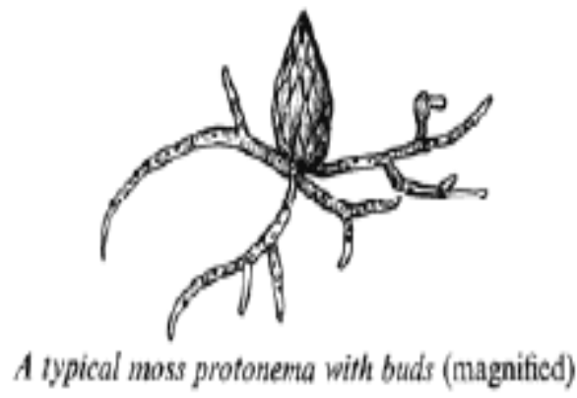

Spore dispersal mechanism is elaborate in mosses.
Eg: Funaria, Polytrichum, Sphagnum etc.

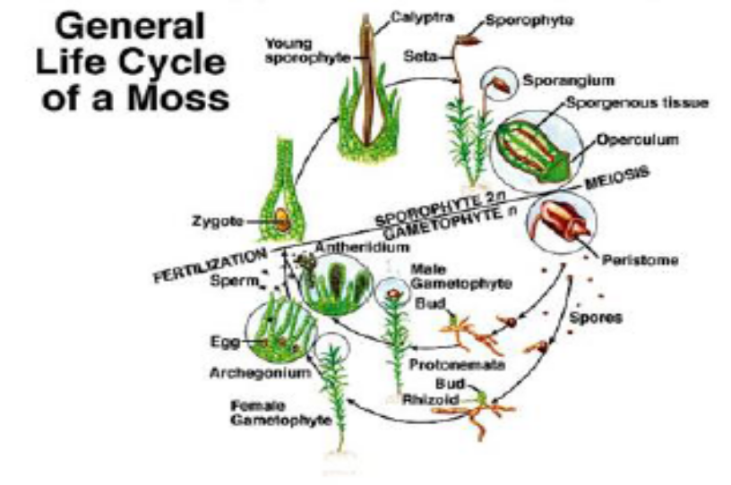

Economic Importance
• They are food for herbaceous animals.
• Sphagnum (Moss) - in form of peat is used as fuel.
• It is also used for trans-shipment of living material because of its water holding capacity
• Prevent soil erosion.
• Along with lichens they are the first colonizers on barren rocks.
• They decompose rocks making substrate for the growth of higher plant (Succession).
3.3 PTERIDOPHYTES:
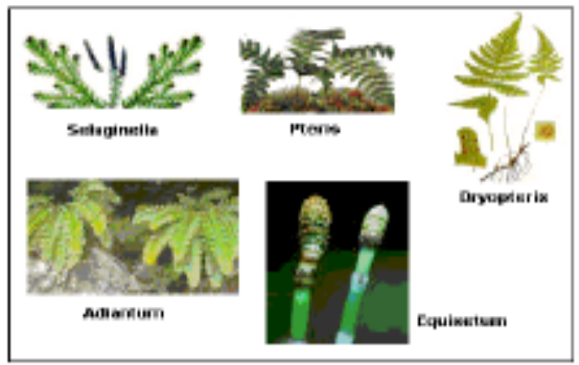

First terrestrial plant possesses vascular tissue like xylem and phloem. So they are known as vascular cryptogams.
Commonly known as botanical snake.
Plant body differentiated into true root, stem and leaf.
Plant body is the sporophytic generation.
Stem is rhizomatous and regenerate when aerial parts are destroyed.
Leaves may be small (microphyll) as in Selaginellaor large (macrophyll) as in ferns
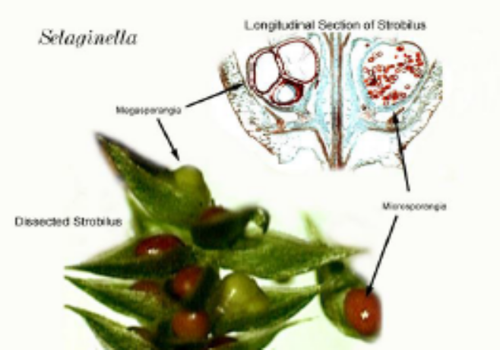
Coiling of youg leaves - Circinate vernation is seen in pteridophytes.

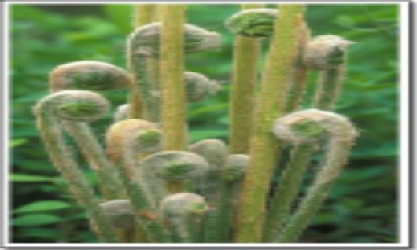

Leaves are of two types vegetative and fertile. Fertile leaves are the spore bearing leaves called sporophylls.
Spores are formed inside the sporangia.
In Sporangia, the spore mother cells give rise to spores after meiosis.
Spores germinate to form haploid gametophytic, photosynthetic heart shaped multicellular structure called prothallus which bears antheridia and archegonia.
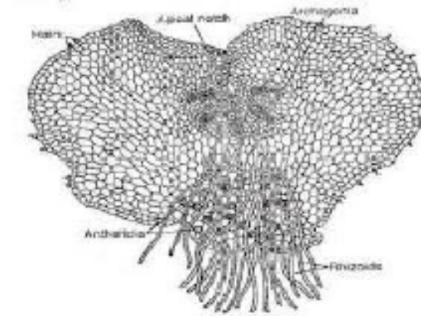
Prothallus requires cool, damp shady areas for growth and water is essential for fertilization.
The antheridia bear antherozoidsand archegonia bears the egg cell respectively which on fertilization form zygote which on germination forms the sporophyte.
Most of pteridophytes produce similar kinds of spores hence called homosporous.
Genera like Selaginellaand Salviniaproduce two kind of spores, macro or large spores and small or microspores and are said to be heterosporous. Microspore and macrospore germinate and gives rise to male and female gametophyte respectively.
In heterosporous condition the female gametophyte is not free living, it is retained in the parent sporophyte till the beginning of the embryo development.
Seed bearing plants are evolved from heterosporouspteridophyte.

Pteridophytes further classified into four classes:
• Psilopsida (Psilotum)
• Lycopsida (Selaginella)
• Sphenopsida (Equisetum )
• Pteropsida (Pteris).
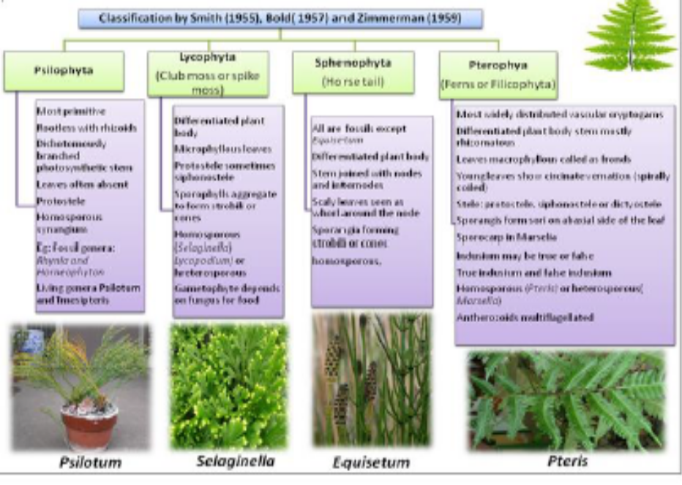

Economic importance:
Some members are Medicinal- Dryopteris
Helps in Soil binding
Used as Ornamental plants
Edible plants- Marcelia
Used in Crop rotation- Azolla
Helps in Symbiotic nitrogen fixation.
Play an important role in plant succession on bare rocks or soil.
Sphagnum is used to keep seedlings in gardens and cut plant parts moist during transportation and propagation.
Common names:
• Creeping pine/Club moss- Lycopodium
• Spike moss(Resurrection plant- Selaginella
• Water fern- Azolla(smallest pteridophyte)
• Walking fern (Maiden hall fern)-Adiantum
• Adder’s tongue fern- Ophioglossum
• Fossil pteridophyte- Cooksonia
• Leafless Pteridophyte- Psilotum
• Horse tail- Equisetum
3.4 GYMNOSPERMS:
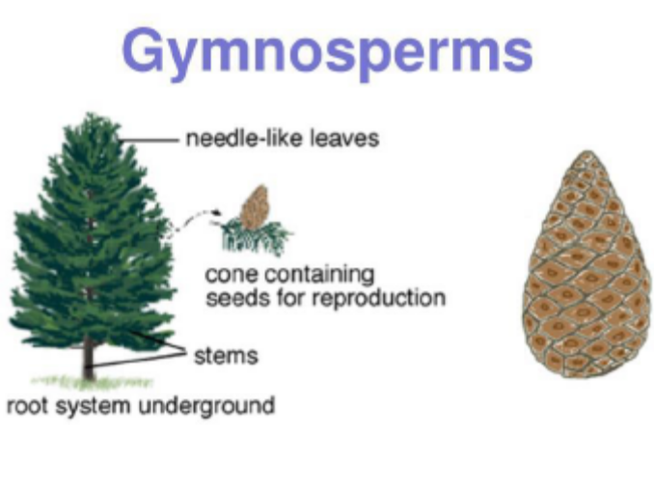
Have naked seeds as the ovules are not enclosed by any ovary wall and remain exposed (no fruit covering).
Flowerless seed bearing plants.
Ovules are not enclosed by ovary wall.
Dominant plants during the Jurassic period.
Gymnosperm includes medium-sized trees or tall trees and shrub.
Tap root system is generally present. May be associated with mycorrhiza-Association between fungus and roots of higher plants.Eg: Pinus.
Coralloid roots with nitrogen fixing bacteria as in Cycas.
Stem is branched (Pinus), or unbranched (Cycas).
Leaves are adapted for extreme temperature, humidity and wind-needle like leaves with thick cuticle, sunken
stomata. Eg: Pinus.
Leaves may be simple or compound.
Stem is unbranched as in Cycas
Branched in Pinusand Cedrus
Well-developed vascular system –xylem without vessels.
REPRODUCTIONS:
Sporophylls are aggregated to form strobuli or cone. They are generally monosporangiate or of two types male and female cones.
Male cones are short lived and female ones are long lived.
Male strobili or male cone – microsporophyllswhich bear microsporangia having microspores which develop into reduced gametophyte called pollen grain.
Female cone or female strobili –megasporophyllswhich bear megasporongiahaving megaspores which are enclosed within the megasporangium(Nucellus).
One megaspore develops into female gametophyte bearing two or more archegonia.
Pollen grains are carried by wind and reach the ovules.
They form pollen tube which reaches the archegonia and release male gametes into the ovule.
Fusion of the gametes takes place and zygote is formed which produce embryos. Ovules develop into seeds which are not covered.
The endosperms in gymnosperms is a prefertilisation product and haploid in nature.
The dominant photosynthetic independent stage is the sporophyte. The gametophyte is single to few celled and not free living.
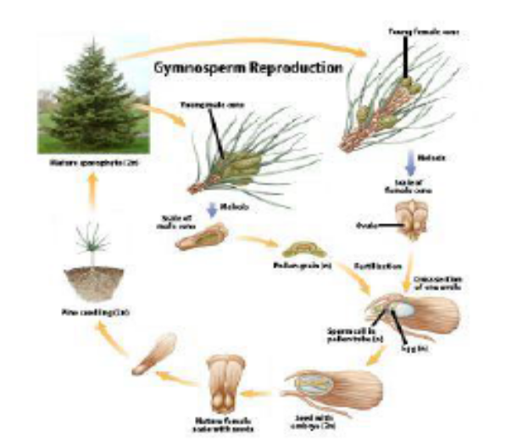

Classified into four classes:
• 1.Cycadopsida Eg: Cycas
• 2. Coniferopsidaeg: Pinus
• 3. Gnetopsida: Eg: Gnetum.
• 4. Gingopsida- Ginko

Economic importance:
Timbers for furniture, Pulp wood, Pencil box, Musical instruments etc.
Production of resins, Turpentine etc.-E.g.-Pinus
Edible seeds: Eg- Cycas, Pinus, Ginkgo.
Medicinal Eg: Ephedrine from Ephedra (used for respiratory problems)
Taxol– from Taxusspecies to freeze cancer cells.
Common names:
Maiden hair tree- Ginkgo
Sago palm /Panda of the plant kingdom- Cycas
Largest gymnosperm- Sequoia
Smallest gymnosperm- Zamia
Gymnosperm with xylem vessels- Ephedra, Gnetum.

3.5 ANGIOSPERMS:
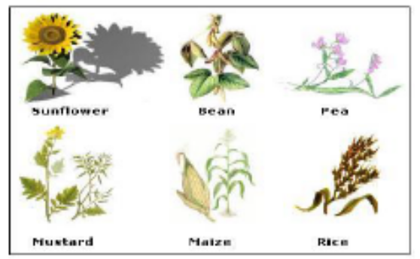

Angiosperms are known as flowering plants and have covered seeds.
They are divided into two classes –
• 1.Dicotyledons (have two cotyledons)
• 2. Monocotyledons (have one cotyledon).
Smallest angiosperm: Wolfia(microscopic).
Large tree: Eucalyptus over 100 meters.
Reproductive organs developed in flowers.
The Male sex organs in a flower are called stamens or androecium.
It has filament and anther. Anthers on meiosis produce pollen grains. Pollen grains have two male gametes.
Female reproductive part is the pistil or gynoecium. It has stigma, style and ovary.
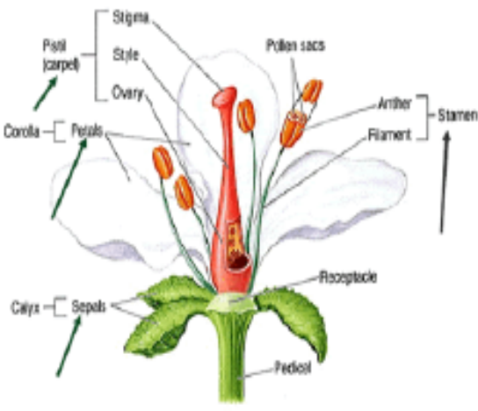

Ovary has one or many ovule in which female gametophyte (embryo sac) develops by meiosis.
Embryo sac has 7 cells and 8 nuclei.
• 1 egg cell
• 2 synergids
• 3 antipodal
• One central cell having two polar nuclei.
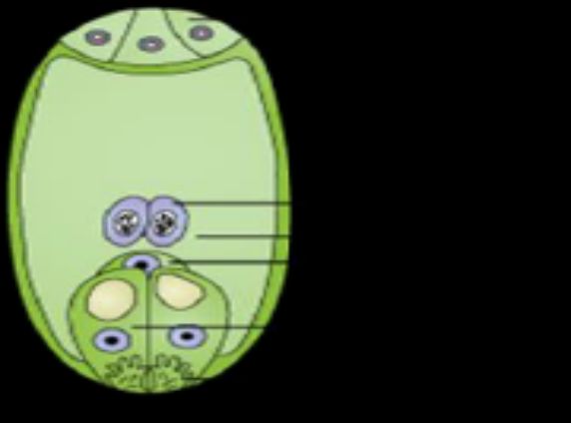
Pollen grain are carried by various agents like wind, water, birds, insects etc. and reaches the stigma.
Pollen grains produces pollen tube which contains two male gametes and enters into the embryo sac.
One male gamete fuses with egg cell to form zygote and is called syngamywhich develops into embryo.
Other male gamete fuses with secondary nucleus (formed by fusion of two polar nuclei) which forms triploid primary endosperm nucleus (PEN) and is called triple fusion. PEN develops into endosperm which nourishes the developing embryo. As two fertilization (syngamy and triple fusion) takes place inside the embryo sac at the same time, it is called double fertilization.
Endosperm is triploid. Ovules develop into seeds and ovaries into fruits.
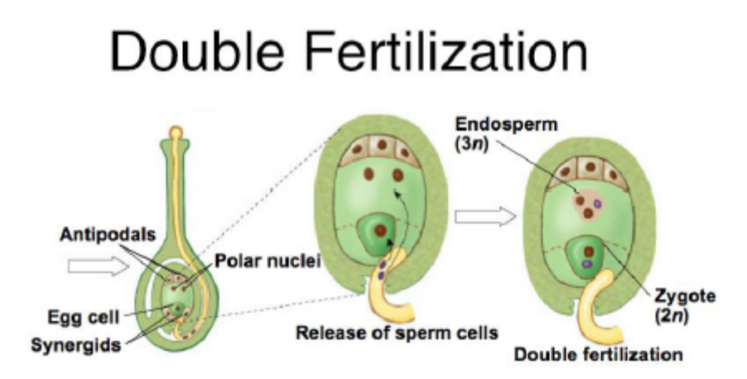

LIFE CYCLE OF ANGIOSPERMS
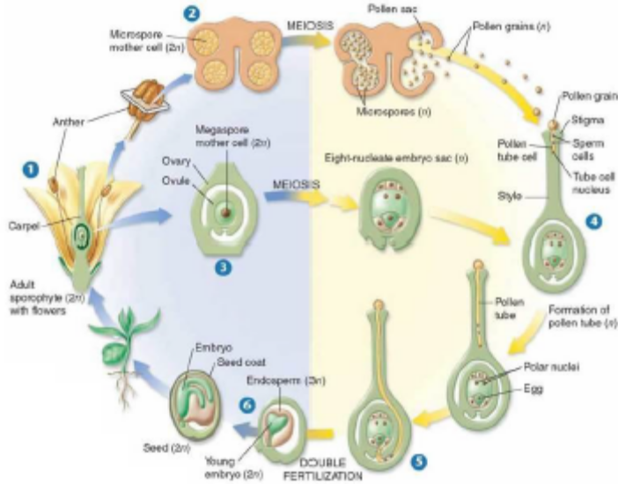

3.6 Alternation of generation: There is an alternation of a haploid gamete producing gametophytic and spore producing sporophytic generation.
Three types-
- Haplontic life cycle: In this type the dominant, photosynthetic phase is a free living gametophyte produced by haploid spores. The gametophyte produces gametes by mitosis and the gametes fuse to form the zygote which represents the sporophytic generation. Zygote undergoes meiosis to form haploid spores. Here the Gametophytic phase is dominant. e.g.,Chlamydomonas.

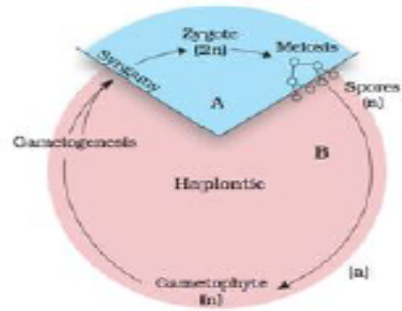
2. Diplontic life cycle: Here the diploid sporophyte is the dominant photosynthetic independent phase of the plant. The gametophyic phase is represented by one to few celled haploid gametophyte.Heresporophytic phase is dominant.
e.g., Angiosperms and Gymnosperms.
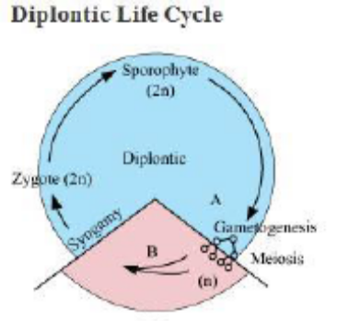

3. Haplo-Diplontic life cycle: In this type both haploid and diploid phases are multicellular and often free living. Seen in bryophytes and pteridophytes.Although most algal genera show haplontic life cycle, some of them such as Ectocarpus, Polysiphonia, Kelps,
etc. exhibit haplo-diplontic life cycle. Fucusa brown alga exhibits diplontic life cycle.

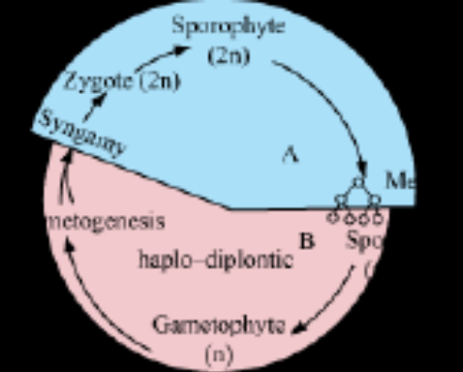

FAST TRACK REVISION:
1. Plant Kingdom Divided into two-Cryptogamae (non flowering seedless plants) and Phanerogamae
(flowering, seed bearing plants).
2. Based on plant body Cryptogamae divided into Thallophyta, Bryophyta and Pteridophyta.
3. Thallophytes again divided into
• 1.Algae (pigmented thallophytes)
• 2. Fungi (nonpigmentedthallophytes)
• 3. Lichens: Symbiotic association between algae and fungi.
• 4. Phanerogamae divided into two
• 1. Gymonosperma (naked seed plants) and
• 2. Angiosperma( covered seeded plants)
4. Angiosperms are again divided into two
• 1.Monocots (have single cotyledon, fibrous root system and parallel venation)
• 2. Dicots (have two cotyledons, tap root system and reticulate venation).
6. Algae are simple, thalloid, autotrophic and largely aquatic organisms.
7. Depending on the type of pigment possessed and the type of stored food, algae are classified into three
classes namely Chlorophyceae, Phaeophyceae, and Rhodophyceae.
8. Vegetative reproduction- fragmentation, asexual - formation of different types of spores and sexually by
the formation of gametes which show isogamy, anisogamy and oogamy.
9. Bryophytes are plants which can live in soil but are dependent on water for sexual reproduction. Their plant
body is more differentiated than that of algae.
10. Thallus like plant body, prostrate or erect, and fixing structures are called rhizoids. They possess root like,
leaf like, and stem like structures.
11. The bryophytes are divided into liver worts, hornworts and mosses.
12. Liverworts have thalloid plant body and dorsiventral.
13. Mosses have upright and slender axis bearing spirally arranged leaves.
14. The plant body is a gametophyte and after fusion of the gametes the zygote produce a multicellular body
called the sporophyte.
15. In pteridophytes, plant body is a sporophyte with root, stem and leaves.
16. The sporophyte in Pteridophyte bear sporangia which produce spores which on germination form
gametophyte.
17. Gametophyte in Pteridophyte bears male and female sex organs called antheridia and archegonia.
18. Water is needed for fertilization.
19. The gymnosperms are the plants which produce naked seeds. After fertilization the seed remains exposed.
20. Gymnosperms produce microsporophyll and megasporophyll. Microsporangia and Megasporangia are
borne on the sporophylls.
21. Sporophylls-Microsporophyll and megasporophyll.
22. The pollen tube produced by the pollen grain releases the male gamete into the ovule, where it fuses with
the egg cell in archegonia. Following fertilization, the zygote develops into embryo and the ovules into seeds.
23. In angiosperms, the male sex organs or stamen and the female sex organ the pistil are born in a flower.
24. Stamen consists of anther and filament.
25. Pistil contains ovary, style and stigma.
26. The pollen grain produces two male gametes. One male gamete fuses with the egg and is called syngamy
and forms zygote which develops to form the embryo.
27. The other male gamete fuses with the polar nuclei and is called triple fusion and forms the primary
endosperm nucleus which develops to form the endosperm which gives nourishment for the developing
embryo.
28. As two fertilization are taking place inside the embryo sac at the same time –syngamy and triple fusion, it
is called double fertilization.
29. Angiosperms are divided into two classes-Monocotyledons and Dicotyledons.

MULTIPLE CHOICE QUESTIONS:
- The pyrenoids are made up of:
- Proteinaceous centre and a starchy sheath
- Core of protein surrounded by fatty sheath
- Core of starch surrounded by sheath of protein
- Core of nucleic acid surrounded by protein sheath.
Ans. i
- Cosider the following features:
- Chlorophyll a and c
- Fucoxanthin
- Floridean starch
- Flagella 2 in number unequal and lateral
Which of these is seen in Phaeophyceae?
- I,II,III
- I,II,IV
- II,III,IV
- I,II,III,IV
Ans: ii
- The endosperm of a gymnosperm develops ______ fertilization, whereas the endosperm of an angiosperm develops _________ fertilization.
- Before, before
- After, after
- After, before
- Before after
Ans: iv
- In Pinus,
- The stem is branched
- The roots have fungal association in the form of mycorrhiza
- The male and female strobili are formed on different trees.
Of the above statements:
- Only I is correct
- Only II is correct
- Only I and II are correct
- Only I,II and III are correct.
Ans: iii.
- Identify the incorrect statement:
- The earliest system of classification used only gross superficial morphological characters.
- Linnaeus classification of plants was a natural classification as it was based on androecium structure.
- Artificial systems gave equal weightage to vegetative and sexual characteristics.
- Natural classification systems are based on natural affinities among the organisms.
Ans: ii
- Match each term with its definition and choose your answer from the codes given:
I | Isogamy | 1 | The union of two gametes
II | Syngamy | 2 | Two gametes, one larger than the other
III | Heterogamy | 3 | Two kinds of gametes. One motile and the other non motile.
IV | Anisogamy | 4 | Two kind of morphologically distinct gametes.
V | Oogamy | 5 | Both gametes morphologically indistinguishable
Codes:
 | I | II | III | IV | V
i | 1 | 2 | 3 | 4 | 5
ii | 4 | 1 | 2 | 3 | 5
iii | 5 | 1 | 2 | 4 | 3
iv. | 3 | 1 | 2 | 4 | 5

Ans: iii
- Identify the incorrectly matched pairs:
i | Chalmydomonas | Microscopic unicellular algae
ii | Volvox | Colonial algae
iii | Ulothrix | Filamentous algae
iv | Fucus | Isogamous algae
Ans: iv
8. Cyanobacteria are classified under
a. Protista
b. Plantae
c. Monera
d. Algae
9. Fusion of two gametes which are dissimilar in size is termed as
a. Oogamy
b. Isogamy
c. Anisogamy
d. Zoogamy
10. Holdfast, stipe and frond constitutes the plant body in case of
a. Rhodophyceae
b. Chlorophyceae
c. Phaeophyceae
d. All of the above
11. . A plant shows thallus level of organization. It shows rhizoids and is haploid. It needs water to complete its life cycle because the male gametes are motile. Identify the group to which it belongs to
a. Pteridophytes
b. Gymnosperms
c. Monocots
d. Bryophytes
12. A Prothallus is
a. A structure in pteridophytes formed before the thallus develops
b. A sporophytic free living structure formed in pteridophytes
c. A gametophyte free living structure formed in pteridophytes
d. A primitive structure formed after fertilization in pteridophytes
13. Plants of this group are diploid and well adapted to extreme conditions. They grow bearing sporophylls in compact structures called cones. The group in reference is
a. Monocots
b. Dicots
c. Pteridophytes
d. Gymnosperms
14. The embryo sac of an Angiosperm is made up of
a. 8 cells
b. 7 cells and 8 nuclei
c. 8 nuclei
d. 7 cells and 7 nuclei
15. Mannitol is the reserve food material of which group of algae
a. Chlorophyceae
b. Phaeophyceae
c. Rhodophyceae
d. None of the above

16. If the diploid number of a flowering plant is 36. What would be the chromosome number in its endosperm
a. 36
b. 18
c. 54
d. 72
17. Protonema is
a. Haploid and is found in mosses
b. Diploid and is found in liverworts
c. Diploid and is found in pteridophytes
d. Haploid and is found in pteridophytes
18. The giant Redwood tree (Sequoia sempervirens) is a/an
a. Angiosperm
b. Free fern
c. Pteridophyte
d. Gymnosperm

19. Food is stored as Floridean starch in
a. Rhodophyceae
b. Phaeophyceae
c. Chlorophyceae
d. None of the above

20. An example of plants with Haplontic life cycle is :
a. Mango plant
b. Volvox
c. Fucus
d. Kelps
21. An example of plants with Diplontic life cycle is
a. Ectocarpus
b. Chlamydomonas
c. Pinus
d. Spirogyra
22. An example of plants with Haplo- diplontic life cycle is
a. Wolfia
b. Eucalyptus
c. Cycas
d. Sphagnum
23. The plant body in higher plants is well differentiated and well developed. Roots are the organs used for the purpose of absorption. The equivalent of roots in the less developed lower plants is :
a. Rhizoids
b. Root hairs
c. Thalus
d. Lenticles
24. Most algal genera show haplontic life style. An example of Haplo-diplontic alga is
a. Volox
b. Ulothrix
c. Laminaria
d. Polysiphonia.
25. An alga having diplontic life cycle is
a. Fucus
b . Porphyra
c. Dictyota
d. Eudorina
26. In Bryophytes male and female sex organs are called ____________ and __________.
a. Antheridium, Archegonium
b. Penis, Testis
c. Microsporangium, Megasporangium
d. Stamen, Pistil
27 . Which of these are called the amphibians of the plant kingdom :
a. Angiosperms
b. Bryophytes
c. Gymnosperms
d. Pteridophytes
28. Formation of two types of spores – microspores and megaspores is a characteristic feature in the life cycle of a few members of pteridophytes and all spermatophytes. On the basis of this what are these plants called :
a. Homosporous
b. Heterosporous
c. Monoecious
d. Dioecious
29. In which plant will you look for mycorrhiza and corolloid roots :
a. Gymnosperms
b. Chlorophyceae
c. Angiosperms
d. Pteridophytes
30. Gametophyte is a dominant phase in the life cycle of a bryophyte, hence they are described as :
a. Haplo-diplontic plants having a gametophyte-dependent multicellular sporophyte
b. Haplo-diplontic plants having a sporophyte-dependent multicellular gametophyte
c. Haplontic plants having a dominant gametophyte
d. Diplontic plants having a dominant gametophyte
31. Lichen is usually cited as an example of ‘symbiosis’ in plants where an algal and a fungal species live together for their mutual benefit. Which of the following will happen if algal and fungal partners are separated from each other?
a. Both will survive and grow normally and independent from each other.
b. Both will die
c. Algal component will survive while the fungal component will die.
d. Fungal component will survive while algal partner will die.
32 Which system of classification were given by Carolus Linnaeus
Answer : artificial system

33. Which characteristics were considered in the artificial system of classification
Answer : only superficial morphological characteristics , vegetative characters etc .

34. The system of classification based on evolutionary relationships between different organisms is
Answer : Phylogenetic Classification systems

35. The algae which forms colonies , is :
Answer :volvox

36. Name the alga which are present in filamentous forms
Answer : Spirogyra & Ulothrix

37. The algae which can grow up to 100 m in length
Answer : Kelps

38. Algae reproduce vegetatively by _____ and asexually by ______
Answer: Fragmentation & Producing spores

39. The most common type of spores that algae produce are
Answer : Zoospores

40. Spores which are flagellated(moving/motile) and produce new plant on germinating are
Answer : zoospores

41. Example of alga having flagellated gametes and isogamous reproduction
Answer : Ulothrix

46. An alga having non flagellated gametes and isogamous reproduction
Answer : Spirogyra

47. An alga showing anisogamous reproduction is
Answer : Eudorina

48. Volvox shows which type of sexual reproduction
Answer : Oogamous.

49. An alga which shows branch like structures
Answer : Polysiphonia

50. Alga produce large amounts of hydrocolloids , give an example
Answer : Algin( brown algae) and Carrageen(red algae)

51. Agar , a product used in preparation of ice cream and jellies is obtained from
Answer : Gelidium and Gracilaria

52. An alga used by space travellers for protien supplement
Answer : Chlorella

53. The different shapes of chloroplasts in green algae are
Answer : Discoid , plate like , reticulate , cup shaped , spiral or ribbon shaped

54. The storage body located in a chloroplast is
Answer : Pyrenoid

55. Zoospores are produced in special structures called as
Answer : Zoosporangia

56. A branched , filamentous form of phaeophyceae
Answer : Ectocarpus

57. The pigments present in Chlorophyceae are
Answer : Chlorophyll a and Chlorophyll b

58. The pigments present in Rhodophyceae
Answer : r-phycoerethrin, Chlorophyll a and Chlorophyll b

59. The pigments present in Phaeophyceae
Answer : Chlorophyll a , Chlorophyll C , Fucoxanthin

60. The plant body (in alga) is attached to the substratum by
Answer : Holdfast

61. What are pear shaped gametes present in brown algae called
Answer : Pyriform

62. The main plant body in bryophytes is ____ and is called as _____
Answer : Haploid & Gametophyte
63. The zygote of a bryophyte produces a multicellular body called as
Answer : Sporophyte

64. A bryophyte ( moss ) provides peat , which is a fuel and a trans shipment packaging material
Answer : Sphagnum

65. Mosses along with ____ colonise rocks
Answer : Lichens
z
66. ____ decompose rocks making the substrate suitable for growth of higher plants
Answer : Missed

67. Mosses prevent soil erosion and reduce the impact of falling rain by
Answer : Forming dense mats on the soil

68. The thallus in liverworts is____ and closely _____ to the substrate.
Answer : Dorsiventral & pressed

69. Asexual reproduction in liverworts takes place by
Answer : Fragmentation and Gemma formation

70. The Sporophyte in liverworts is differentiated into :
Answer : Foot , Seta and Capsule

71. The Gametophyte in mosses consists of two stages name them
Answer : Protone (1st) and Leafy stage (2nd)

72. The first terrestrial plants to have vascular tissues
Answer : Pteridophytes

73. Define gemma.
Ans. Gemma are green, multicellular, asexual buds which develop in receptacles called as
gemma cups.
74. Which group of plants is regarded a first lerrestrial plank ? Why?
Ans. Pteridophytes. As they possess vascular tissues – xylem and phloem.
75. The gametes and spores of phaeophyceae have a distinct morphology. Give its name.
Ans. Pyriform (pear-shaped). Bear two laterally attached flagella.
76. Which substance has ,structural similarity to floridean starch ?
Ans. Amylo pectin and glycogen.
77. Name the organisms which exhibit heterospory and seed habit.
Ans. Selaginelia and Salvinia.
77.Name seedless vascular plants.
Ans. Pteridophytes.
78. Which pigment is responsible for red colour of red algae?
Ans. Phycobilin, phycoerythrin & phycocyanin.
79. What is a cone?
Ans. The fruiting body of gymnosperms which consists of micro & megasporophyll are called
as cone.
80. Name a unicellular algae.
Ans. Chlamydomonas
81.Why some bryophytes are called liverworts.
Ans. Some bryophytes are called liverworts as they are liver shaped eg. marchantia.
82.What are rhizoids?
Ans. Rhizoids are slender, unicellular or multicellular hair like structure, which penetrate in
the moist soil & absorb the water for plants.
83.Name the algae which is used for fodder to poultry birds.
Ans. Laminaria.
84.Which groups of plants is called vascular cryptogam ?
Ans. Pteridophyta.
85.What is a cone ?
Ans. The fruiting body of gymnosperm which consists of micro & megasporophyll are called
as clone.
86.What are come bearing plants called
Ans. Connifers
87.Name any red algae which is used as vegetables?
Ans. Porphyra
88.What do you mean by thallus?
Ans. It is a plant body which is not differentiated into root, stem & leaves.
89.Name the vascular plants which produces only spores but no flowers or seeds?
Ans. Pteridophytes.
90. Where are the antheridia & archaegonia located in ferns?
Ans. Prothallus
91.What are the two main classes of bryophytes?
Ans. Liverwort & Mosses.

SOME ADDITIONAL QUESTIONS:

Very Short Answer Type Questions
- Food is stored as Floridean starch in Rhodophyceae. Mannitol is the reserve food material of which group of algae?
- Give an example of plants with
  - a. Haplontic life cycle
  - b. Diplontic life cycle
  - c. Haplo- diplontic life cycle
- The plant body in higher plants is well differentiated and well developed. Roots are the organs used for the purpose of absorption. What is the equivalent of roots in the less developed lower plants?
- Most algal genera show haplontic life style. Name an alga which is
  - a. Haplo-diplontic
  - b. Diplontic
- In Bryophytes male and female sex organs are called ____________ and __________.

Short Answer Type Questions
- Why are bryophytes called the amphibians of the plant kingdom?
- The male and female reproductive organs of several pteridophytes and gymnosperms are comparable to floral structures of angiosperms. Make an attempt to compare the various reproductive parts of pteridophytes and gymnosperms with reproductive structures of angiosperms.
- Heterospory i.e., formation of two types of spores – microspores and megaspores is a characteristic feature in the life cycle of a few members of pteridophytes and all spermatophytes. Do you think heterospory has some evolutionary significance in plant kingdom?
- How far does Selaginella one of the few living members of lycopodiales (pteridophytes) fall short of seed habit.
- Each plant or group of plants has some phylogenetic significance in relation to evolution : Cycas, one of the few living members of gymnosperms is called as the ‘relic of past’. Can you establish a phylogenetic relationship of Cycas with any other group of plants that justifies the above statement?
- The heterosporous pteridophytes show certain characteristics, which are precursor to the seed habit in gymnosperms. Explain.
- Comment on the lifecycle and nature of a fern prothallus.
- How are the male and female gametophytes of pteridophytes and gymnosperms different from each other?
- In which plant will you look for mycorrhiza and corolloid roots? Also explain what these terms mean.

Long Answer Type Questions
- Gametophyte is a dominant phase in the life cycle of a bryophyte. Explain.
- With the help of a schematic diagram describe the haplo-diptontic life cycle pattern of a plant group.
- Lichen is usually cited as an example of ‘symbiosis’ in plants where an algal and a fungal species live together for their mutual benefit. Which of the following will happen if algal and fungal partners are separated from each other?
  - a. Both will survive and grow normally and independent from each other.
  - b. Both will die
  - c. Algal component will survive while the fungal component will die.
  - d. Fungal component will survive while algal partner will die.
Based on your answer how do you justify this association as symbiosis.
- Explain why sexual reproduction in angiosperms is said to take place through double fertilization and triple fusion. Also draw a labelled diagram of embryo sac to explain the phenomena.
- Draw labelled diagrams of
  - a. Female and male thallus of a liverwort.
  - b. Gametophyte and sporophyte of Funaria.
  - c. Alternation of generation in Angiosperm.

