CHAPTER-7: EVOLUTION
Evolution: Process that results in heritable changes in a population spread over many generations (change in allele frequencies over time) leading to diversity of organisms on earth. It is the genetic change in a population or species over generations (Genes mutate, individuals are selected, and populations evolve).
Origin of life : 3.5 bya (billion year ago)
Origin of earth : 4.5 bya
Origin of universe : 20 bya.
Big Bang Theory
• Single huge explosion expanded universe. The gases condensed under gravitation and formed the galaxies of the present day universe.
• There was no atmosphere on early earth. Water vapour, methane, carbon-dioxide and ammonia released from molten mass covered the surface.
• The UV rays from the sun broke up water into Hydrogen and Oxygen and the lighter H2 escaped.
• Oxygen combined with ammonia and methane to form water, CO2 and others. The ozone layer was formed.
Theories of origin of Life:
• Theory of Special creation : God or super natural powers created the life.
• Theory of Panspermia / Cosmozoic : Greek thinkers thought units of life called spores were transferred to different planets including earth. ‘Panspermia’ is still a favourite idea for some astronomers.
• Theory of Spontaneous Generation : life has come from decaying matter like straw.
Louis Pasture discarded the spontaneous generation of life by using swan necked flask experiment.
Theory of Chemical Evolution :
• Oparin of Russia and Haldane of England proposed that the first form of life could have come from pre-existing non-living organic molecules (e.g. RNA, protein, etc.) and that formation of life was preceded by chemical evolution.
• The conditions on earth were – high temperature, volcanic storms, reducing atmosphere containing gases like CH₄, NH₃, etc.
• Chemical evolution theory was experimentally proved by S.L. Miller & Urey (1953).
• They created electric discharge in a closed flask containing CH4, H2, NH3 and water-vapour at 8000 C.
• He observed formation of amino acids. In similar experiments others observed formation of sugars, nitrogenous bases, pigment and fats.
• These molecules form single cells which were called co-acervates.
• The first form of life arose slowly through evolutionary forces from non-living molecules.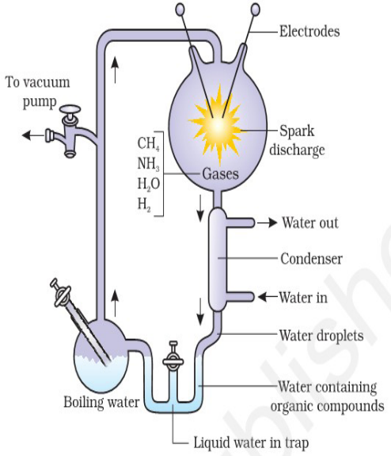
Evolution of Life forms : A Theory
• Charles Darwin travelled around the world by sea in a sail ship called H.M.S. Beagle.
• He observed the gradual evolution of life forms in Galapagos Island and Malay Archipelago.
• All the existing life forms share similarities and share common ancestors present at different periods in the history of earth (epochs, periods and eras).
Evidences for Evolution :
• Palaeontological evidences : Fossils founds in rock and support the evolution. Different-aged rock sediments contain fossils of different life-forms in different sedimentary layers indicates the geological period in which they existed.
• Embryological Evidences :

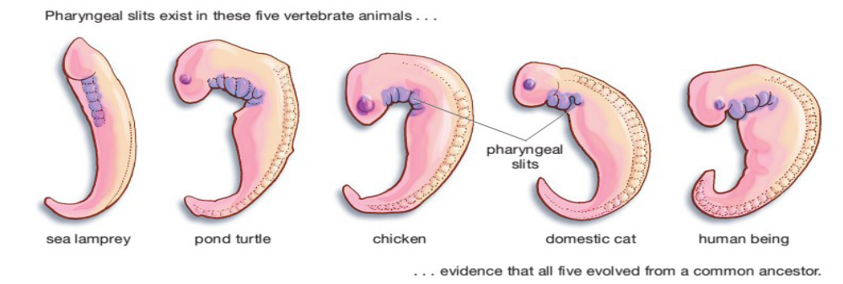•• Ernst Haeckel proposed Biogenetic Law –“Ontogeny recapitulates phylogeny”. It means each individuals repeats their evolutionary history during their embryological development. (Ontogeny– Individual development, Phylogeny – species development)
• The Protonema, an early stage in the development of moss or fern gametophyte, resembles the filamentous green algae in structure, physiology and growth pattern. This suggests an algal ancestry of bryophytes and pteridophytes.
• The gymnosperms have normally become independent of water in fertilisation. However, the primitive gymnosperms such as Cycas and Ginkgo have flagellated sperms and need water for fertilization just like the pteridophytes, their most likely ancestors.
• The seedlings of acacia tree initially develop simple leaves, but the leaves that develop later arecompound.
Molecular evidence in Evolution
• The degree of similarity in the base sequence in their nucleic acids, and amino acid sequence in their proteins are indicated.
• Human DNA differs in only 1.8% of its base pairs from chimpanzee DNA.
• There is no difference between the two in the amino acid sequence for the protein cytochrome C.
• Similarity in the molecular structure of actin and tubulin proteins in all animals point to their common ancestry.
Comparative anatomy & morphology :
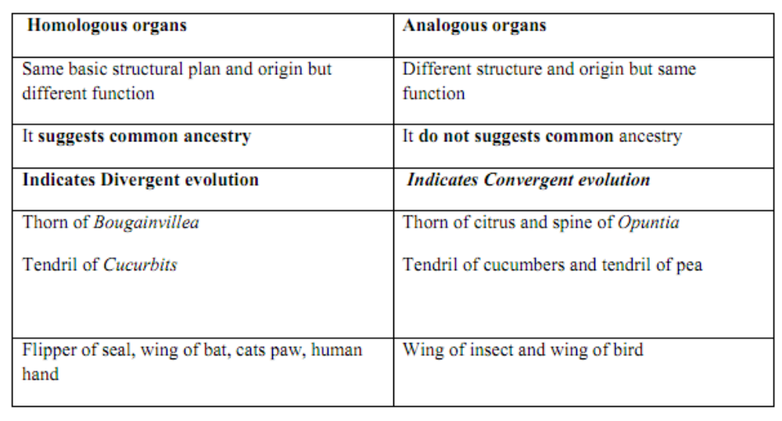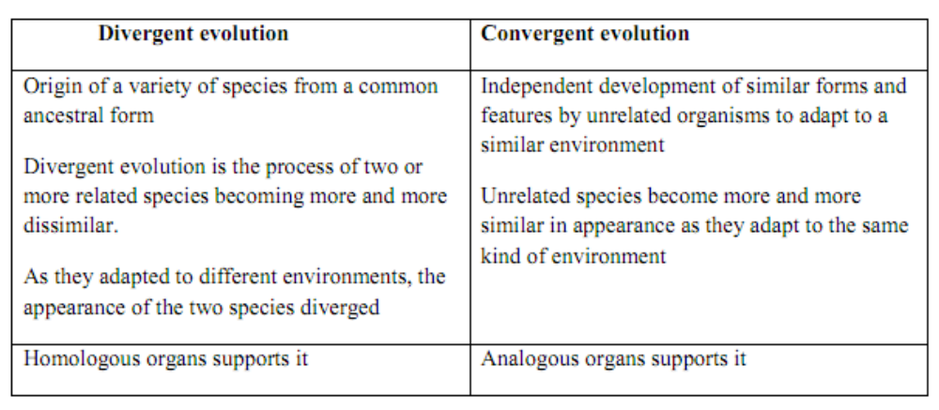
Refer Fig.7.3, page 131 NCERT.
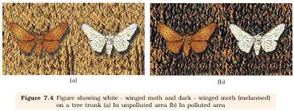

Anthropogenic Action :

Before 1850 | After 1920
• More white winged moth in urban areas  than dark winged or melanised moth.  • No industrialization  • Tree trunk white color  • Predators attack on dark moth than white. | • Less white winged moth in urban areas than dark winged or melanised moth.  • Industrial revolution occur  • Tree trunk colour- dark  • Predators attack on white moth than dark.
Moths are able to camouflage themselves, i.e. hide in the background, survived. This type of evolution is due to anthropogenic action.
- Lichen act as a industrial pollution indicator
• Excess use of herbicides, pesticides, antibiotics etc. develops resistant organisms / cells appearing in a time scale of months or years and not centuries.
Adaptive radiation
The evolutionary process which produces new species from single point origin and spread to other geographical areas (habitat) is called adaptive radiation.
Eg. Darwin finches found in Galapagos Island and Australian Marsupials.
Darwin finches | Australian Marsupials.
Thirteen species of finch evolved on the  Galapagos Islands, all of them descendants of a single species of finch native to South America.They changed their food habit to avoid competition, so their beaks got modified according to their feeding habits like fruit, insect, seed, bark, new leaves, algae etc.  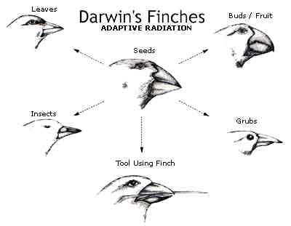 | 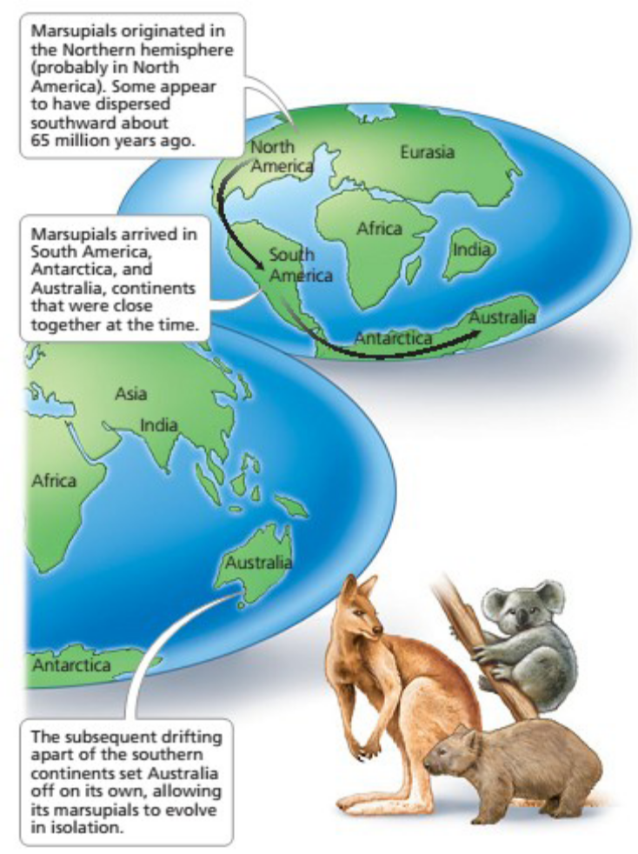
Biological Evolution:
- Darwin wrote a book – origin of species by natural selection in 1859. According to Darwin, evolution is a natural selection takes a million of year. In microbes, new species forms in few days because they form few million of individuals in a day. Acc. to Darwin, Nature selects for fitness and it is based on characteristics which are inherited.
- Branching descent and natural selection are the two key concepts of Darwinian Theory of evolution. According to him all the species inhabiting earth today descended from ancestral species (descent with modification) and natural selection is the mechanism for such descent with modification. Natural Selection states that a population of organisms can change over the generations if individuals having certain heritable traits leave more offspring than other individuals, resulting in a change in the population’s genetic composition over time.

MECHANISM OF EVOLUTION :
Darwinism | Hugo de Vries
• Evolution is small.  • It is directional.  • Mostly beneficial  • Slow process (many steps) | • Evolution is small.  • It is random / non directional.  • Mostly harmful to organism.  • Single step large mutation (saltation)
Hardy-Weinberg principle:
• Allele frequencies in a population are stable and is constant from generation to generation.
• The gene pool (total genes and their alleles in a population) remains a constant. This is called genetic equilibrium.
• Sum total of all the allelic frequencies is 1.
• Individual frequencies, for example, can be named p, q, etc. In a diploid, p and q represent the frequency of allele A and allele a.
• The frequency of AA individuals in a population is simply p2 and frequency of aa is q2.
p2 + 2pq + q2 = 1 or, (p + q)2 = 1
Five factors are known to affect Hardy-Weinberg equilibrium :
• Gene migration or gene flow- emigration, immigration.
• Genetic drift : Sudden changes in polulation
• Mutation : Sudden changes in DNA
• Genetic recombination : crossing over
• Natural selection:
Sometimes the change in allele frequency is so different in the new sample of population that they become a different species. The original drifted population becomes founders and the effect is called founder effect
MODERN SYNTHETIC THEORY OF EVOLUTION
Darwinism, the theory of natural selection has a wide acceptance. However, it has been criticised
too, on the ground it could not explain how the variations arise. With progress in genetics, the sources of
variation were explained and Darwin’s theory was modified. Now, the most accepted theory of
evolution is known as SYNTHETIC THEORY OF EVOLUTION, in which the origin of species is
based on the interaction of genetic variation and natural selection.
Natural selection causes allele frequencies of a population to change. Depending upon which traits are favoured in a population it can produce three different results.
(1) Stabilizing selection - If both the smallest and largest individuals contribute relatively fewer offspring to the next generation than those closer to average size do, then stabilizing selection is operating. It reduces the variation but does not change mean value.
(2) Directional selection – If individuals at one extreme of the size distribution e.g. (the larger ones)contribute more offspring to the next generation then the other individuals do, then the mean size of individuals in the population will increase. In this case directional population is operating. If directional selection operates for many generations, an evolutionary trend within the population results. 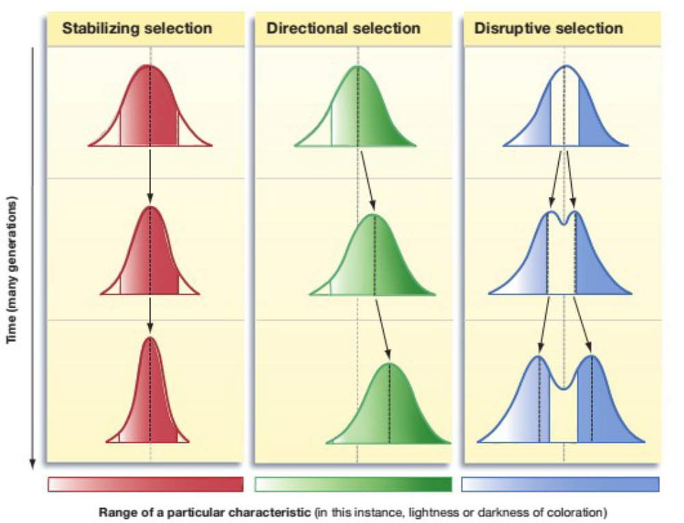
(3) Disruptive selection- When natural selection simultaneously favours individuals at both extremes of the distribution, disruptive selection is operating. As a result we can see two peaks in the distribution of a trait.
HUMAN
Time period | Name | Brain capacity | Remarks
10-15 Mya | Dryopithecus (ape like) |  | East Africa, Asia; closely related to chimpanzeee
10-15 Mya | Ramapithecus (man like) |  | Shivalik Hills; erect posture,small canine
2 mya | Australopithecus ( cave dwellers) | 500cc | African Ape Man ; height  1.5mts
 | Homo habilis | 700cc | Tool Maker, Community  Life , ate fruits
1.2 mya | Homo erectus | 800cc to 1300cc | Knew how to use fire, larger  Teeth, ate meat
100,000-  40,000 mya | Neanderthal man | 1450cc | East and central Asia
25000mya | Homo sapiens (Modern man) ; | 1650cc | height1.5 to1.8 mts; flat face
EVOLUTION

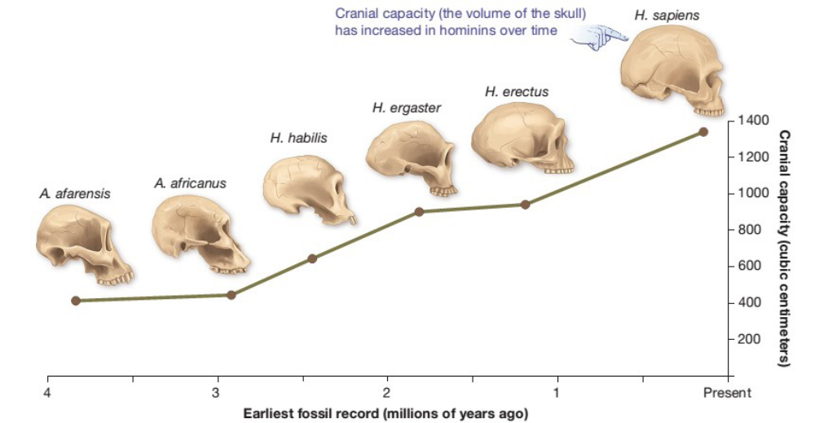
PERIOD  Precambrian  Cambrian  Ordovician  Silurian  Devonian  Carboniferous  Permian  Triassic  Jurassic  Cretaceous  Tertiary  Quaternary | EVENTS  Origin of life, Oxygen evolution through photosynthesis  Flourishing of the invertebrates, increase in algal diversity, appearance of vertebrates.  Plants begin to colonize land.  Increase in diversity of fish.  Amphibians appear  Extensive forest, dominance of amphibians, increase in  diversity of insects, first reptiles appear.  Age of reptiles begin  Dinosaurs evolve and spread, first mammal appear  First bird and first flowering plant appear.  Dominance of flowering plants.  Age of mammals begin  Evolution of human, Large mammals and birds became  extinct.
Useful video links:
https://www.youtube.com/watch?v=-hJOgHPmUvY
https://www.youtube.com/watch?v=WhFKPaRnTdQ
https://www.youtube.com/watch?v=aTftyFboC_M
https://www.youtube.com/watch?v=P3GagfbA2vo
https://www.youtube.com/watch?v=2oKlKmrbLoU&t=172s
Assignments:
VERY SHORT ANSWER TYPE QUESTIONS:
- Which theory of origin of life states that life on earth came from outer space?
- Name the sail ship in which Darwin travelled.
- Give the example of analogy in plants.
- Do placental animals in Australia show adaptive radiation like marsupials? Comment.
- What is essence of Darwinian theory of evolution?
- Name the biologist famous for his work on populations.
- How do mutations arise in a population?
- If Q is the frequency of occurrence of an allele A in a population, then what is the probability of individuals with genotype AA?
- Progymnosperms originated in which period?
- The fossils discovered in Java belonged to which ancestor of man?
- Name a fish like reptile that evolved from land reptile 200 years ago.
- For a long time it was believed that life originated from decaying matter. What was this theory. Who disproved it?
- If origin of life is in progress in other planet other than earth, what should be the conditions there.
- Who stated that population increases geometrically but the food increases arithmetically.
- Name the scientist who had come to the same conclusion as that of Darwin about natural selection. Which place did he visit to come to the conclusion.
- Name any two vestigial organs found in human body.
- What is the cause of speciation according to Hugo De Vries.
- Name the phenomenon by which rapid speciation take place.
- Name the scientist who set up a special experiment to prove Oparins theory.
- Name the common ancestors of apes and man.
- Which period is known as the age of amphibians?
- What provided the energy for biotic synthesis on primitive earth.
- What is meant by gene pool.
- Which period is called as the age of reptiles?
- Name the species of human being which is most closely related to modern man.
- What is founder effect?
- Coelocanth was caught in 1938 in South Africa, why is it significant in the evolutionary history of vertebrates?
- Give examples of convergent evolution from plant and animal.
- List two characteristics of mutation that helped in explaining evolution by Hugo De Vries.
- Why are Lichens regarded as pollution indicaters.
- Pick out the ancestral line of angiosperms from the list given: Conifers, seed ferns, cycads , ferns
- Mention the type evolution that is brought out by the similarity between potato and sweet potato.
- What is saltation according to Hugo de Vries.
- What does Hardy Weinberg’s p2+2pq+q2=1 convey?
- When does a species become founder to cause founder effect?
- Write probable difference in eating habit of Homo habilis and Homo erectus.
- List two main propositions of Oparin and Haldane
SHORT ANSWER TYPE QUESTIONS:
- Name the gases used by miller in his experiment and which theory was more or less accepted by his experiment?
- How the concept of common ancestor was concluded by Darwin?
- Which characteristics are selected by the nature?
- How can you say that homology indicates common ancestry?
- How Darwin came to the conclusion of adaptive radiation in galpago islands?
- What do these pictures illustrate with reference to evolution.
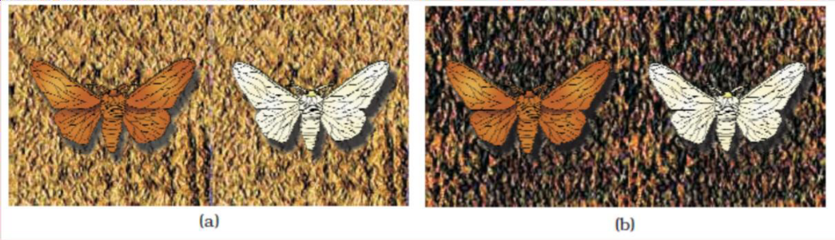

- How did Louis Pasteur disprove the theory of spontaneous generation.

Areas identified for slow learners:

Evolution |  | Origin of life  Big Bang  Miller’s Experiment |  |  |  | Adaptive Radiation  Branching descent and natural selection.  Mechanism of evolutionSaltation. |  |  |  | Explanation and interaction with students giving diagrammatic examples of marsupials .  Discuss stepwise Darwin’s theory of evolution giving example of Darwin’s finches.  Discuss the concept of mutation and speciation.
Divergent Evolution |  |  | Hardy-Weinberg  Principle. |  |  |  |  | Discuss the factors affecting Hardy-  Weinberg equilibrium  .
Divergent Evolution |  |  | Founder effects. |  |  |  |  | Allele frequency in the new sample of population drifted from original population.
Homologous Organs |  |  | Origin and Evolution of man. |  |  |  |  | Discussing Human evolution stepwise giving characters mainly brain capacity
 | Chapter- 7 | Prepared by:  Ranchi Region

